**CS-420 OPERATING SYSTEMS**

**Final Exam Study Guide**

1. **CHAPTER 1 MATERIAL:**
2. **ENIAC:** Electronic Numerical Integrator and Computer (1945) world’s first general purpose programmable computer.
3. **Von Neuman Architecture:** Changed computing by 1. Stored program into memory by storing a program’s data & instructions instead of having to use plug & board switches. 2. Introducing the fetch-decode-execute cycle and also by implementing a predefined set of instructions or operational codes (opcodes). 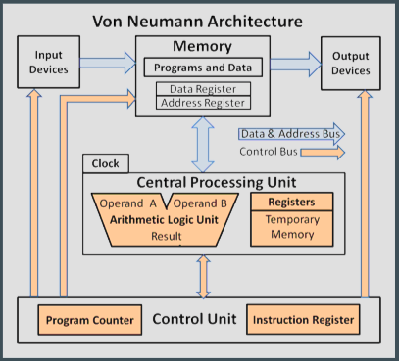
4. **Transistor:** It is essentially an electrical switch that can be turned on/off to represent binary data of 1 being on and 0 being off. They changed computing because they where more reliable and smaller than vacuum tubes essentially making electronics significantly smaller, more powerful and consumed less power.
5. **Common logic gates:** AND, OR, XOR, NOT GATES. 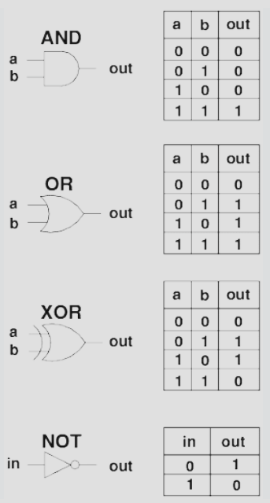
6. **1 Bit Adder:**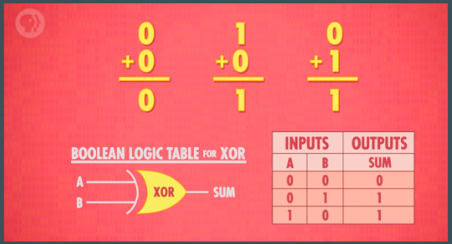
7. **Half-Adder:**

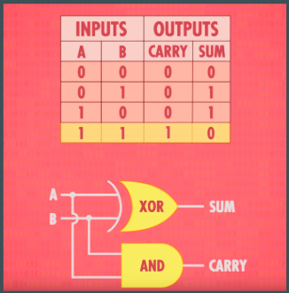

1. **Full Adder:**

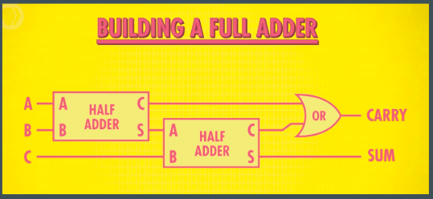

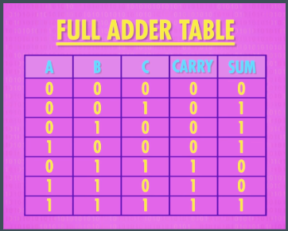

1. **8-Bit Adder:**

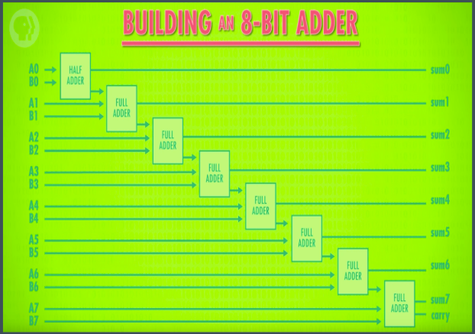

1. **256-BIT Memory:**

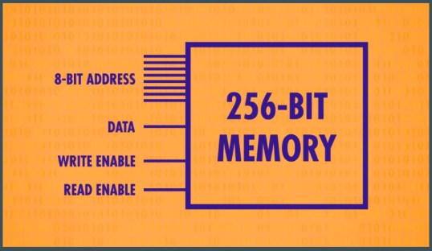

1. **256 BYTE Memory:**

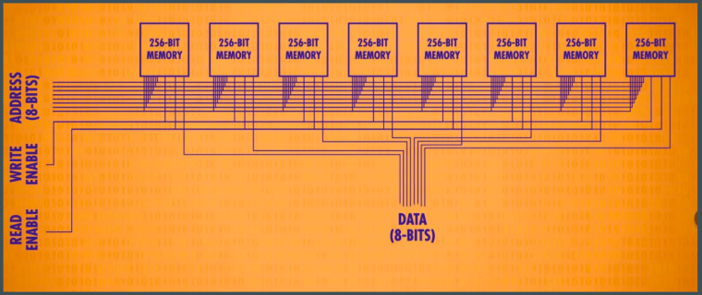

1. **Instruction Cycle:** How a CPU processes instructions step by step is the fetch-decode-execute cycle.
2. **Fetch:** CPU fetches/reads the next instruction in memory in which a program counter (PC) tells where the CPU can find the next instruction which in turn is stored in the Instruction Register (IR). 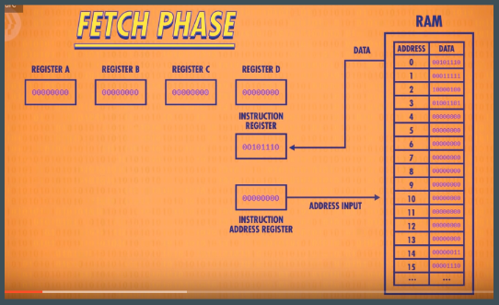
3. **Decode:** CPU decodes the instruction which is an operational code (opcode) that is interpreted to determine the operation to execute.

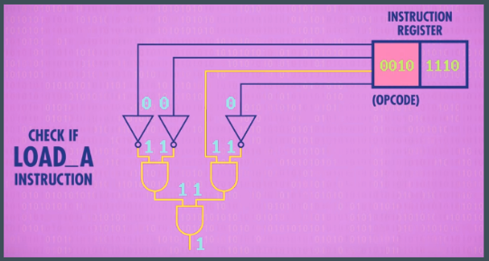

1. **Execute:** The CPU then executes the instruction by using its Arithmetic Logic Unit (ALU), registers, or memory. Finally the Program Counter (PC) is updated to point to the next instruction.
2. **Role of the operating system:** The role of the operating system is to bridge the gap between the bare metal hardware and the end user.
3. **Operating System (OS):** The software that runs on the bare metal hardware of a computer and provides essential support for users to develop and use applications in the most efficient and safe manner.
4. **Multiprogramming:** A technique that keeps several programs resident in main memory and switches the execution (context switches) between the different programs to maximize CPU utilization and other system resources.
5. **Time-Sharing (Multitasking):** An extension of multiprogramming where the CPU switches (context switch) between the different programs in main memory by a determined quanta (quantum) time allowed for a program to run on the CPU to allow for acceptable response times to each program/user.
6. **Kernel:** the minimal set of functions necessary for an Operating System to manage the system resources safely and efficiently. The kernel provides the most essential services for memory and device management, creation and managing units of computation, and for communication among the different concurrent activities within the system.`
7. **Security Issues:** To handle issues of security, the instruction set provided by the CPU is divided into two sets of instruction types: Privileged instructions & Non-Privileged Instructions.
8. **Privileged Instruction:** Instructions that perform critical operations like accessing I/O devices or the CPU’s status and control registers thus only the OS Kernel is allowed to execute privileged instructions.
9. **Non-Privileged Instruction:** Instructions that any program can execute including the OS kernel.
10. **CPU state modes:** The CPU operates in two different modes that allows the CPU to either execute privileged or non-privileged instructions that is indicated by a special mode bit. The two different modes are Kernel Mode & User Mode.
11. **Kernel Mode:** CPU state mode that the CPU can execute both privileged or non-privileged instructions.
12. **User Mode:** CPU state mode that the CPU can execute only non-privileged instructions.
13. **Graphical User Interface (GUI):** Presets various icons on the screen in which the user can click to interact with the Operating System or applications.
14. **OS Shell:** A command interpreter that accepts and interprets textual commands by the user via a keyboard so that the Operating System can execute the user’s command inputs.
15. **System Call:** A request from an application for an Operating System service.
16. **Supervisor Call (Kernel Call):** A privileged instruction that automatically transfers execution control to the Operating System Kernel.
17. **Interrupt:** An event that diverts the current execution of a program to the Operating System kernel in order to respond to an event.
18. **Trap (Internal Interrupt):** An interrupt triggered by the currently executing instruction by the program currently executing on the CPU.
19. **Interrupt Handler:** A Operating System Kernel function that is executed whenever an interrupt occurs.
20. **Moore’s Law:** The observation that the number of transistors in an integrated circuit doubles about every two years.
21. **5 Generations Of Computers:** There are 5 generations of computers.
22. **Generation 1:** Enabling Hardware Technology: Vacuum Tubes; OS Type: None; Characteristics: No Operating System or system software, programming was done by experts using machine code.
23. **Generation 2:** Enabling Hardware Technology: Transistors; OS Type: Batch OS; Characteristics: Introduction of multiprogramming.
24. **Generation 3:** Enabling Hardware Technology: Integrated Circuits; OS Type: Interactive Multi-User Operating System; Characteristics: Introduction of time-sharing.
25. **Generation 4:** Enabling Hardware Technology: Microprocessors; OS Type: Desktop/Laptop OS; Characteristics: User friendly GUI.
26. **Generation 5:** Enabling Hardware Technology: Networking Hardware; OS Type: OS for supercomputers, distributed systems & mobile devices; Characteristics: Parallel processing.
27. **CHAPTER 2 MATERIAL:**
28. **Process:** An instance of a running program.
29. **Process Control Block (PCB):** Abstraction of a currently running process. A data structure that holds information of a process which includes the current instruction address, call stack, set of resources used by the process, and the program being executed.
30. **6 Process states (The Omni-present triangle or Finite-State Machine):** 1. New, 2. Ready, 3. Running, 4. Blocked, 5. Suspended, 6. Terminated.

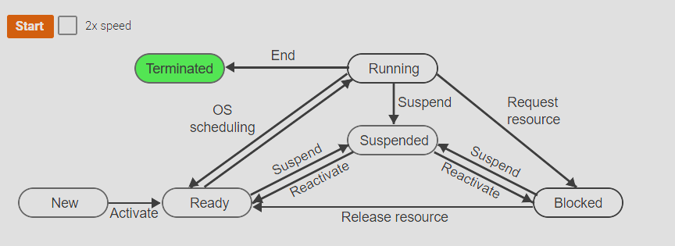

1. **(Core/Primary State) Ready State:** A process that is allowed to compete for the CPU to be executed.
2. **(Core/Primary State) Running State:** A process that is currently running on the CPU (only 1 process at a time can be at the running state).
3. **(Core/Primary State) Blocked State:** A process that requested an already allocated resource and thus gets blocked on that resource and therefore cannot execute any further on the CPU and must be removed from the CPU by the OS.
4. **Context Switch:** When a process on the running state on the CPU is removed by the OS to allow another process to compete/run on the CPU. Context switching has overhead and too much context switches decreases CPU utilization to actually execute the instructions of an actual process.
5. **Physical CPU:**A real hardware instance of a CPU. Multiple processes may run on one physical CPU using a technique known as time sharing.
6. **Virtual CPU:** Each process is given a virtual CPU which is a CPU that the process assumes is available only to itself. A virtual CPU can just be an abstraction of the physical CPU or it can be software that emulates the behavior of a different CPU.
7. **Benefits of Virtual CPUs:** Independence from the number and type of CPUs provides several crucial benefits: Multi-user support: Multiple users, each represented by one or more separate processes, can share the same machine without being aware of each other. Multi-CPU transparency: An application written to utilize multiple CPUs will run correctly, although perhaps more slowly, if only one CPU is available. Portability: An application compiled for one type of CPU can run on a different CPU without being modified or even recompiled.
8. **The grand illusion:** The user’s perspective is that many applications are running simultaneously or at the same time. The Process’s perspective is that it is the only one running on the CPU and no other processes exist. The reality of the hardware is that only one process can run on the CPU at a time and processes have to share that CPU to keep the illusion, multiprogramming is implemented to allow each process to execute on the CPU to create the illusion that many programs/applications are running simultaneously. But at the same time a process is allowed to believe that it is the only one running on the CPU or the only process that exists.
9. **Organization of process control blocks (PCBs):** 1. Array of structures, pros are that the overhead of having to dynamically create/allocate new process control blocks are done on startup thus having a longer startup time that generally does not cause an issue for the user thus new processes are created faster due to the overhead of having to create them is at start up of a computer. The cons are that there can only be a limited amount of process control blocks since the array of structures is of a fixed size. 2. A linked list of process control blocks, pros are that the Operating System only needs to keep a track of all process control blocks necessary and deletes all process control blocks that are not needed, it can create however many process control blocks it requires. The cons are that the overhead of having to dynamically create/allocate new processes is present when the computer is running and can slow it down.
10. **Ready List (RL):** A list that contains all process control blocks that are currently in the ready state that is allowed to compete to execute on the CPU.
11. **Waiting List (WL):** A list that contains all process control blocks that are currently blocked upon a request to an already allocated resource.
12. **Process creation hierarchy:** a graphical representation of the dynamically changing parent-child relationships among all processes. The process creation hierarchy changes each time a process is created or destroyed. When the Operating System starts a Root process is created that just starts all other child processes and thus becomes the parent of all other processes. The root process is created by a program called the boot loader which is responsible for starting up the Operating System.
13. **Create Process Function [create()]:** When the currently running process initiates the creation of a child process, the Operating System executes a crate process function, create(). The create process function allocates a new Process Control Block then fills out the PCB entries with initial values, and then links the PCB to other data structures in the system.
14. **Destroy Process Function [destroy()]:** A process ‘p’ can be terminated by the parent process by calling the function destroy(p). Completing all work or committing a fatal error also results in the process’s destruction. The destroy process function destroys a process by freeing the Process Control Block data structure and removing any references to the PCB from the system.
15. **The 3 common functions used to create a new process in linux:** fork(), execvp(), wait_pid();

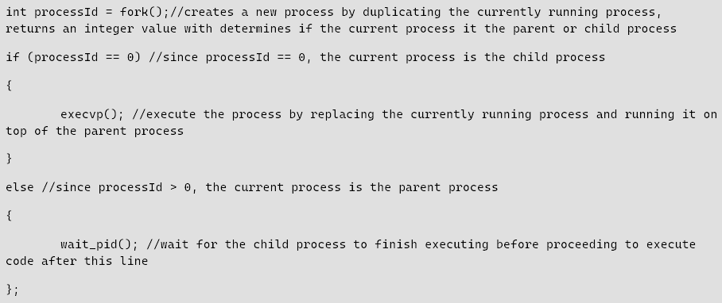

1. **fork() [in windows it is CreateProcess()]:** used to create a new process in linux by duplicating the currently running process then returns a integer value for the processId. If it is equal to 0 then it means the current process running is the child process, if it is > 0 then it is the parent process in which it must wait upon it until the child process finishes executing.
2. **execvp():** is used to replace the currently running process with the newly created process by running the process on top of the parent process thus having to make the parent process wait upon the child process until it finishes executing. When fork() returns an integer value of 0 this means it is currently the child process and then it can call the execvp().
3. **wait_pid():** is used to wait upon a child process until it has finished executing before continuing with the code. When fork() returns an integer value > 0 this means it is currently the parent process and then it can call wait_pid() to wait for the child process until it finishes executing. The value returned by fork() which is an integer value > 0 is the child process’s processId.
4. **sysctl():**System control allows for read/write operations on the kernel level at runtime useful for low-level system programming.
5. **Resource Control Block (RCB):** An abstraction of a resource. A data structure that represents a resource and has multiple fields like the state of the resource is in if it is currently allocated or not and a waiting list that contains a linked list of all processes blocked on that resource waiting for that resource to become freed and available for the next process at the head of the waiting list to obtain allocation of said resource.
6. **Request Resource Function [request()]:** Allocates a resource ‘r’ to a process ‘p’ or blocks ‘p’ if ‘r’ is currently allocated to another process.
7. **Release Resource Function [release()]:** Allocates the resource ‘r’ to the next process on the ‘r’ waiting list. If the waiting list is empty, ‘r’ is marked as free.
8. **Scheduler Function:** Determines which process that is currently in the ‘ready’ state that is also currently inside the Ready List (RL) should be executed/run on the CPU next. Which process should be executed on the CPU depends on its priority, the process with the highest priority is the next to execute on the CPU.
9. **The 5 Times When The Scheduler Function Is Typically Called:** 1. Upon process creation and ready to put into the ‘ready’ state and placed on the Ready List (RL) [create()], 2. Upon process termination/completion of execution on the CPU [delete()], 3. Upon a process being blocked when requesting an already allocated resource [request()], 4. Upon a resource being released to allow another process to allocate it [release()]. 5. Upon a resource running for far too long on the CPU and thus must be context switched off the CPU to allow other processes to compete to be executed on the CPU next [context switching].
10. **Threads:** An application ran as a single process (single-threaded process) follows a single path of execution by 1 program counter and 1 stack pointer. Whenever the execution is blocked, the entire process gets blocked. An application could have many parts that could or requires to be run concurrently if and only if those parts of code for the program could block independently of each other and not block the entire process. A solution for this problem would be to create many other processes to run different sections of the same program but this would incur the overhead of having to create new PCBs, instead we introduce the idea of threads which is an instance of a portion of a program in which it has its own program counter, stack pointer. Each thread can execute independently from the other threads on the CPU even if the other threads are blocked, the entire process is not blocked and therefore can still continue to execute. However if all threads are blocked then the process is now blocked. Depending on the number of cores the CPU has will determine the number of threads that can be executed on the CPU by the process. If the CPU cores is equal to or greater than the number of threads inside the PCB then all threads can execute but if there is less than then the CPU can only execute a limited number of the total threads and thus has to alternate between thread execution on the CPU.
11. **Single-Threaded process:** The process has only one program counter.
12. **Multi-Threaded process:** The process has a program counter for each thread.
13. **Thread Control Block (TCB):** A data structure that holds the bare minimum necessary information from the PCB that is needed for the thread to execute independently. Some of the PCB information include but are not limited to the program counter & stack pointer needed to execute different sections of the process’ code and hold different information in its own stack via its own stack pointer.
14. **CHAPTER 3 MATERIAL:**
15. **Long Term Scheduling:** Scheduling decisions are made at two different levels, long term scheduling decides when a process should enter the ‘ready’ state and start competing for the CPU. (Essentially in the omni-present triangle, long term scheduling is all the directional arrows except for the arrows pointing from the ready state to the running state and the running state to the ready state).
16. **Short Term Scheduling:** Scheduling decisions are made at two different levels, short term scheduling decides which of the ‘ready’ processes should run next on the CPU. (Essentially in the omni-present triangle, short term scheduling the directional arrows pointing from the ready state to the running state and the running state to the ready state).
17. **Non-Preemptive Scheduling:** A scheduling algorithm that allows a process to continue to run on the CPU unit it either gets blocked upon requesting an already allocated resource or finishes/terminates execution.
18. **Preemptive Scheduling:** A scheduling algorithm that may stop or context switch the currently running process on the CPU to allow another process that is currently in the ready state to compete for the CPU. Preemptive Scheduling is typically done when the scheduler function is executed upon the 3 following events: 1. When a process enters the ‘ready’ state and now reside inside the Ready List (RL), 2. When a resource is freed thus allowing a new process to gain allocation that is currently waiting upon that resource thus the process is now also inside the RL in the ‘ready’ state, 3. When the OS periodically context switches a process currently running on the CPU to allow for other processes to run, this period is typically defined by a Quanta (quantum) or ‘q’ time.
19. **Priority of a process:** Is a numerical value that indicates the priority level of a process the better the priority (higher or lower, depending on how the value is interpreted) is what the scheduler function will use to determine weather to run a process next or not.
20. **Arbitration Rule:** The OS picks a random process to execute if there are multiple processes with the same priority level.
21. **Useful metrics for engineering what the scheduler should prioritize:** Engineering the scheduler to prioritize what types of processes depends on what the OS’s goals are. The metrics to consider are throughput, turnaround time, response time, proportionality, predictability/reliability.
22. **The 3 Types of processes:** 1. Batch Process, 2. Interactive Processes, 3. Real-Time Processes.
23. **Batch Process:** A process that performs a long-running and generally repetitive task that does not require any intervention from the user.
24. **Main Objective In Scheduling Batch Processes:** Maximize throughput (the number of processes completed per unit of time).
25. **Scheduling Algorithms designed for batch processes:** First In First Out (IFO) Scheduling Algorithm, Shortest Job First (SJF) Scheduling Algorithm, Shortest Remaining Time (SRT) Scheduling Algorithm.
26. **First In First Out (FIFO) Scheduling Algorithm:** A Non-Preemptive Scheduling algorithm that schedules processes strictly according to the process’s arrival time in the Ready List. Earlier the process entered the Ready List, the higher their priority. If processes arrive at the same time the arbitration rule is enforced, and a random process is chosen to run next.

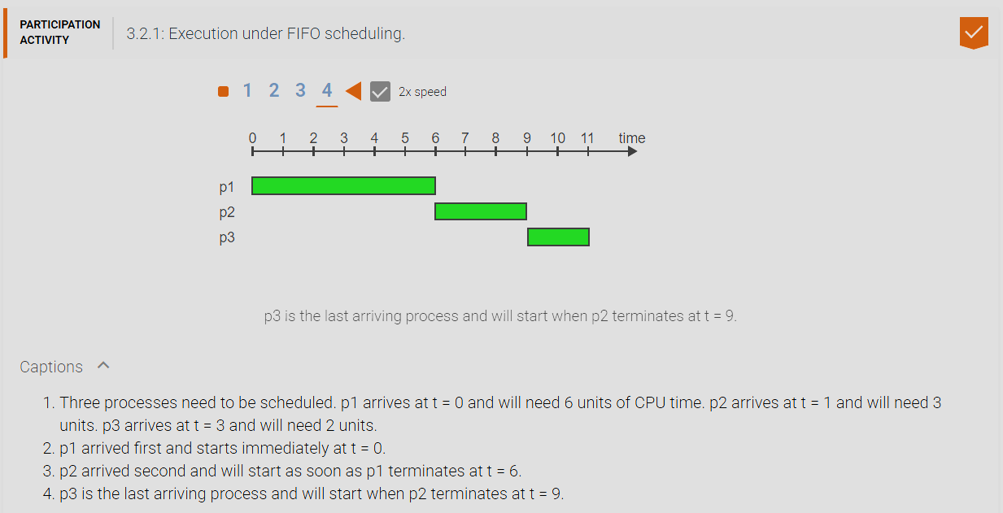

1. **Shortest Job First (SJF) Scheduling Algorithm:** A Non-Preemptive Scheduling Algorithm that Schedules processes based on the total CPU time it will require for a process to finish executing. If processes have the same total CPU time then the arbitration rule is enforced, and a random process is chosen to run next. The issue with this algorithm is that the total CPU time is just an estimation, and we don’t truly know in reality how long a process may take and some processes that appear to have shorter total CPU times may in reality have a longer time to execute. This algorithm can lead to some processes into starvation where shorter and shorter processes continuously get added into the ready list leading to some processes that have a much longer job never being able to execute on the CPU.

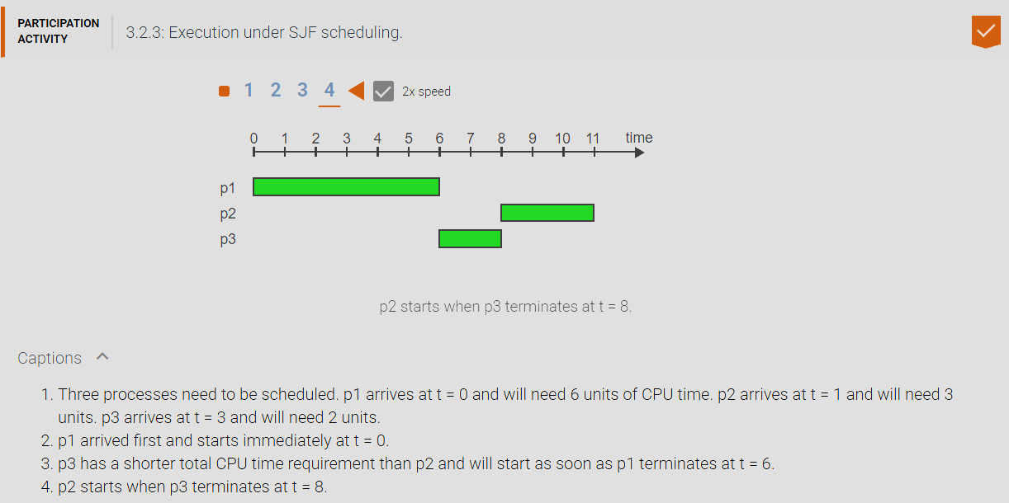

1. **Shortest Remaining Time (SRT) Scheduling Algorithm:** A Preemptive Scheduling Algorithm that Schedules processes according to the remaining CPU time left for a process to finish execution. If processes have the same remaining CPU time left then the arbitration rule is enforced and a random process is chosen to run next. The issue with this algorithm is that the remaining CPU time is just an estimation, and we don’t truly know in reality how long a process may take and some processes that appear to have shorter total CPU times may in reality have a longer time to execute. This algorithm can lead to starvation of some processes when shorter and shorter remaining time processes continuously enter the ready list leading to processes with longer remaining times from never being able to execute on the CPU.

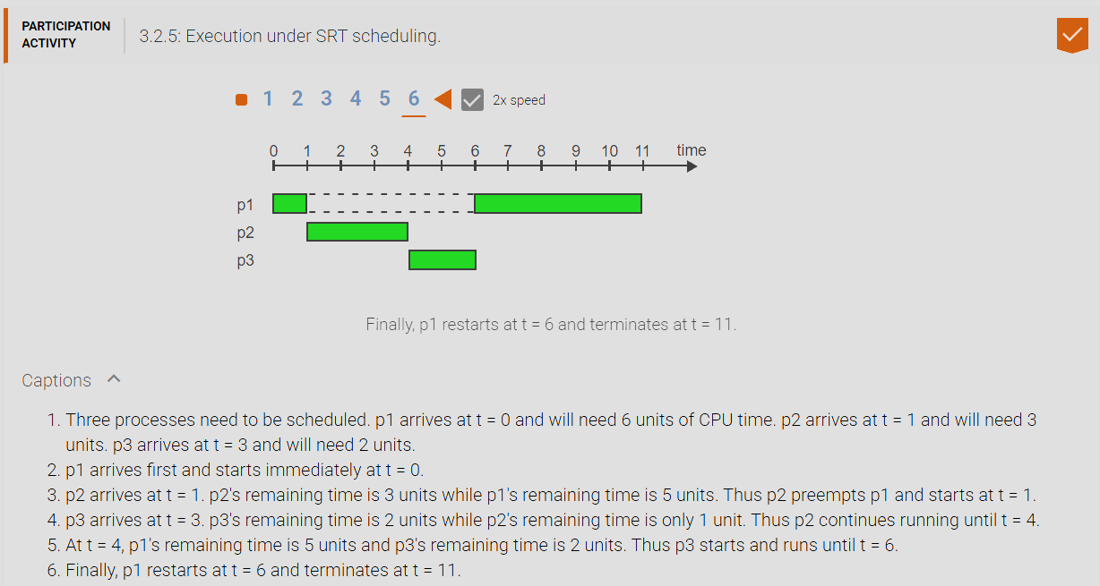

1. **Estimating Total CPU Time Formula:** Sn = last estimate of the total CPU time, Sn+1 the next estimate of the total CPU time, Tn = last observed total CPU time. a = alpha (weight from 0 <= a <= 1). Sn+1 = a * Tn + (1 – a) * Sn. When alpha is closer to 0 the prediction graph adapts to the observed graphs far more slowly thus is resistant to outlier spike behaviors however the prediction graph is way less accurate to the observed graph. When alpha is closer to 1 the prediction graph adapts to the observed graphs far faster thus are susceptible to outlier spike behaviors however the prediction graph is way more accurate to the observed graph.

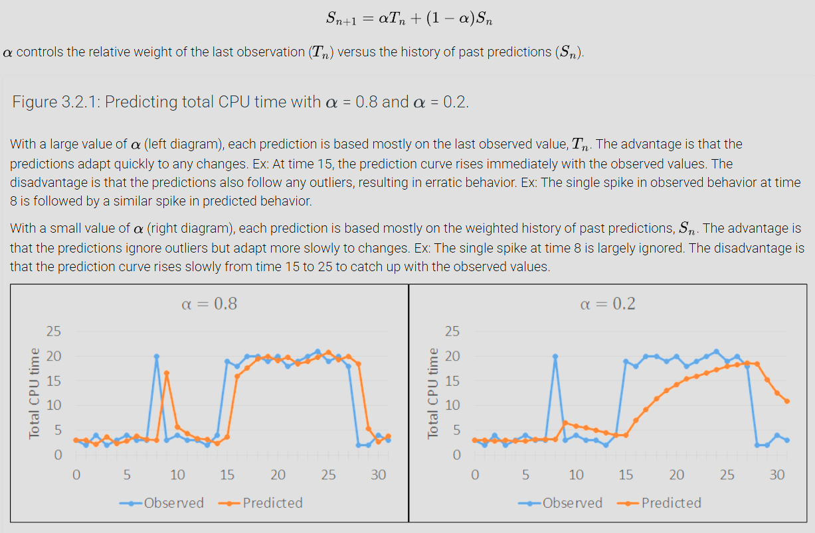

1. **Turnaround time:** The time between the arrival and departure (The sum total CPU time and the waiting time). Essentially how long did the process exist before termination.
2. **Average Turnaround Time (ATT):** The mean of the set of all process’s Turnaround time.

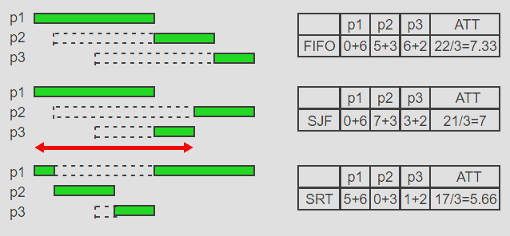

1. **Starvation:** Is the indefinite postponement of a process while other processes are allowed to proceed.
2. **Interactive Process:** Communicates with the user in the form of a dialog by receiving commands or data from the keyboard or a pointing device and responding by generating output on the user’s terminal or another output device.
3. **Main Objective Of Scheduling Interactive Processes:** Provide acceptable response rates for the user inputs.
4. **Scheduling Algorithms designed for Interactive Processes:** Round Robin (RR) Scheduling Algorithm, Multilevel Scheduling (ML) Scheduling Algorithm, Multilevel Feedback (MLF) Scheduling Algorithm. All interactive processes must require preemptive scheduling algorithms because they use a time quantum to allow processes to execute on the CPU for a limited amount of time.
5. **Time Quantum (quanta) (q):** A small amount of time typically from 10 to 100 milliseconds during which a process is allowed to use the CPU before it can get context switched off to allow another process to compete for the CPU. A higher time quantum (quanta) increases the likelihood of a process to complete its execution at the cost of increasing the response times thus reducing the response rates (i.e higher response time = lower response rates since they are inversely related). A lower time quantum (quanta) decreases the likelihood of a process to complete its execution but allows for reduced response times thus increasing response rates, however too low of a time quantum decreases CPU utilization by spending most of its time doing context switching overhead thus the CPU spends less time running actual processes.
6. **Round Robin (RR) Scheduling Algorithm:** A Preemptive Scheduling Algorithm that Schedules processes by using a single queue in which the priority is determined solely by its position in the queue. Each process is allowed to run for ‘q’ time quanta units until it has to be context switched and then placed at the back end/tail of the queue if it still has not terminated during its allocated time to run on the CPU.

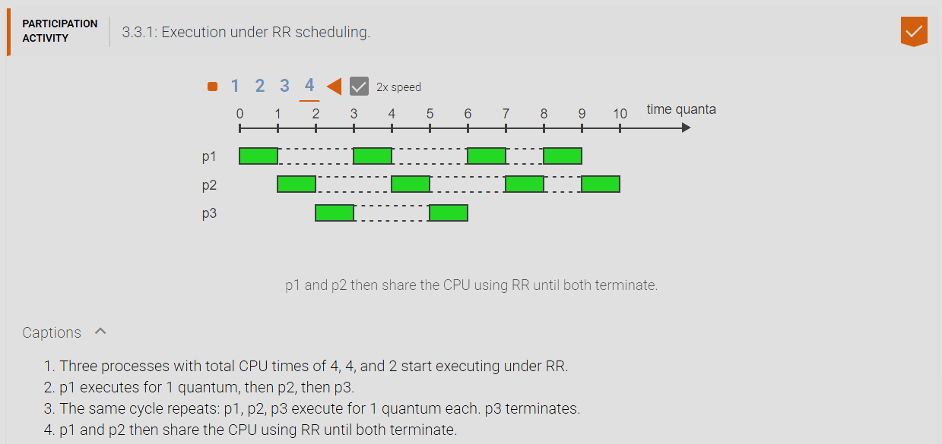

1. **Multilevel (ML) Scheduling Algorithm:** A Preemptive Scheduling Algorithm that Schedules processes by having multiple Round Robin Queues where each queue is of a different priority level. Processes inside a queue cannot be executed until the level with a higher priority is fully emptied of all its processes. Each process runs for a ‘q’ time quantum before they get context switched off if they have not yet finished executing and placed at the back of their respective Round Robin Queue level. This algorithm can lead to starvation of Round Robin queues with lower priority levels if the Round Robin queues with a higher priority continuously gets new processes added onto it.

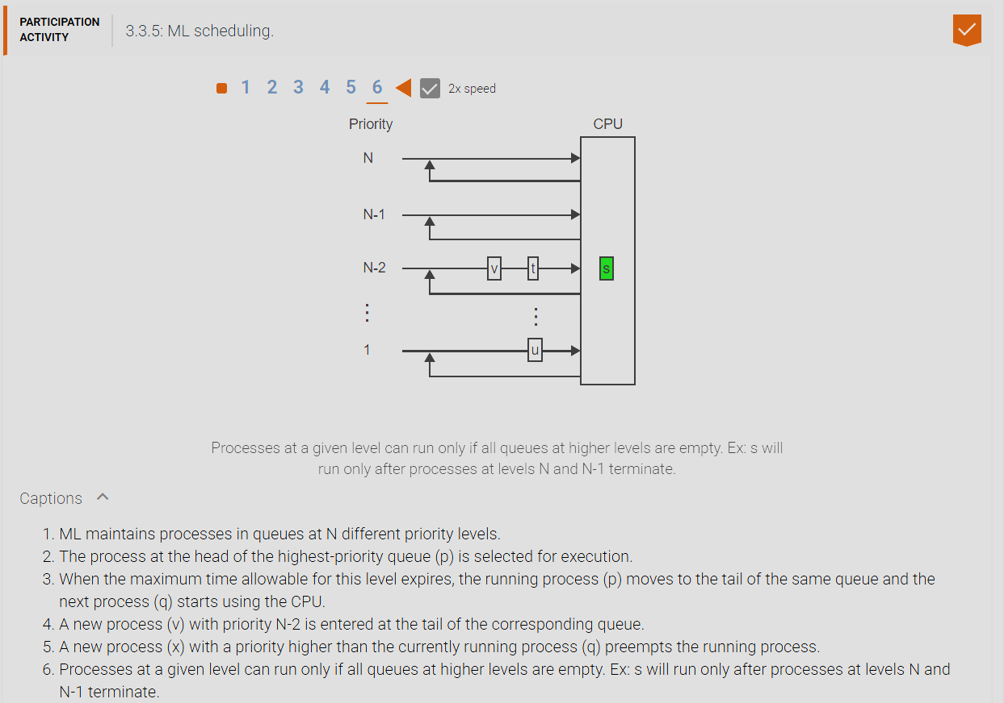

1. **Multilevel Feedback (MLF) Scheduling Algorithm:** A Preemptive Scheduling Algorithm that is similar to multilevel (ML) Scheduling Algorithm where each level now has a different time quantum ‘q’ that doubles each new level. Processes start at the level with the highest priority and with the time quantum ‘q’, if the process does not finish executing and has used up all the time quantum ‘q’ allocated to it, it must proceed to the next level where when the level with higher priority than it finishes all processes in its RR queue then the processes at the current level can now execute. The process continues to go down to the next level if it continues to not be able to terminate until it reaches the last level where theoretically the ‘q’ time quantum is infinite and therefore the process must eventually finish execution. This fixes the issue of starvation of multilevel feedback in which processes at the lower levels when they execute are provided with every more so increasing time quantum to execute on the CPU thus they are more and more likely to actually terminate at the lower levels when they can actually run on the CPU because of the larger and larger time quantum allocated for them to run.

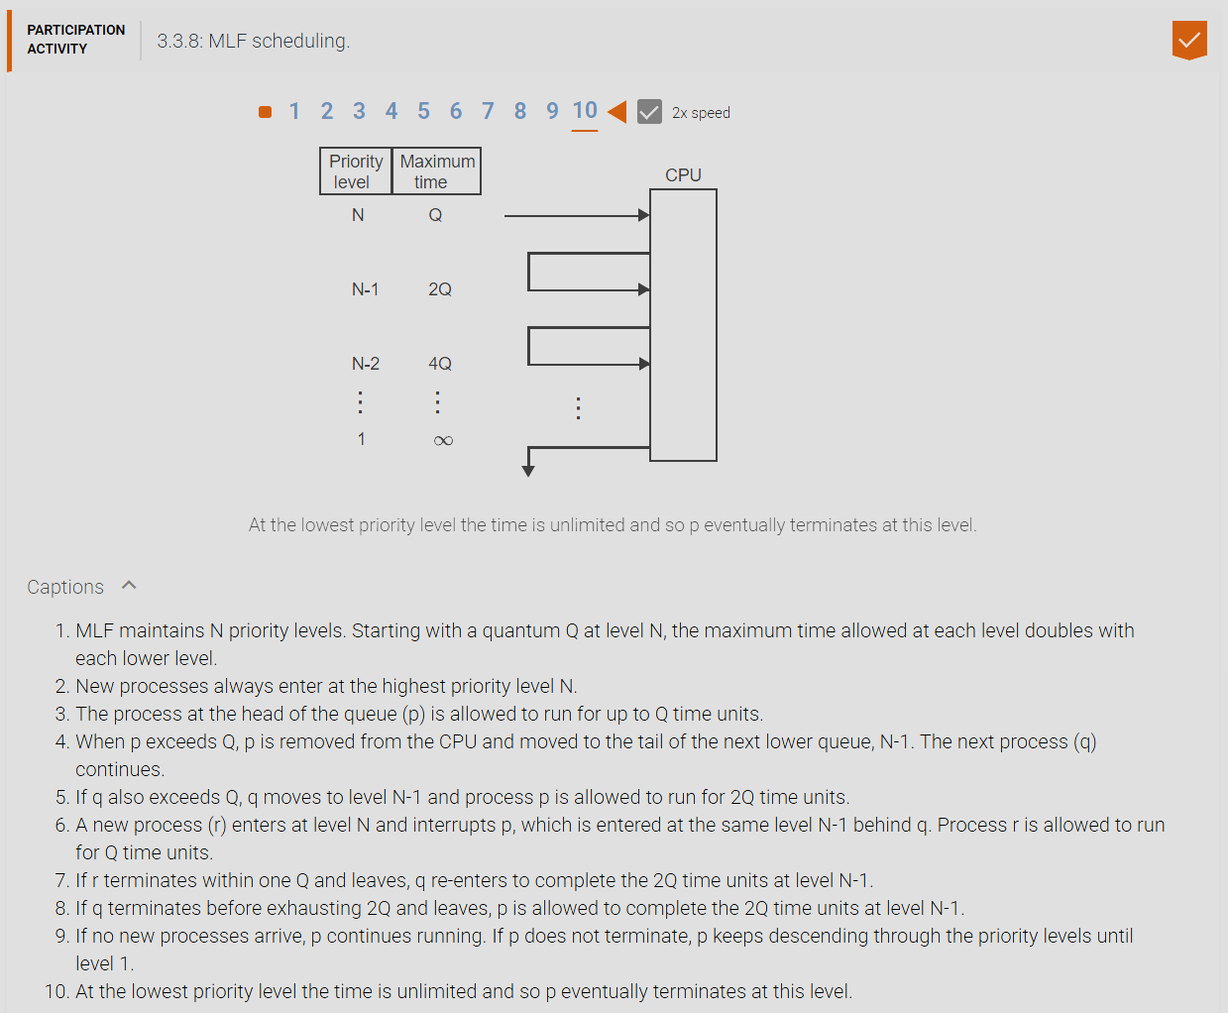

1. **Response Time:** The response time of a process is the elapsed time from the submission of a request like pressing the enter key or clicking a mouse button until the response begins to arrive. Guaranteeing adequate response time is the primary goal in the scheduling of interactive processes.
2. **Real-Time Process:** Characterized by continual input, which must be processed fast enough to generate nearly instantaneous output. Each arriving input item is subject to a deadline. Examples of which is streaming of audio or video, processing and displaying radar data, control of robots or of fly-by-wire aircraft.
3. **Main Objective Of Scheduling Real-Time Processes:** To execute critical processes within a specified timeline and must be done by a certain deadline.
4. **Scheduling Algorithms designed for Real-Time Processes:** Rate Monotonic (RM) Scheduling Algorithm, Earliest Deadline First (EDF) Scheduling Algorithm. Because of the nature of real-time processes you are not worried about starvation about these processes because they will always have the highest priority compared to batch and interactive processes.
5. **Period:** A time interval (typically in milliseconds or even microseconds) within which each input must be processed. The end of each period is the implicit deadline for processing the current item.
6. **Rate Monotonic (RM) Scheduling Algorithm:** A Preemptive Scheduling Algorithm that Schedules processes according to the period. The shorter the period, the higher the priority.

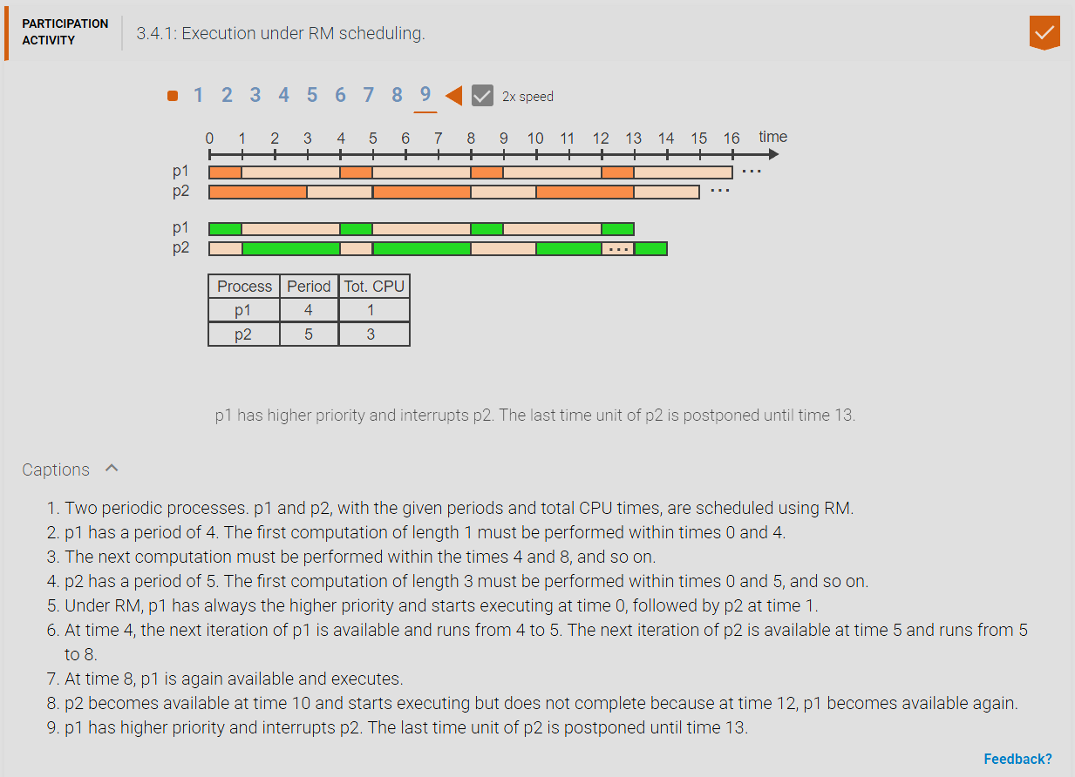

1. **Earliest Deadline First (EDF) Scheduling Algorithm:** A Preemptive Scheduling Algorithm that Schedules processes according to the shortest remaining time until the deadline. The shorter the remaining time the higher the priority.

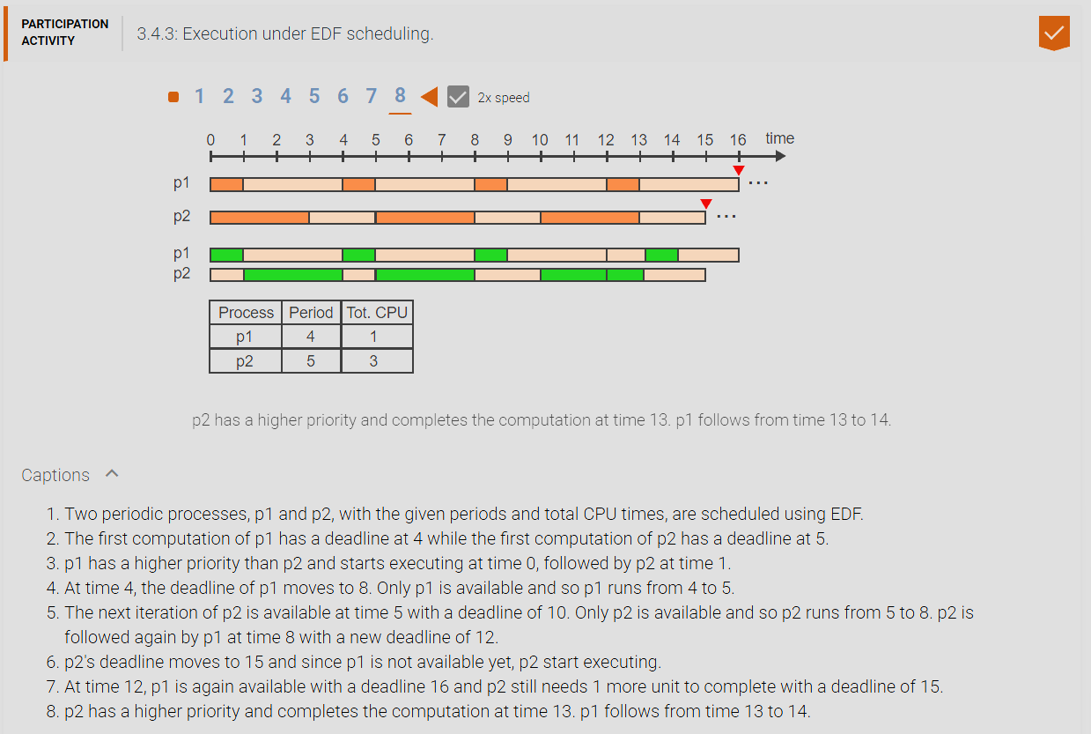

1. **Feasible:** A schedule is feasible if all the deadlines of the processes that are inside the scheduled set can be met.
2. **CPU Utilization (U):** The sum of all Ti divided by Di where Ti is the total CPU time for each process in the scheduled set and Di is the period for each process in the scheduled set. If U > 1 then no schedule is feasible to meet all the deadlines. If U = 1 then the CPU is fully utilized at 100% and if U <= 1 then a schedule is feasible to meet all the deadlines. For Example process p1, p2, and p3 all have a period time of 1 and all have a total CPU time of 1. Therefore (1+1+1) = 3 total CPU time required to finish executing the process and (1+1+1) = 3 total period time in which their deadlines must be met. Since total CPU time & total period time are both equal there is just enough time to execute all processes to meet the deadline with no room to spare and 3 divided by 3 is equal to 1 so U = 1 which means that CPU utilization is at 100%. If process p1 had a total CPU time of 2 then (2+1+1) = 4 total CPU time which means 4 > 3 and therefore the total CPU time required is bigger than the period time allotted and therefore there is not enough time to execute all the processes to meet the deadline and therefore a schedule is not feasible because 4 divided by 3 is 1.333~ which is bigger than 1. Since U > 1 a schedule is not feasible, likewise if process p1 had a total CPU time of 0.5 then (0.5+1+1) = 2.5 total CPU time which means 2.5 < 3 and therefore the total CPU time required is less than the period of time allotted and therefore there is enough time to execute all the processes to meet the deadline with room/time to spare. Since 2.5 divided by 3 is 0.8333~ therefore U < 1which means the CPU is underutilized.

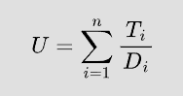

1. **Combined Approaches:** An OS running only batch processes or only real-time processes could rely on only one of the suitable algorithms. Ex: SJF for a batch OS and EDF for a real-time OS. A general-purpose OS needs to handle different types of processes and thus a combination of different scheduling algorithms must be used.
2. **2 Tier Scheduling Scheme:** The simplest approach is to divide processes into two groups. Real-time processes at the top with the highest priority level and batch & interactive processes at the next level. Real-time processes at the highest level has a multilevel FIFO non preemptive queues then has multilevel Round Robin preemptive queues with a time quantum ‘q’. As for batch and interactive processes they are added to a multi-level feedback algorithm which is also preemptive and with a time quantum ‘q’ that doubles each new level. Since there are 2 tiers, the scheduler alternates scheduling processes of the first tier then the second tier, prioritizing tier 1 to run first or scheduled more since they are real time processes with higher priority. This will prevent tier 2 batch/interactive processes from starvation.

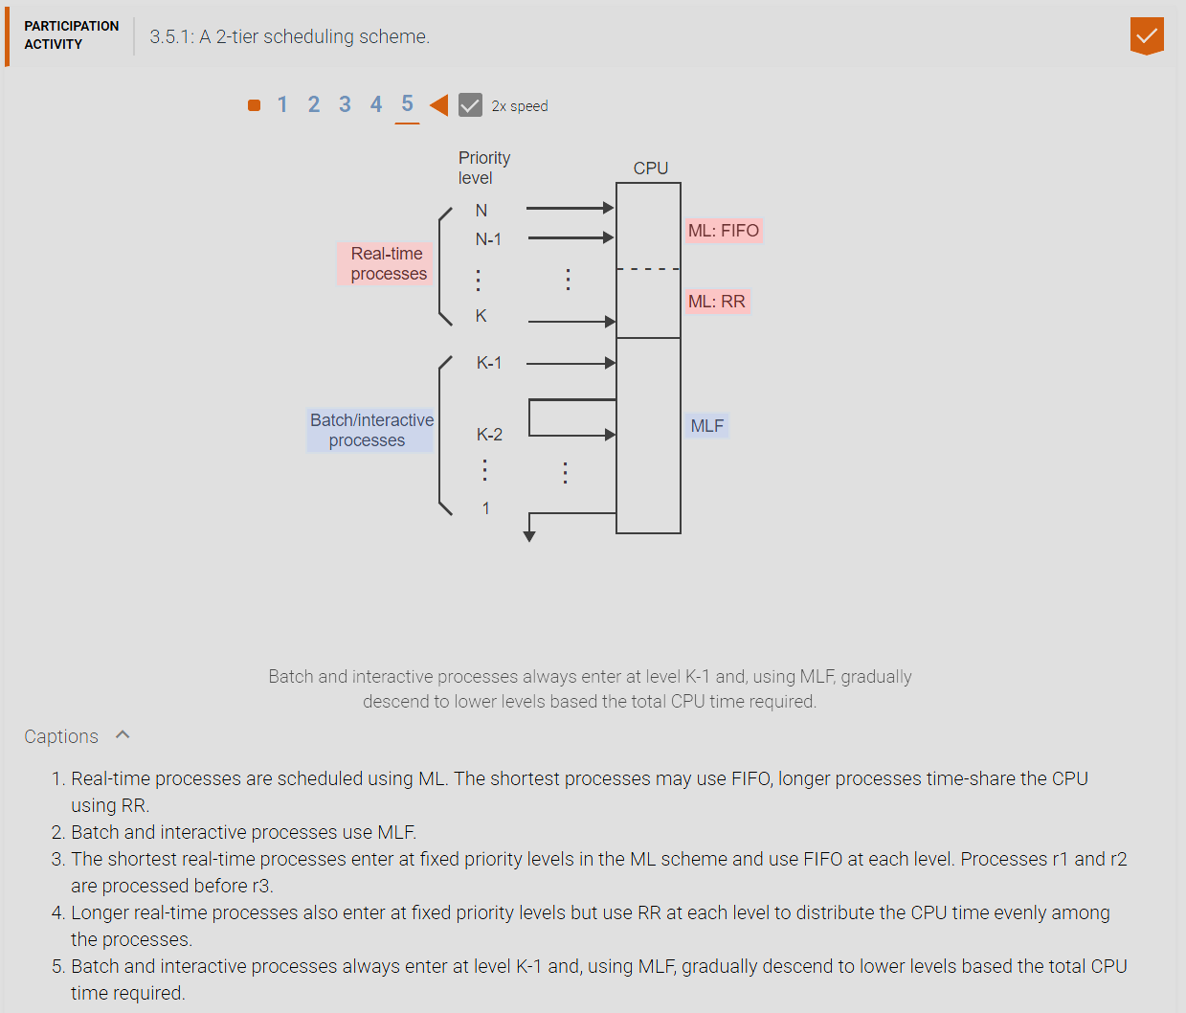

1. **2 Tier Scheduling Scheme With Floating Priorities:** Most modern general-purpose Operating Systems (Ex: Windows, Linux) use more sophisticated scheduling strategies to provide more flexibility. Real time processes use either FIFO or RR in a ML scheme. Interactive and batch processes use a variation of MLF. Every process is assigned a base priority at creation, but an increment is added based on the past action the process has taken. Ex: Returning from a request for keyboard input would add 6 to the base priority while returning from a request for disk input would add only 1. Thus the current priority depends on the type of process and the process’s behavior. A 2-tier scheduling scheme with floating priorities allows for real time processes to have multilevel feed back in which each level has a priority Round Robin queue and each process runs for a time quantum ‘q’. Followed by a multilevel feedback scheduling algorithm for batch and interactive processes where they start at the top at k-1 with each next level having a double ‘q’ time quantum. If an interactive process has return from a request its priority is increased by a value and thus goes up a level of higher priority thus having a higher chance of executing. Batch processes simply filter down the levels until they terminate. Again the 2 tiers are scheduled alternating to prevent starvation of the second tier of batch/interactive processes. This is because if only tier 1 at the top always gets prioritized and scheduled always, if new real time processes always enter the first tier will lead to starvation of the second tier for batch/interactive processes. This is what generally happens to general purpose Operating Systems.

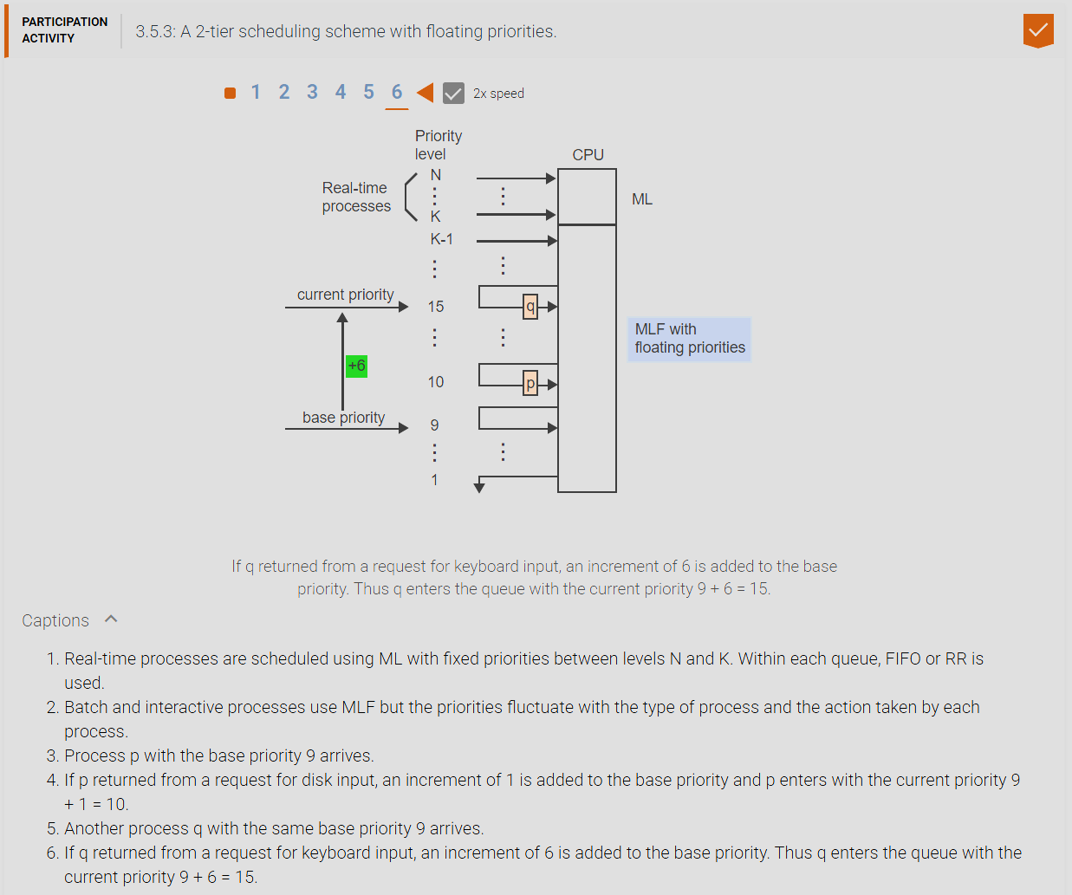

1. **CHAPTER 4 MATERIAL:**
2. **Concurrency:** is the act of multiple processes (or threads) executing at the same time. When multiple physical CPUs are available, the processes may execute in parallel. On a single CPU, concurrency may be achieved by time-sharing. When concurrent processes access a common data area, the data must be protected from simultaneous change by two or more processes. Otherwise the updated area may be left in an inconsistent state.
3. **Race Conditions:** Because of concurrency, race conditions can occur. Race conditions are when two or more processes share the same resources (like memory, data, files etc…) and happen to interfere/overwrite (usually at the same time) that shared resource’s data leading to unexpected/inconsistent results.
4. **Critical Section (CS):** A Critical Section is the solution to the race condition problem that is caused by concurrency. A CS Is a segment of code that cannot be entered by a process while another process is executing a corresponding segment of the code (If mutual exclusion is not guaranteed then race conditions is now a possibility). Rules for Critical Sections: 1. No two processes may enter simultaneously inside the Critical Section, 2. No assumptions may be made about speeds or the number of CPUs, 3. No process running outside its critical section may block any process. 4. No process should have to wait forever to enter its critical section.
5. **What are the 4 requirements for a software solution to the critical section problem?:** 1. Guarantee Mutual Exclusion (Only one process at a time can enter the critical section of code, Mutual exclusion eliminates the possibility of race conditions). 2. Prevent Lockout (If a process is not attempting to enter the critical section, it should not block another process from trying to enter), 3. Prevent Starvation (Processes should not be able to repeatedly go inside a critical section and prevent others from entering indefinitely). 4. Prevent Deadlock (If two or more processes try to enter the critical section they should not block each other from entering).

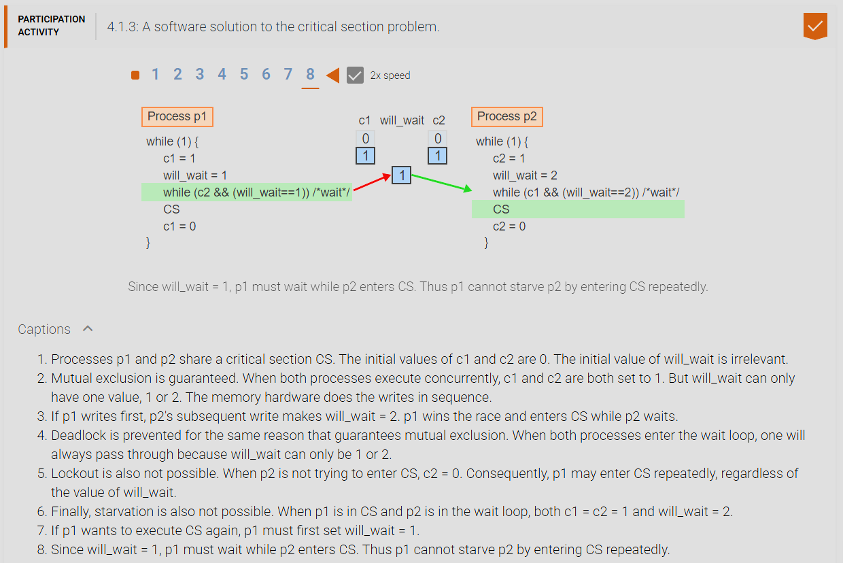

1. **Code that causes lockout example:**

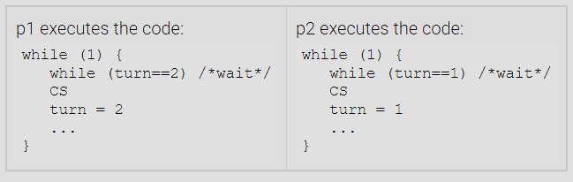

1. **Code that causes deadlock example:**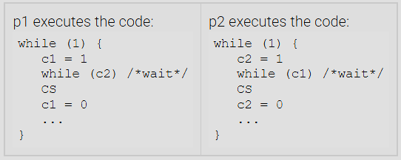
2. **Process Cooperation (Producer Consumer Problem):** In addition to the Critical Section problem, where processes compete for access to a shared resource, many applications require the cooperation of processes to solve a common goal. A typical scenario is when one process produces data needed by another process. The producer process must be able to inform the waiting process whenever a new data item is available. In turn, the producer must wait for an acknowledgement from the consumer, indicating that the consumer is ready to accept the next data item.

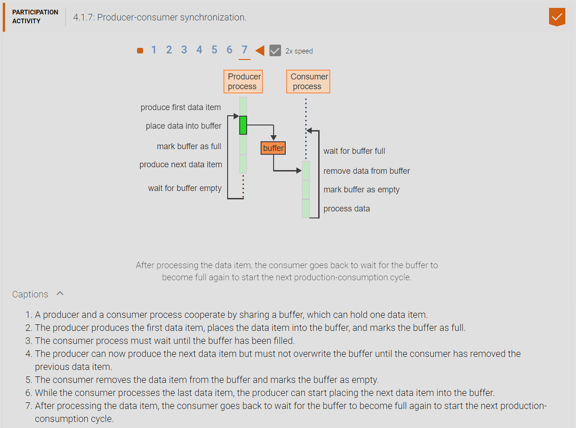

1. **sleep() & wakeup(process) functions:** The sleep() function is used by either the producer or consumer process to put them into the blocked state waiting until they are ready to produce or consume again. The wakeup(process) function is used by either the producer or consumer process to put the argument process into the ready state so they can continue to produce or consume again.

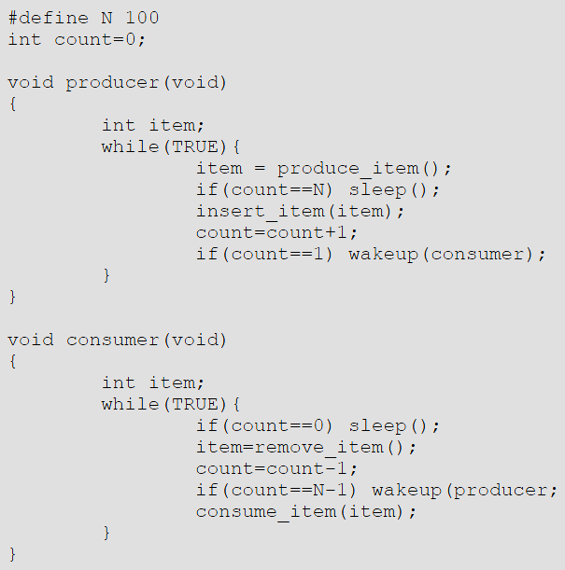

1. **Problems with software solutions to the critical section problem:** 1. Software solutions to the critical section problem only works for two processes, they fail to work for 3 or more processes. 2. Software solutions are inefficient, when a process is not inside the critical section they are ‘busy waiting’ and therefore not doing anything and when they execute on the CPU all they do is wait and waiting CPU time, if there are hundreds of processes busy waiting the CPU is literally not doing much of anything besides waiting until the handful of processes that are inside the critical section can execute on the CPU. 3. The solution addresses only competition among processes. To address problems of process cooperation, entirely different solutions must be devised.
2. **Real solution to the critical section problem are Semaphores:** Semaphores are general-purpose synchronization primitives that are atomic which means that they are indivisible and their operations cannot be interrupted at all. Thus preventing race conditions inside their atomic operations since they cannot be interrupted. Semaphores are a hardware solution to the critical section problem because software solutions are inadequate way of solving this issue, they solve the problems of the critical section problem and the producer-consumer problem. A semaphore is a non-negative integer variable that can be accessed using only two special operations (down) P(s) and (up) V(s).

V(s): s = s + 1

P(s): if s > 0 then s = s – 1 else repeat wait() until s > 0 end

1. **The CS problem using semaphores:** Semaphores offer a very intuitive and elegant solution to the CS problem that satisfies all requirements. A single semaphore, initialized to 1, is sufficient to solve the problem for any number of processes attempting to enter a CS.

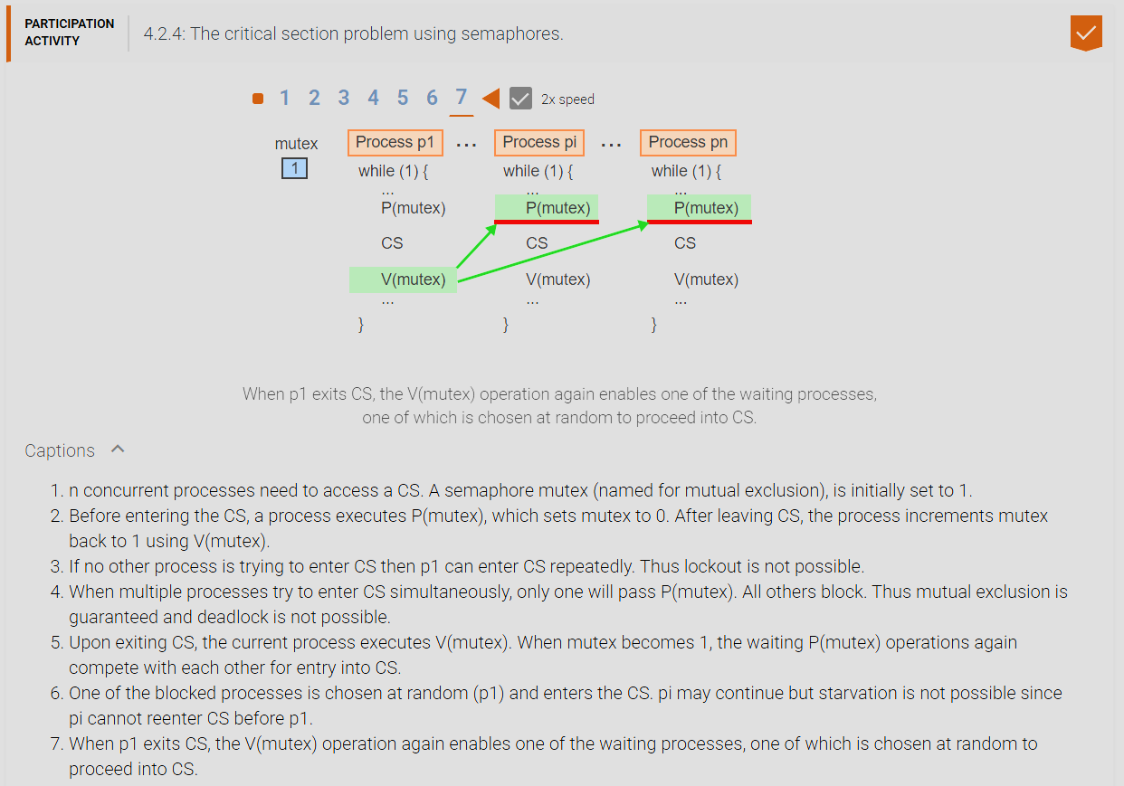

1. **Producer And Consumer Problem (Bounded-Buffer Problem):** 1. Common fixed-sized shared buffer. Process 1 produces into the buffer, Process 2 consumes out of the buffer. The bounded-buffer problem is a classic synchronization problem intended to illustrate process cooperation. A producer process shares a buffer with a consumer process. The buffer has a fixed number of slots. The producer fills empty slots with data in increasing order. The consumers follows the producer by removing the data in the same order. The buffer is called a circular buffer because, upon reaching the last slot, each process continues with the first slot (modulo n). The solution must guarantee the following: Consumers do not overtake producers and access empty slots. Producers do not overtake consumers and overwrite full slots.

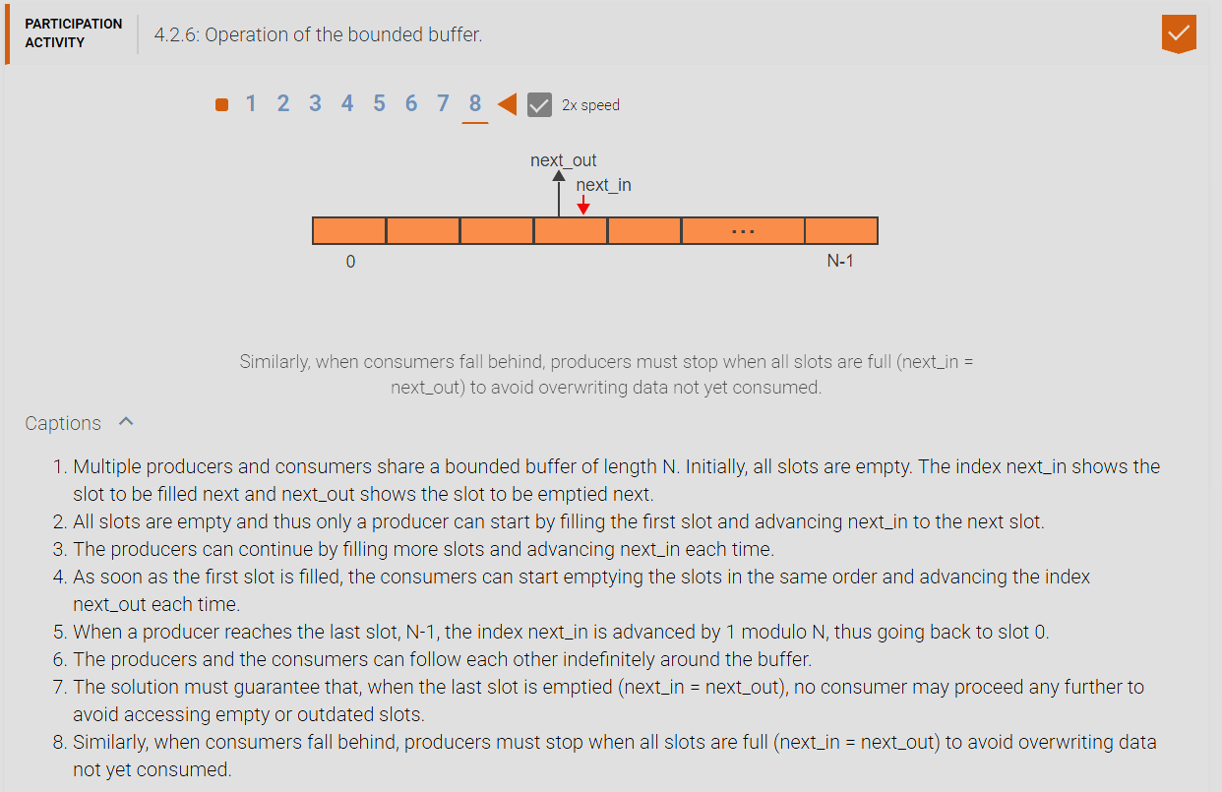

1. **The bounded-buffer problem using semaphores:** Semaphores offer a very intuitive and elegant solution to the bounded-buffer problem that satisfies the requirements that producers do not overtake consumers and vice versa. Two semaphores are used to coordinate the processes. The semaphores are used to coordinate the processes. The semaphore f represents the number of full buffer slots and is increment each time the producer places a new data into the buffer and decremented each time the consumer removes an item from the buffer. The semaphore ‘e’ represents the number of empty slots and is modified by the producer and consumer analogously.

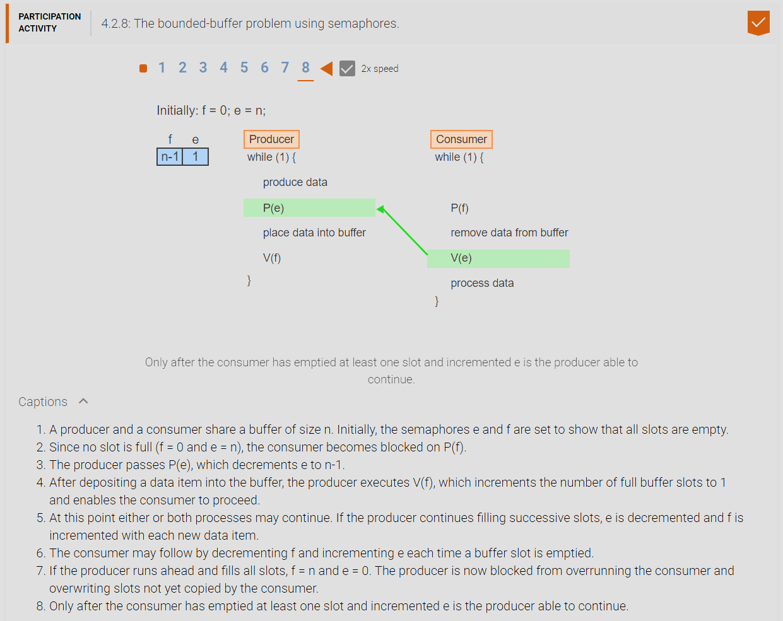

1. **Implementing Semaphore-Like Functionality:** Hardware support for synchronization: Most contemporary computer architectures offer hardware support for process synchronization in the form of specialized machine instructions. 1. Test-And-Set (TS) Instructions (guaranteed to be handled in a single machine cycle). 2. Monitors (A high-level synchronization primitive implemented using down P(s) and up V(s) operations.
2. **Test-And-Set Instruction (TS):** Copies a variable into a register and sets the variable to zero in one indivisible machine cycle. Test-And-Set has the form TS(R,x) where ‘R’ is a register and ‘x’ is a memory location and performs the following operations:

TS(R,x): Copy x into R, Set x to 0.

A lock is a synchronization barrier through which only one process can pass at a time. TS allows an easy implementation of a lock.

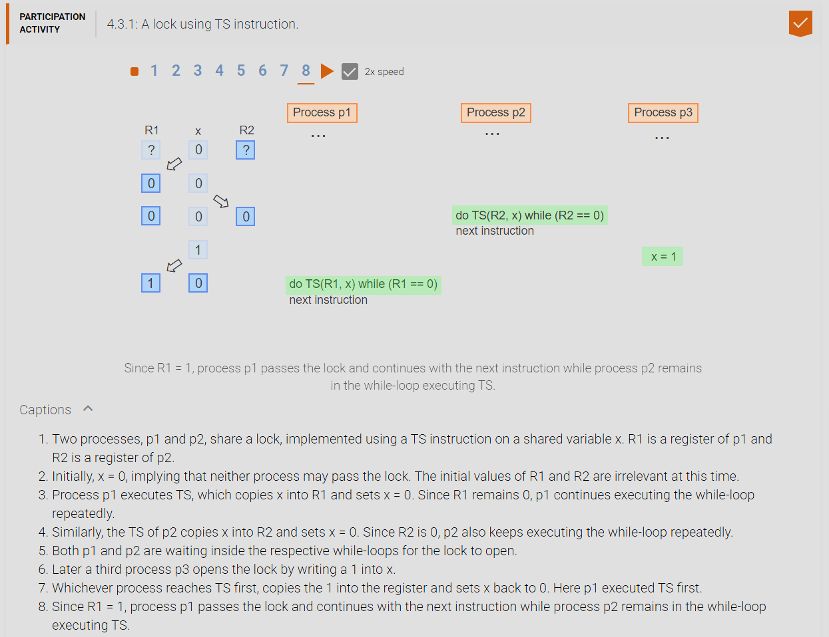

1. **Binary Semaphores:** Many synchronization problems do not require the full power of a general semaphore. A binary semaphore can take only the values 0 or 1. Pb and Vb are the simplified P and V operations that manipulate binary semaphores. Pb and Vb on the binary semaphore sb can be implemented directly using the TS instruction:

Vb(sb): sb = 1

Pb(sb): do TS(R,sb) while R == 0

1. **Busy-waiting:** is the act of repeatedly executing a loop while waiting for some condition to change. Busy-waiting consumes CPU resources and should be avoided whenever possible. The implementation of Pb(sb) using TS is very simple but suffers from the drawback of busy-waiting.

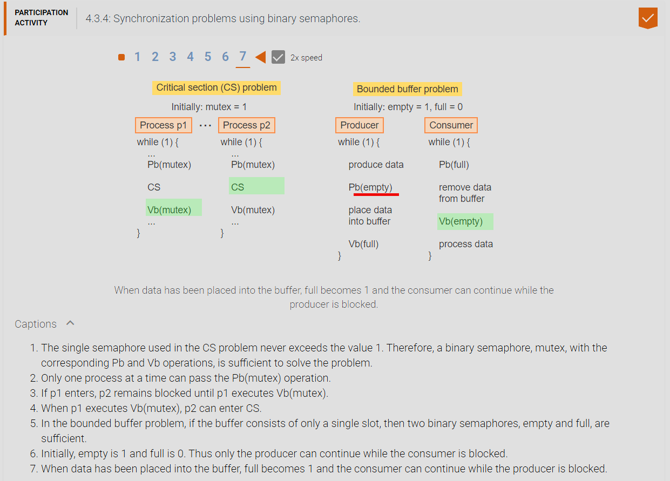

1. **Implementing P and V operations on general semaphores:** A general semaphore ‘s’ can be implemented using a regular integer variable manipulated by the functions P(s) and V(s). To guarantee that only one operation at a time can access and manipulate ‘s’, a binary semaphore is used. The variable ‘s’ serves a dual purpose: When ‘s’ is greater or equal 0, s represents the value of the semaphore. Whenever ‘s’ falls below 0, the value represents the number of processes blocked on the semaphore. To avoid busy-waiting inside P(s) when ‘s’ falls below 0, the process performs a blocking request, which places the process on a waiting list associated with ‘s’. A V(s) operation increments ‘s’ and reactivates one process if one or more are blocked on s.

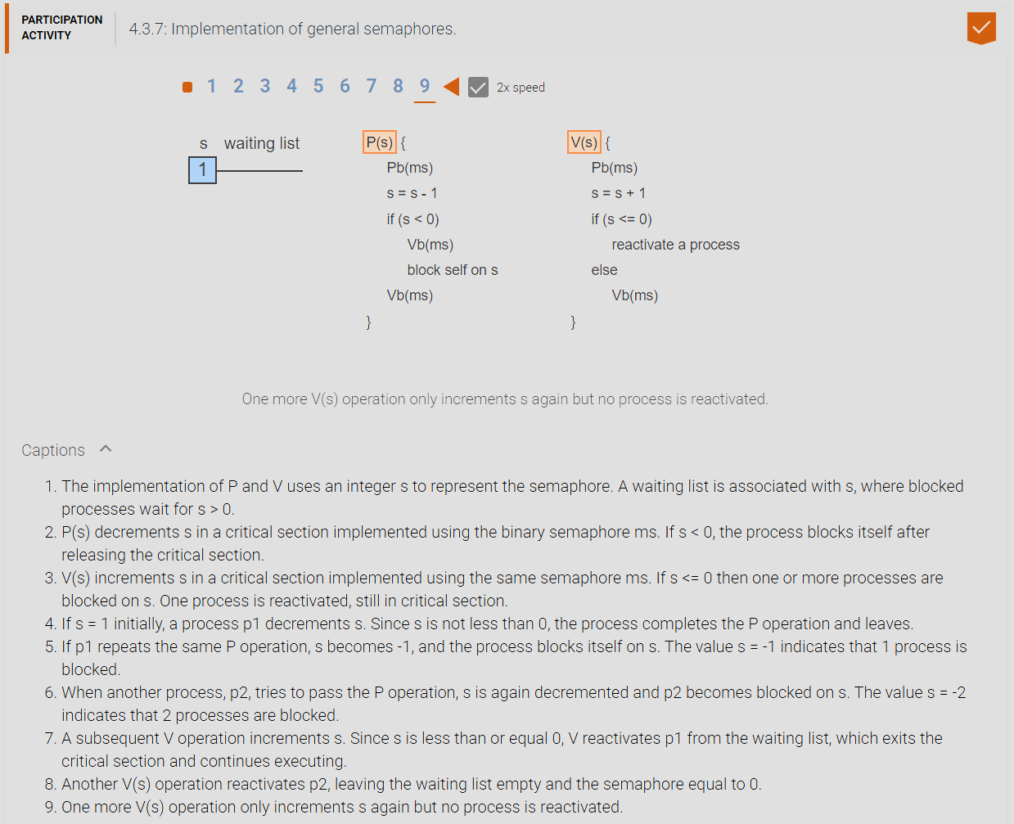

1. **Monitors:** Are simply implementations of semaphores.
2. **The Dining Philosophers Problem:**The dining-philosopher’s problem is representative of situations where multiple processes compete for shared resources but each process needs more than one resource at a time. Five “philosophers”, each representing a concurrent process, are seated around a table. Five “forks”, each representing a resource, are placed on the table such that each two neighboring philosophers share one fork. Each philosopher alternates asynchronously between a phase of “thinking”, which represents execution not requiring any shared resources, and “eating”, which requires the prior acquisition of the two forks adjacent to the philosopher and shared with the two respective neighbors. The main challenge is to prevent deadlock while guaranteeing that any two nonadjacent philosophers can always eat concurrently.

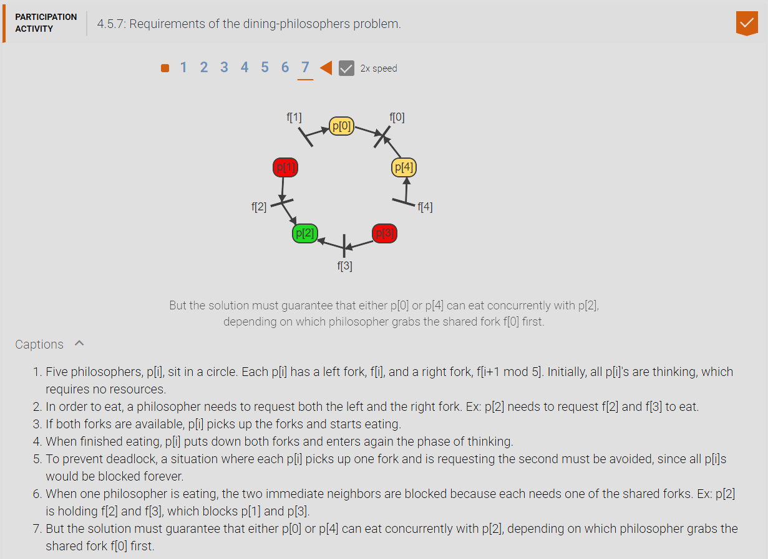

1. **A non solutions to the dining philosopher’s problem:**

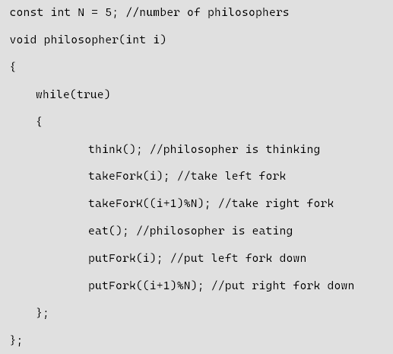

1. **Solution to the dining philosopher’s problem:**

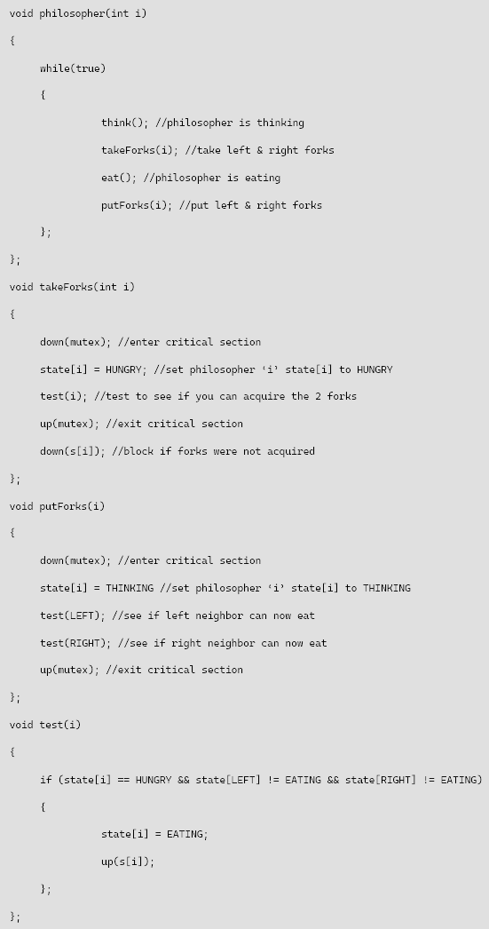

1. **CHAPTER 5 MATERIAL:**
2. **The 4 Conditions For Resource Deadlock:** For deadlock to occur 4 conditions must be satisfied: 1. Mutual Exclusion (Only one process has allocation to a single resource or unit of), 2. Hold and Wait (A process is already holding one resource and is requesting another resource), 3. No Preemption, 4. Circular Wait (A process must issue a resource request that closes a cycle involving at least two processes and two resources).. To eliminate deadlock as long as one of these conditions are negated deadlock cannot occur.
3. **Resource allocation graph:** Shows the current allocation of resources to processes and the current requests by processes for new resources. Useful for determining if a state ‘s’ has a deadlock or a future state ‘s’’ (s prime) could potentially have a deadlock. Resources are represented by squares/rectangles, processes are represented by circles, request for resource allocation is represented by an arrow outgoing of a circle towards a square/rectangle, a resource allocation is represented by an arrow outgoing of a square/rectangle to a circle. A resource allocation graph or RAG represents the current state ‘s’ of the system. 3 Operations move the system into a new state s’ (s prime) which is 1. Resource request, 2. Resource Acquisition, 3. Resource release. A resource allocation graph has a process in process deadlock if there exists a cycle.

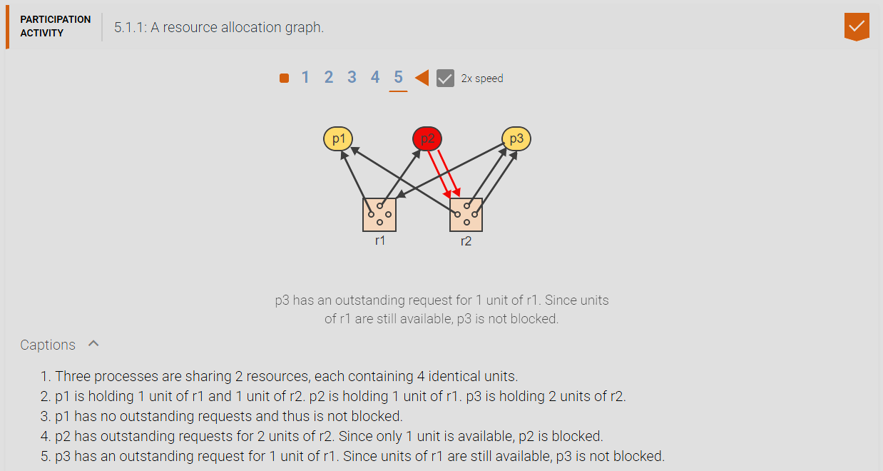

1. **The 3 states a state ‘s’ could be in:** 1. Safe State, 2. Deadlock State 3. Unsafe State.
2. **Safe State:** No sequence/permutations of state transitions exists that would lead s to a deadlock state now and in the future.
3. **Deadlock state:** If state s contains two or more deadlocked processes the state is in a deadlock state.
4. **Deadlocked Process:** A process is blocked indefinitely into the future no matter what state transitions occur now and in the future.
5. **Unsafe state:** If state s could possibly have a deadlock sequence in the future (therefore cannot guarantee that all sequence of state transitions will never result in a deadlocked state) and currently does not have deadlocked processes which would cause the current system into a deadlocked state then a state is considered to be in a unsafe state.
6. **Strategies of dealing with deadlocks:** 1. Ignore the problem/do nothing, 2. Detect & Recover, 3. Dynamic Avoidance, 4. Prevention.
7. **Deadlock Detection (Graph Reduction):** A deadlock in a RAG can be detected by executing a graph reduction algorithm: Repeat until no unblocked process remains in the graph: 1. Select an unblocked process p. 2. Remove p, including all request & allocation edges connected to p. A RAG is said to be completely reducible if at the termination of the graph reduction algorithm all processes have been deleted.
8. **RAG Graph Reduction Practice:**

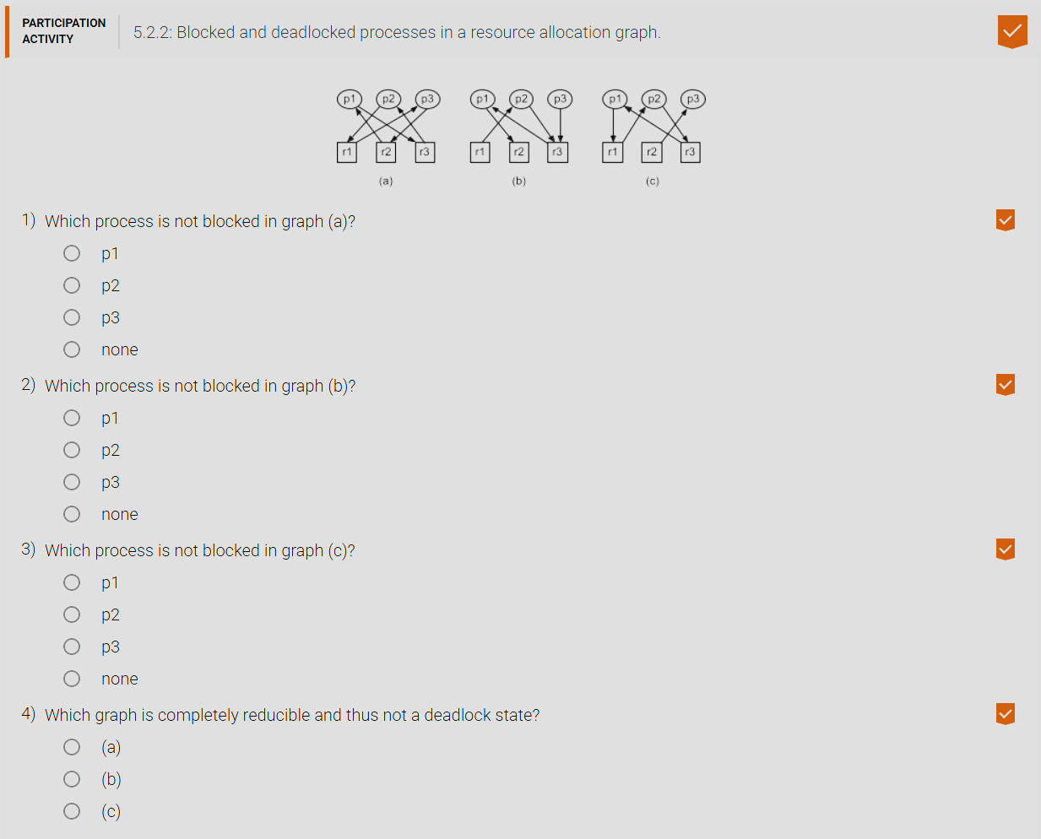

1. **Continuous Deadlock Detection:** Testing for deadlock can be accomplished more efficiently if done on a continuous basis. If the current state ‘s’ is not deadlocked, then the next state s’ can be a deadlock state only if 1. The operation that caused the transition was a request for a resource and 2. The process ‘p’ that issued the request is deadlocked in s’. Continuous deadlock detection then proceeds as follows: If the current operation is a request for a resource and the requesting process p becomes blocked in s’ then execute the graph reduction algorithm until: 1. Either p is removed from the graph, 2. Or no unblocked process remains in the graph. If ‘p’ is removed then s’ is not a deadlock state and the algorithm terminates.

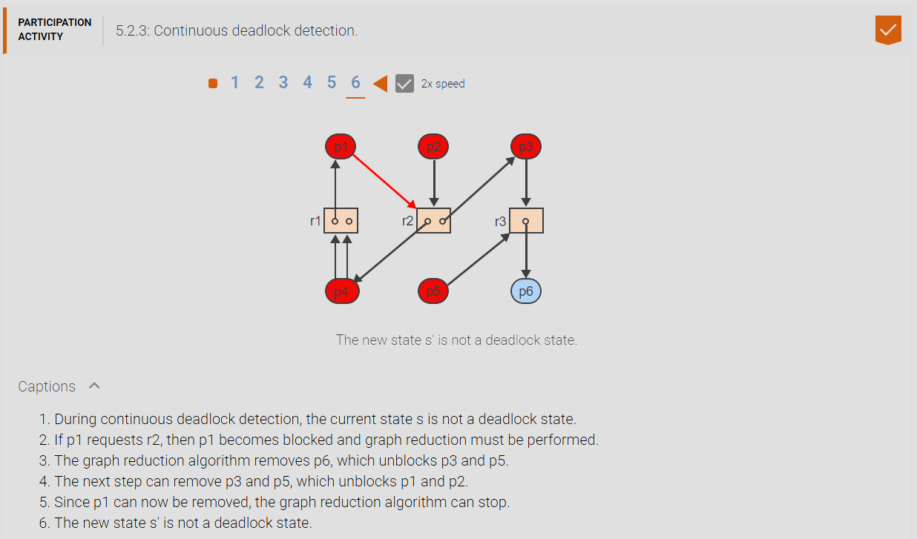

1. **Wait-for-graph:** is a resource allocation graph containing only processes where each process can have multiple incoming resource allocation edges but only one outgoing resource request edge. The term “wait-for” indicates that process p is blocked on a resource currently held by another process p’. If a cycle is present in a wait for graph then there is a deadlock.

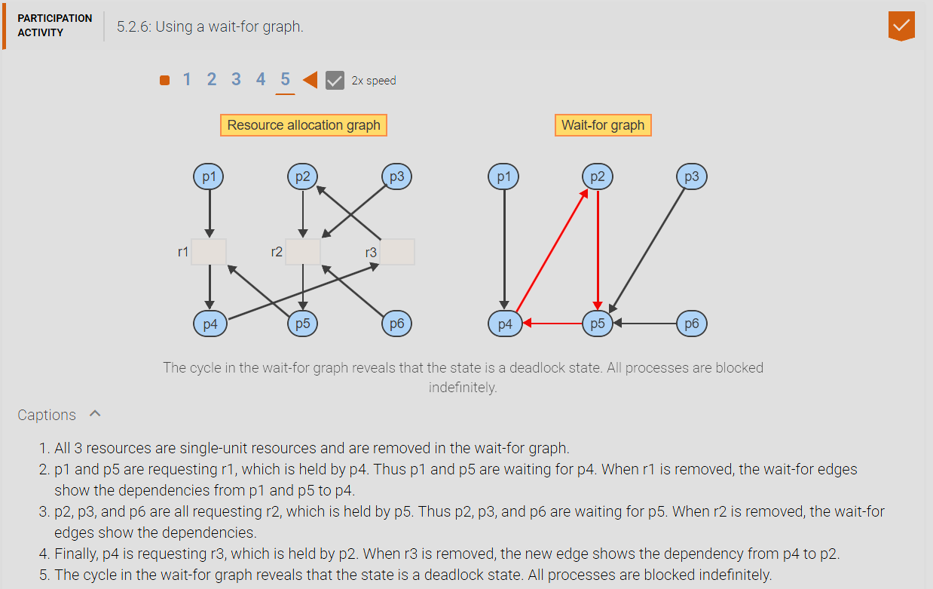

1. **Dynamic Deadlock Avoidance (Maximum Claim):** The maximum claim of a process is the set of all resources the process may ever request. Each potential future claim of a resource is represented by a dashed edge in the resource allocation graph.
2. **Resource Claim Graph:** An extension of the general resource allocation graph. The extended graph shows 1. the current allocation of resources to processes and 2. All current as well as all potential future requests by processes for new resources. A potential request edge may eventually be transformed into an actual request edge and subsequently into a resource allocation edge. But the sum of all request, allocation, and claim edges between a process and a resource will always remain constant.

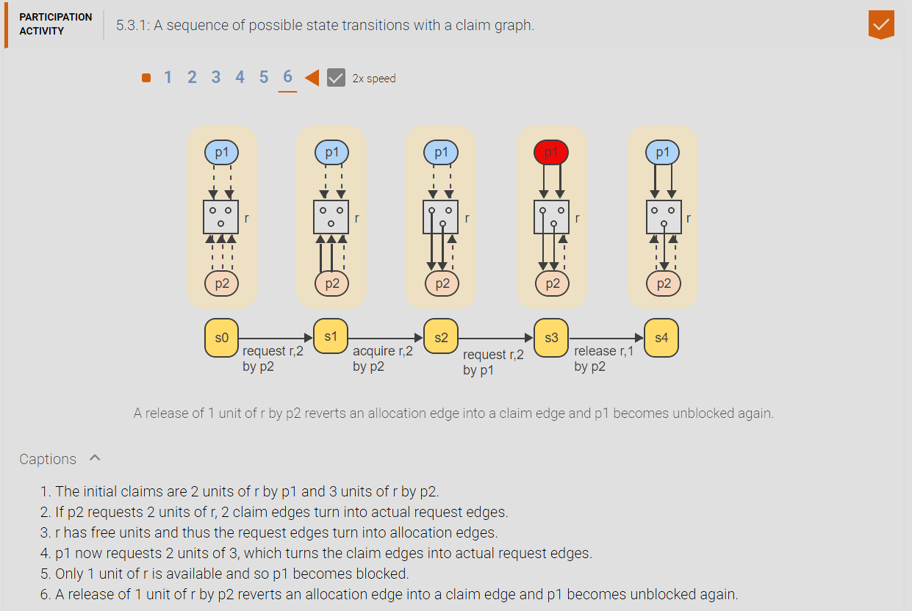

1. **Banker’s Algorithm:**

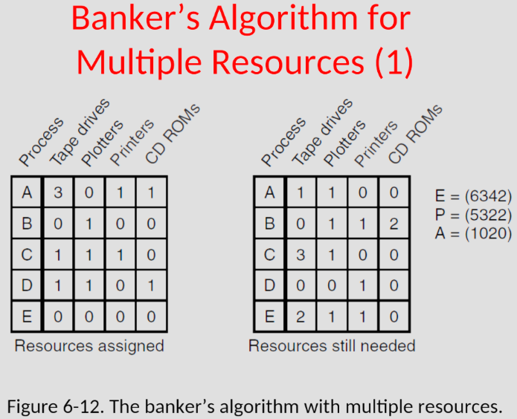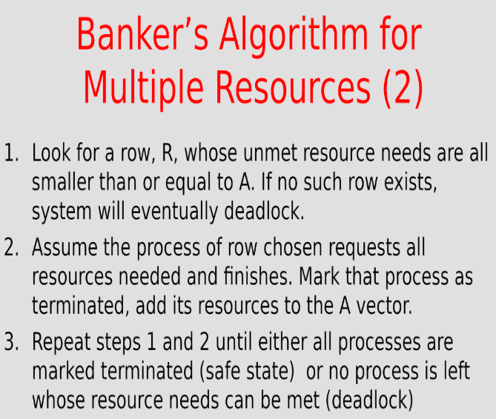

1. **The limitations of the banker’s algorithm:** 1. All predicated on processes stating their resource needs ahead of time. 2. In the real-world, the number of processes is not fixed. 3. In the real-world, the number of resources may not be fixed since resources may go offline. ESSENTIALLY: deadlock avoidance requires knowledge of the future.
2. **Static Deadlock Prevention:** A real OS tries to eliminate one of the 4 conditions for deadlock (1. mutual exclusion, 2. hold and wait, 3. no-preemption, 4. circular wait).
3. **Eliminating mutual exclusion?:** Avoid assigning resources unless absolutely necessary + make sure as few processes claim resources as possible. The problem with this is that it relies on processes to be careful not to horde (which, why should the process care?) which still may not be sufficient. THEREFORE IT IS NOT POSSIBLE TO ELIMINATE MUTUAL EXCLUSION BECAUSE BY DEFAULT ALL RESOURCES CANNOT BE SHARED ELSE RACE CONDITIONS OCCUR!
4. **Eliminating no preemption?:** You could keep a record of past process state – use deadlock detection – cause deadlocked process state to be rolled back to a previous state (process time warp). Problem is that prohibitively costly, opens up all kinds of new cans of worms when processes are cooperating.
5. **Eliminating Hold-And-Wait:**The 3 alternatives to eliminating hold-and-wait conditions are 1. Every process must request all resources ever needed at the same time. The price paid for the simplicity of the approach is poor resource utilization since resources are held for unnecessarily long periods of time and thus unavailable to other processes. 2. Every process must release all currently held resources prior to making any new request. The approach improves resource utilization but results in repeated requests and releases of frequently used resources. 3. A process can be given the ability to test whether a needed resource is currently available. The process must release all currently held resources only if the requested resource is not currently available. Otherwise the new resource may be requested and allocated immediately.

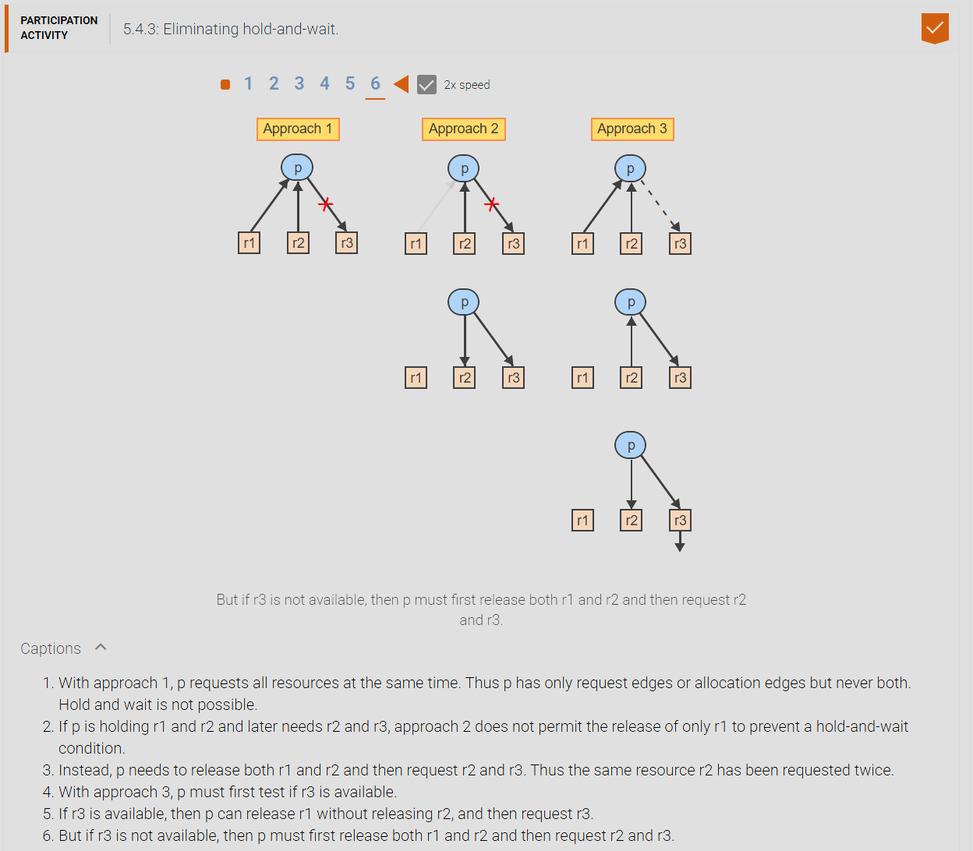

1. **Eliminating Circular Wait:** A cycle in the resource graph can be closed only when two or more processes request the same resources but in a different order. A circular wait is prevent if all processes are required to request all resources in the same order. One approach is to assign a sequential ordering, seq, to all existing resources, such that seq(ri) != seq(rj) for all i != j. All processes are then required to request resources in only increasing sequential order. A process p already holding a resource ri with the sequence number seq(ri) may only request resource rj where seq(ri) < seq(rj). If all processes follow the rule then circular wait is prevented. [number all the resources, resources request must be made in numeric order OR alternatively, never request a resource lower than what a process has currently allocated].

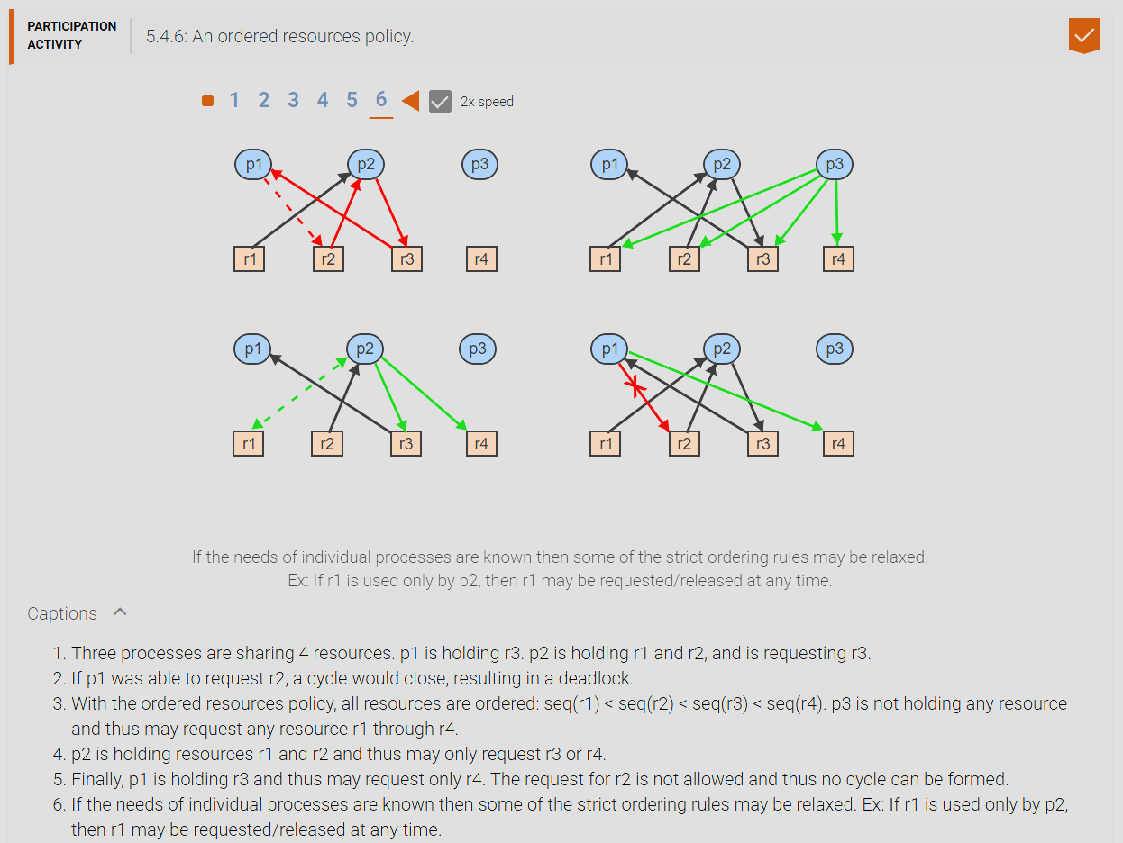

1. **CHAPTER 6 MATERIAL:**
2. **Physical Memory (RAM):** Is a hardware structure consisting of a linear sequence of words that hold a program during execution.
3. **Word:** A fixed-size unit of data. A typical word size is 1, 2, or 4 bytes.
4. **Physical Address:** Is an integer in the range [0 : n – 1] that identifies a word in physical memory of size n. The address comprises a fixed number of bits. A memory of size n requires an address size of k bits, where n = 2^k. During program development, the starting address of a program in physical memory is unknown. To facilitate program development and the sharing of physical memory, the concept of a logical address space is employed.
5. **Logical address space:** Is an abstraction of physical memory, consisting of a sequence of imaginary memory locations in a range [0 : m – 1], where m is the size of the logical address space.
6. **Logical address:** Is an integer in range [0 : m – 1] that identifies a word in a logical address space. Prior to execution, a logical address space is mapped to a portion of physical memory, and the program is copied into the corresponding locations.

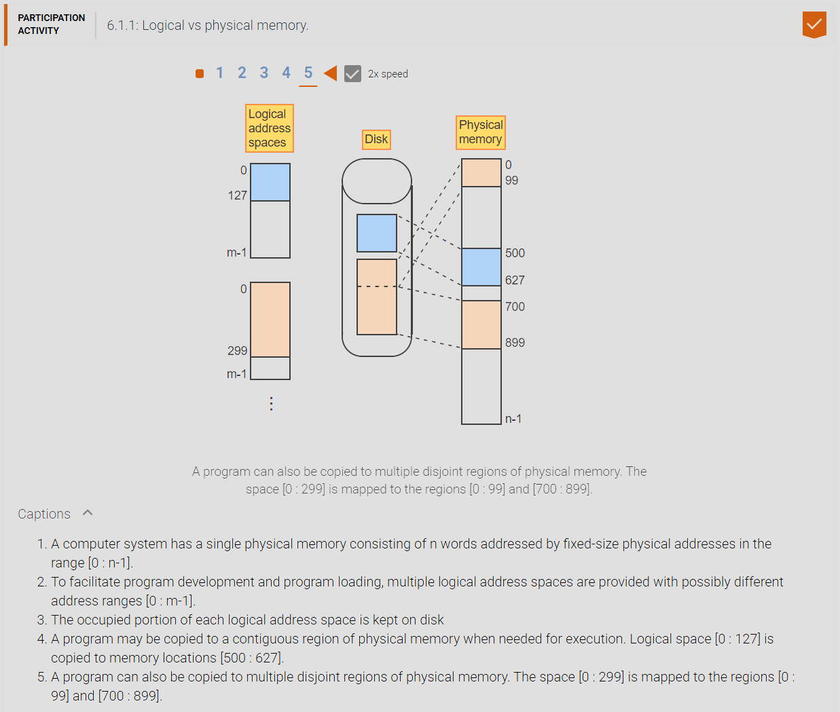

1. **Source module:** is a program or program component written in a symbolic language, like C, or an assembly language, that must be translated by a compiler or assembler into executable machine code.
2. **Object module:** is the machine-language output of a compiler or assembler generated from a source module. An object module may be self-contained and executable or multiple object modules may be linked together into a load module by a linker or linkage editor.
3. **Load module:** is a program or combination of programs in a form ready to be loaded into main memory and executed.

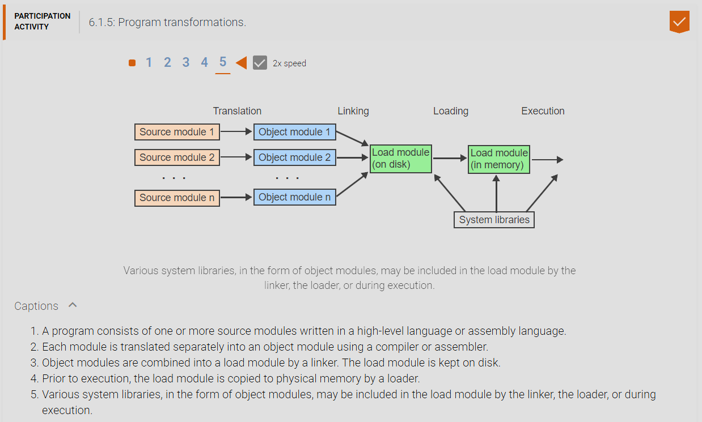

1. **Relocation and address binding:** Since the physical addresses of the program components are not known until load time, the compiler/assembler and the linker assume logical address spaces starting with address 0. During each step of the program transformation, the logical addresses of instructions and data may be changing. Only during the final step of program loading are all logical addresses bound to actual physical addresses in memory.
2. **Relocation:** Is the act of moving a program component from one address space to another. The relocation may be between two logical address spaces or from a logical address space to a physical address space.
3. **Static relocation:** binds all logical addresses to physical addresses prior to execution.
4. **Dynamic relocation:** postpones the binding of a logical address to a physical address until the addressed item is accessed during execution.
5. **Design Tradeoffs:** Static relocation does all logical address bindings while loading a program into memory which takes a longer time for a program to load and start execution, however execution speed on the CPU is much more efficient because it does not have to do any address binding every time on the CPU. Ie slower load times but faster processing. With dynamic address binding, it occurs only when an access occurs for that address in which it then does an address binding. This allows for faster load times because it only needs to load what the CPU needs to access when executing at the cost of slower processing because it has to do address translations every time on the CPU. Another upside is that since programs many times are swapped off physical memory, during static relocation a lot of the portions of logical address space is not necessary for its logical addresses to be binding thus by using dynamic relocation the overhead of having to swap them out of physical memory is significantly reduced.

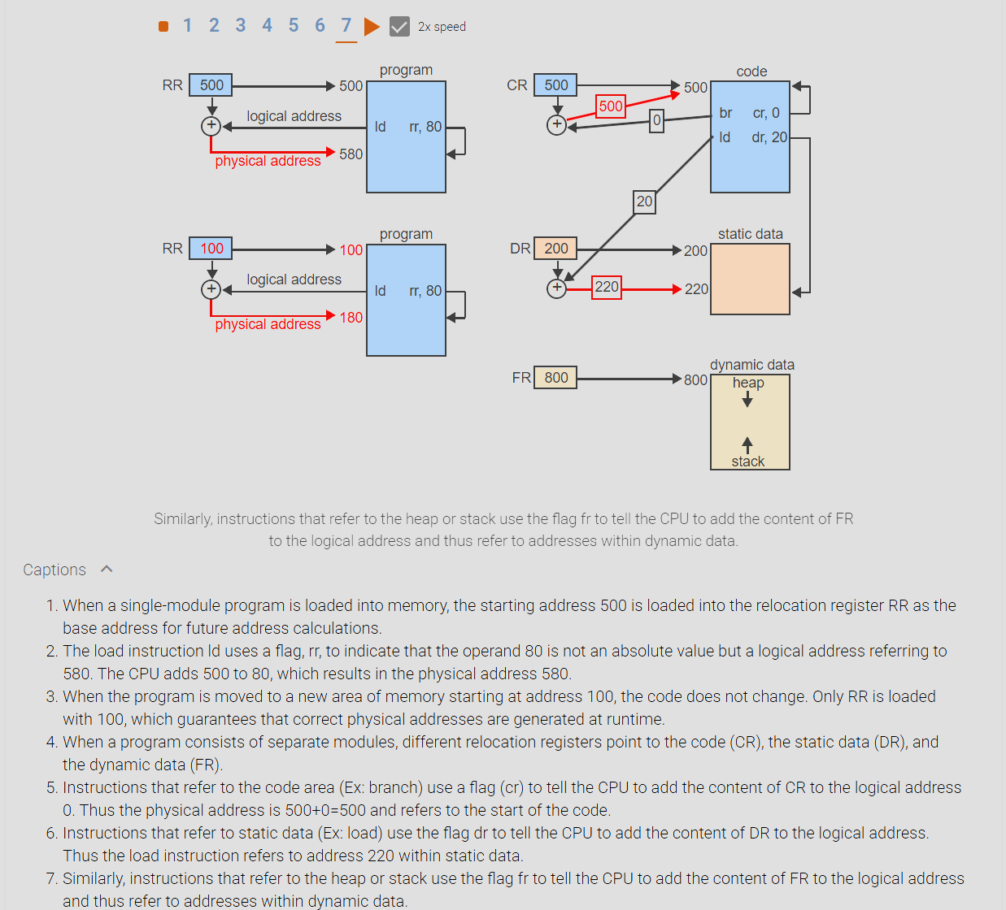

1. **Free space management:** As programs are moved into and out of memory at runtime, the memory space becomes a checkerboard of free and occupied areas of different sizes. The OS keeps track of all free spaces, referred to as holes, using a linked list and must find a hole of appropriate size whenever a new program component is to be loaded into memory. The OS must also coalesce any neighboring holes resulting from the removal of programs from memory to prevent the memory from becoming a fragmented collection of increasingly smaller holes. Different search strategies have been explored
2. **Fragmentation:** when physical memory is a collection of programs and holes where the holes are empty locations of memory that are of variable size and the increasing number of holes that have very small sizes makes them unusable for the average program to be loaded into that location which causes fragmentation.
3. **External Fragmentation:** when the physical memory space is not divided into page-sized frames and when programs are loaded and unloaded or swapped the leave variable sized holes in which these holes could become too small for the average sized program to use thus causing external fragmentation.
4. **Internal Fragmentation:** when the physical memory space is divided into page-sized frames and typically during the last page that is loaded into physical memory leaves areas of the frame in which the last page is resides in physical memory to have unused left-over space is what causes internal fragmentation.
5. **First-fit:** always starts the search from the beginning of the list and allocates the first hole large enough to accommodate the request.
6. **Next-fit:** starts each search at the point of the last allocation.
7. **Best-fit:** searches the entire list and chooses the smallest hole large enough to accommodate the request.
8. **Worst-fit:** takes the opposite approach from best-fit by always choosing the largest available hole for any request. Simulation of different strategies have not produced a clear winner. The choice depends on the average request size relative to the memory size, and the variance of request sizes.

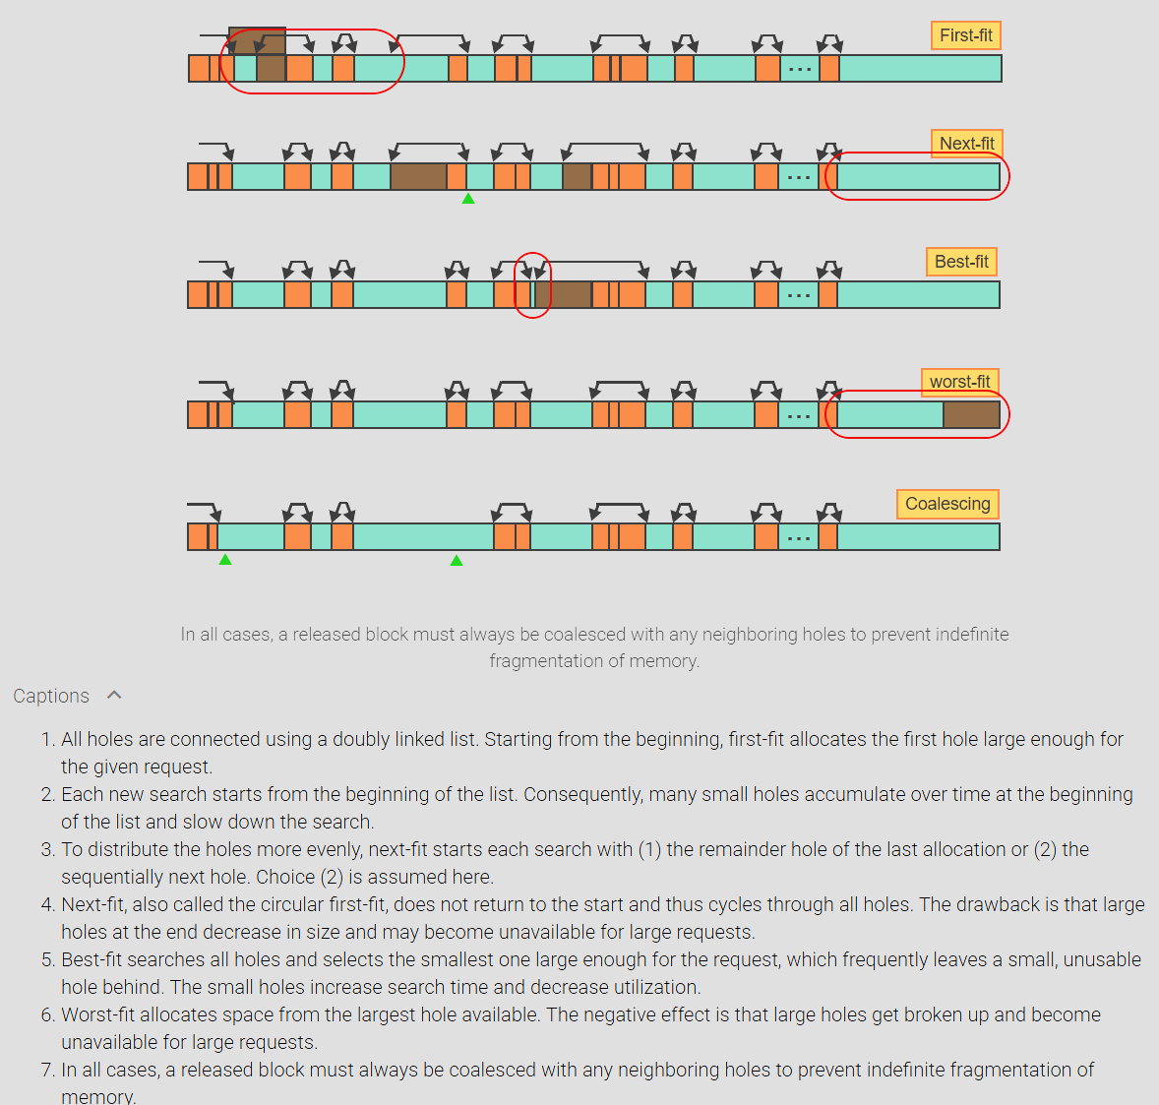

1. **Memory fragmentation and the 50% rule:** Size of memory has been increasing steadily over the past decades but so have the demands of new applications. No matter how much memory is available, applications can always be developed that can benefit from more memory. External memory fragmentation is the loss of usable memory space due to holes between allocated blocks of variable sizes. In a stable state, where on average every release of a block is followed by an allocation of a new block, the ratio between the number of holes and the number of occupied blocks is fixed and cannot be reduced by different allocation strategies. The 50% rule states that, if the probability of finding an exact match for a request approaches 0, one third of all memory partitions are holes and two thirds are occupied blocks. Formally, n = 0.5 m, where n is the number of holes and m is the number of occupied blocks. The 50% rule only refers to the number of holes but not the amount of space occupied by the holes. If the average hole size is equal to the average occupied block size then 1/3 of memory space is wasted. But a small average hole size implies better memory utilization since less memory is wasted on holes.
2. **Swapping and memory compaction:** When no hole is large enough for a request is available, the process can either be delayed until more memory is released, or two possible actions may be taken to create more space.
3. **Swapping:** is the temporary removal of a module from memory. The module is saved on a disk and later moved back to memory. Dynamic relocation is necessary so that the module can be placed into a different location without modification.
4. **Memory compaction:** Is the systematic shifting of modules in memory, generally in one direction, to consolidate multiple disjoint holes into one larger hole.

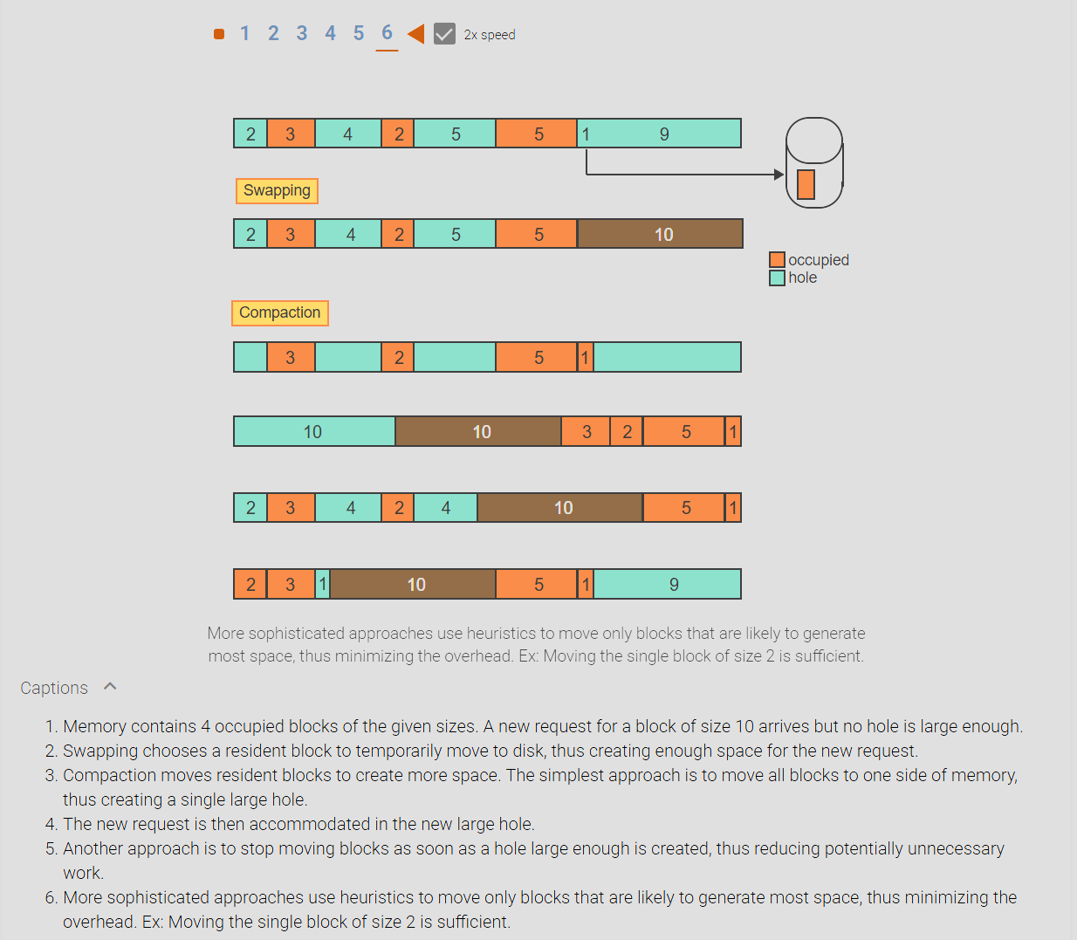

1. **Principles of paging:** The main disadvantage of dividing memory into variable partitions is external fragmentation, which requires the searching of memory for holes large enough to satisfy each request. In addition, swapping or compaction is necessary when no hole large enough is available. Paging divides both the logical address space of a process and the physical memory (RAM) into contiguous, equal-sized partitions such that any logical partition can be mapped into any physical partition. Searching for variable-sized holes becomes unnecessary.
2. **Page:** is a fixed-size contiguous block of a logical address space identified by a single number, the page number.
3. **Page frame:** is a fixed-size contiguous block of physical memory identified by a single number, the page frame number. A page frame is the smallest unit of data for memory management and may contain a copy of any page.
4. **Page table:** is an array that keeps track of which pages of a given logical address space reside in which page frames. Each page table entry corresponds to one page and contains the number or the starting address of the frame containing the page.

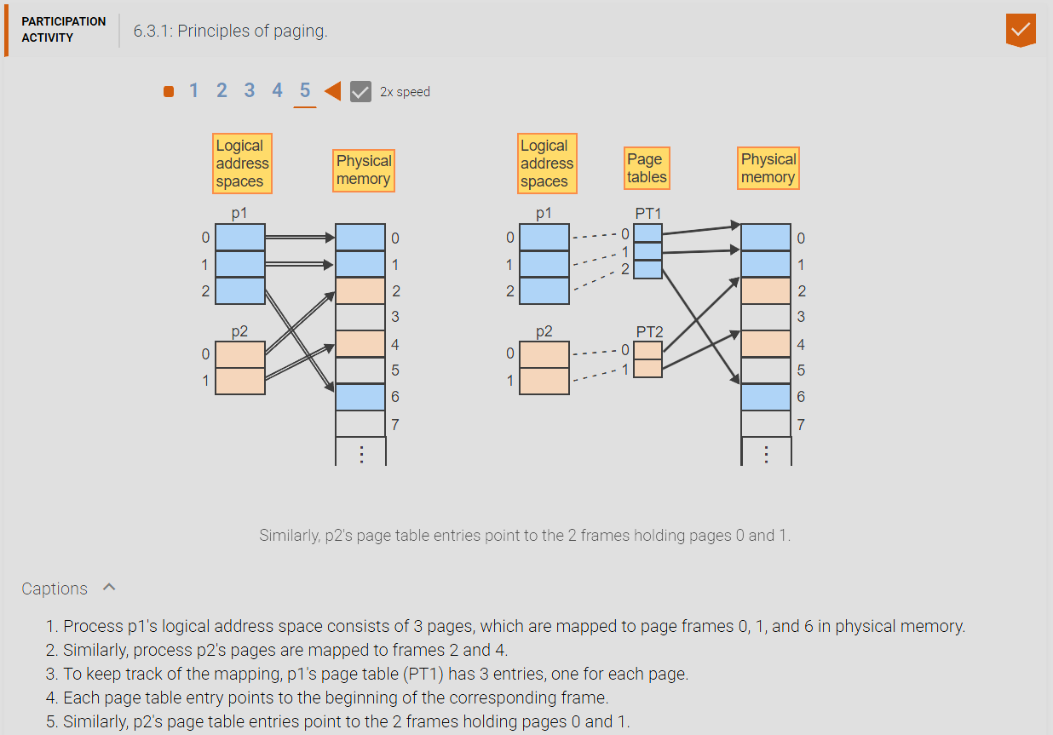

1. **Logical and physical addresses:** The size of an address space is of the form 2^n, where n is the number of bits necessary to form addresses for the entire space. When the address space is partitioned into pages, the page size is of the form 2^k, where k is the number of bits needed to address every word on a page. The remaining n – k bits determine the number of pages: 2^(n – k). The partitioning of the logical address space divides the address into 2 components: the higher-order n – k bits specify the page number p, and lower-order kb its specify an offset w within the page. Physical memory is partitioned in an analogous manner. With m bits in the physical address, 2^m total physical addresses can be formed. The frame size must be equal to the page size and thus k bits are needed to address every word within a frame. The remaining m – k bits determine the number of frames: 2^(m – k).

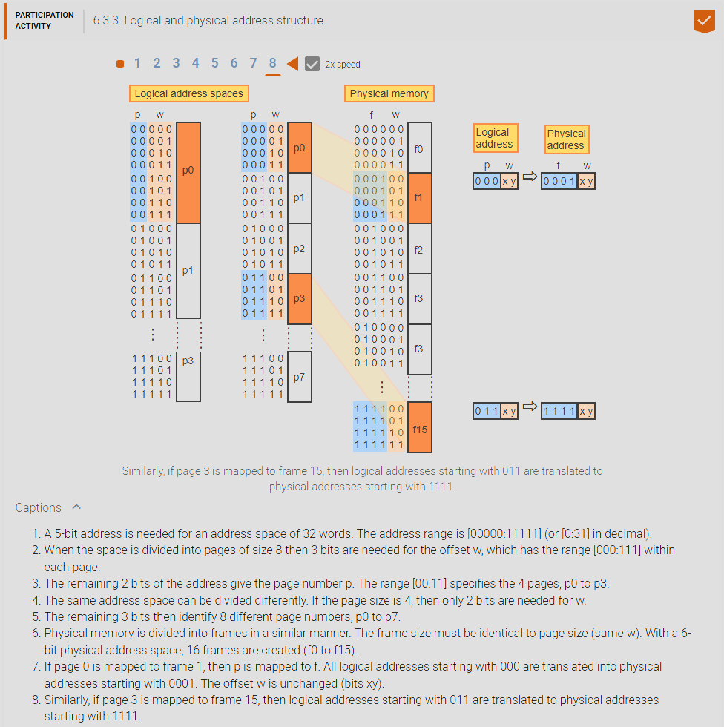

1. **Address Translation:** With paging, a logical address is broken into two components: a page number p and an offset w within the page. Similarly, a physical address is broken into two components: a frame number f and an offset w within the frame. The notations (p, w) and (f, w) denote the concatenation of the two address components. Ex: If p is 4 bits and w is 5 bits, then (2, 6) denotes the 9-bit address 0010 00110, which is the concatenation of the two components, 2 and 6 in binary. The OS must translate logical addresses of the form (p, w) into corresponding physical addresses (f, w): 1. Given a logical address (p, w), access the page table entry corresponding to page p. 2. Read the frame number, f, of the frame containing p. 3. Combine f with the offset w to find the physical address (f, w) corresponding to the logical address (p, w).

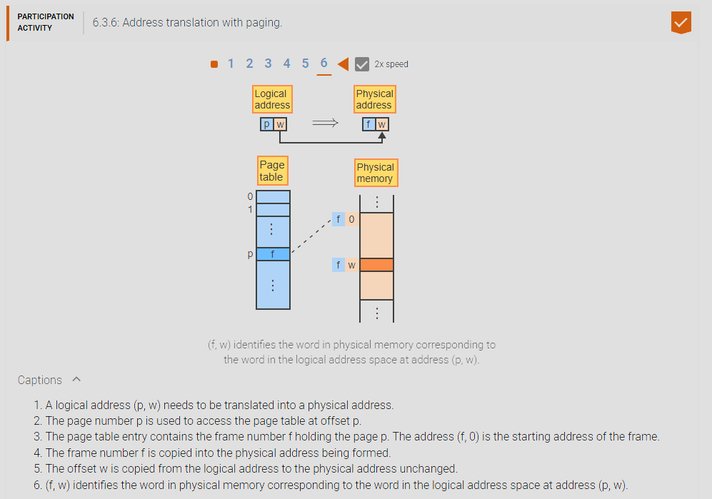

1. **Internal fragmentation and bound check:** Paging avoids external fragmentation by having all pages and page frames the same size so that any page fits into any frame without creating holes between frames. However, the size of a program is generally not an exact multiple of the page size and thus some space remains unused at the end of the last page. Internal fragmentation is the loss of usable memory space due to the mismatch between the page size and the size of a program, which creates a hole at the end of the program’s last page. Most programs also do not need all pages of the entire logical address space and must be prevented from accessing any page not belonging to the program. Some systems implement a valid-bit in each page table entry and prevent access to pages not belonging to the program. But the valid bit does not protect the unused fragment on the last partially filled page. A better approach is to compare every logical address to the program size to prevent access to any memory locations not belonging to the program.

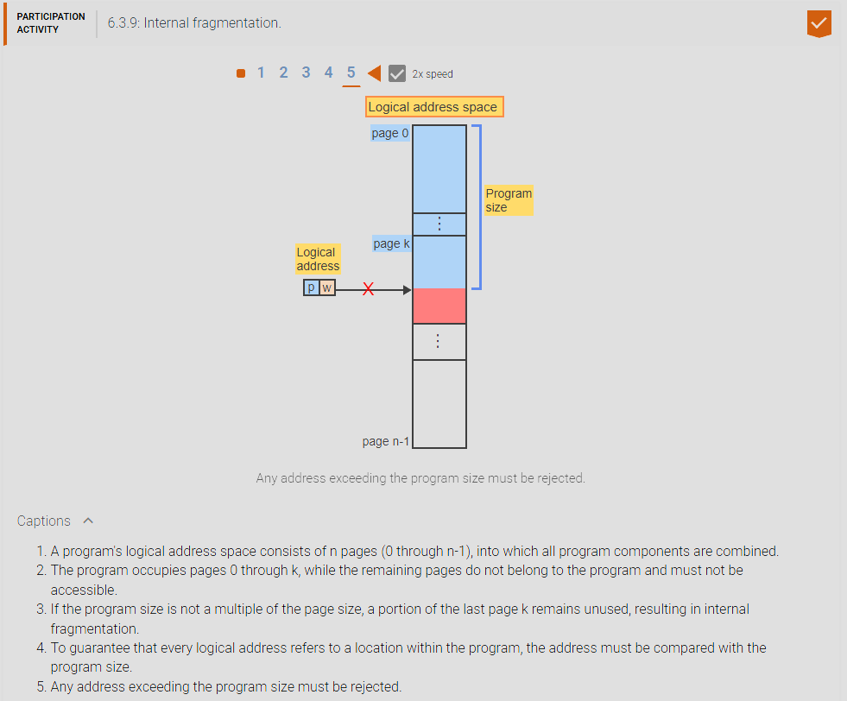

1. **Principles of segmentation:** With paging, all components of a program, including code, static data, the stack, and other data structures, are combined into one contiguous address space divided into fixed-size pages. Since the components are of variable sizes, the boundaries between the logical components do not coincide with page boundaries. The misalignment makes the sharing and the protection of logical components difficult. Segmentation addresses the problem by providing multiple logical address spaces for each process, where each segment can have a different size.
2. **Segment:** Is a variable-size block of a logical address space identified by a single number, the segment number.
3. **Segment Table:** Is an array that keeps track of which segment resides in which area of physical memory. Each entry corresponds to one segment and contains the starting address of the segment.

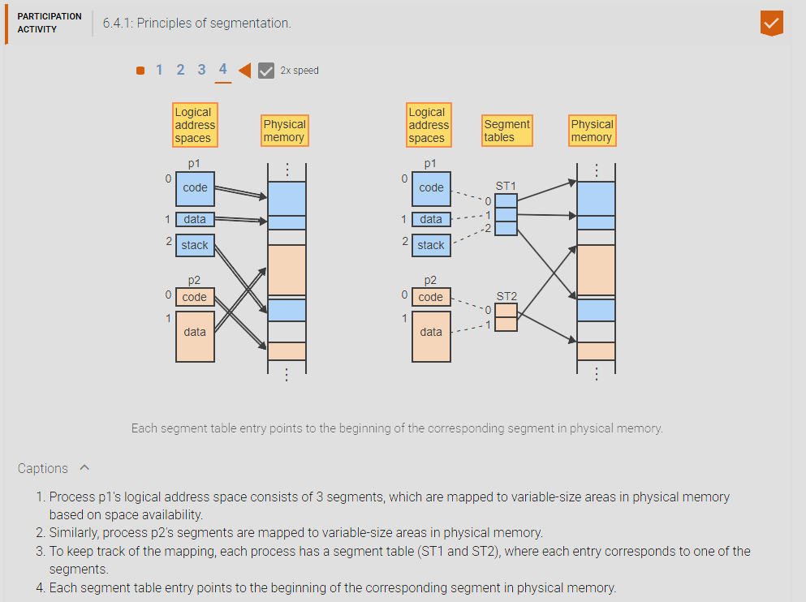

1. **Address Translation:** Similar to paging, segmentation breaks each logical address into two components: a segment number s and an offset w within the segment. With an n-bit physical address, 2^n addresses can be formed. If k bits are used for the offset w, then 2^(n – k) segment numbers can be formed. A segment table is analogous to a page table but with two important differences: With paging, all pages have the same size, 2^k. Since segments have variable sizes, 2^k cannot be the actual segment size but only the maximum possible segment size. To prevent access to locations beyond the segment, the segment size must be kept in the segment table entry and checked during address translation. With paging, the starting address of a frame can be determined from the frame number f, since all frames have a fixed size and thus all start with the address (f, 0). With segmentation, no frames exists and thus a segment table entry must contain the complete starting address of the segment, rather than just segment number s. The OS then translates logical addresses of the form (s, w) into corresponding physical addresses: 1. Given a logical address (s, w), access the segment table entry at offset s and get the segment’s starting address, sa, and size, sze. 2. If w >= sze then reject the address as illegal. 3. Otherwise, add w to sa to form the physical address, sa + w, corresponding to the logical address (s, w).

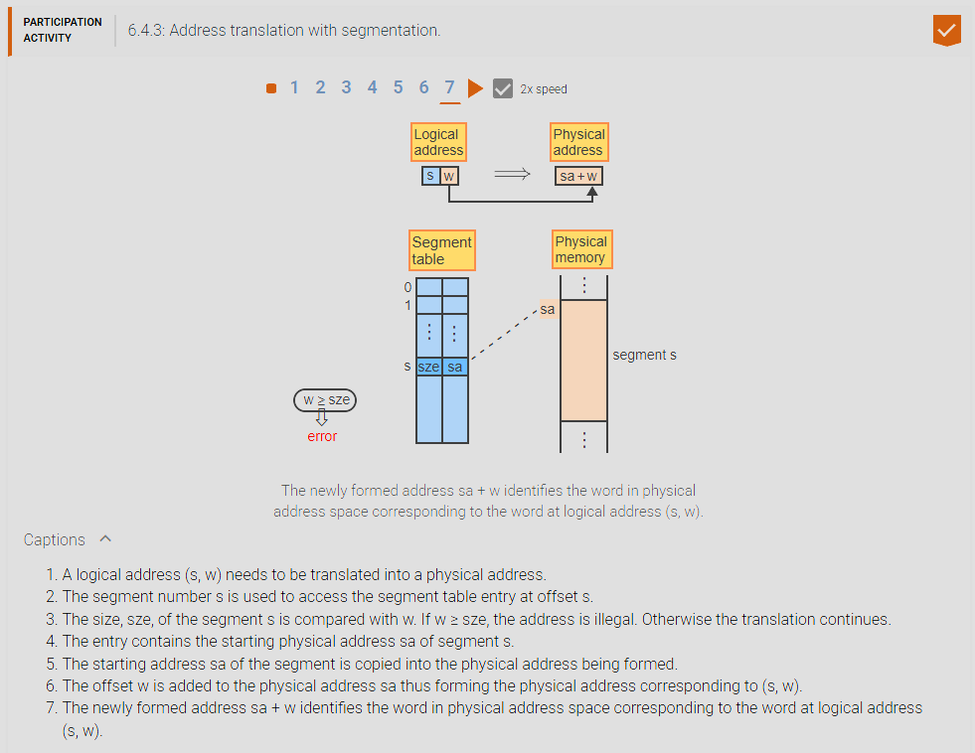

1. **Segmentation with Paging:** The main advantage of segmentation is the ability to create multiple variable-size address spaces. The main advantage of paging is the ability to place any page into any frame in memory. To gain the advantages of both, segmentation can be combined with paging. The logical address space consists of multiple variable-size segments but each segment is divided into fixed-size pages. A logical address is then divided into 3 components: a segment number s, a page number p, and an offset w within the page. A physical address is divided into 2 components as before: a frame number f and an offset w within the frame. Every process has one segment table where each entry points to a page table corresponding to one of the segments and each page table entry points to a page frame. The OS then translates logical addresses of the form (s, p, w) into corresponding physical addresses (f, w): 1. Given a logical address (s, p, w), access the segment table at offset s to find the page table and the size, sze, of segment s. 2. If (p, w) >= sze then reject the address as illegal. Otherwise, access the page table at offset p and read the frame number, f, of the frame containing page p. 3. Combine f with the offset w to form the physical address, (f, w).

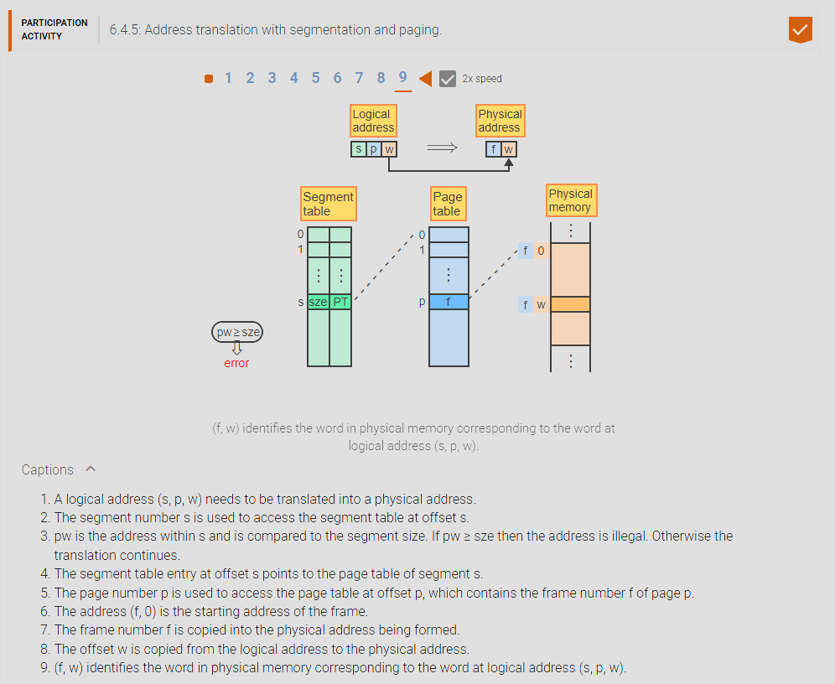

1. **The translation lookaside buffer:** Paging and segmentation both double the number of memory accesses because the address translation must first access the segment or page table. When segmentation is combined with paging, the number of memory accesses triples: First the segment table is accessed, then a page table, and finally the page holding the addressed word. A translation lookaside buffer (TLB) is a fast associative memory buffer that maintains recent translations of logical addresses to frames in physical memory for faster retrieval. They store the most recent logical address translations not the actual addresses themselves. When a logical address (s, p, w) has been translated to a physical address (f, w), the TLB saves the frame number f together with the address component (s, p). When another address in the same segment and page, (s, p, w’), is to be translated, the TLB retrieves the frame number f associated with (s, p) without any memory access. The new offset w’ is then added to f to form the physical address. The TLB can store only a small number of translations. When all entries are full, a new translation must replace an existing one. The principle of locality states that locations accessed recently are more likely to be accessed again than locations accessed in the distant past. The TLB uses the principle of locality to always replace the least recently accessed entry. The TLB’s hit ratio is the fraction of memory accesses that find a match in the TLB. The higher the TLB hit ratio, the lower the overhead of address translation.

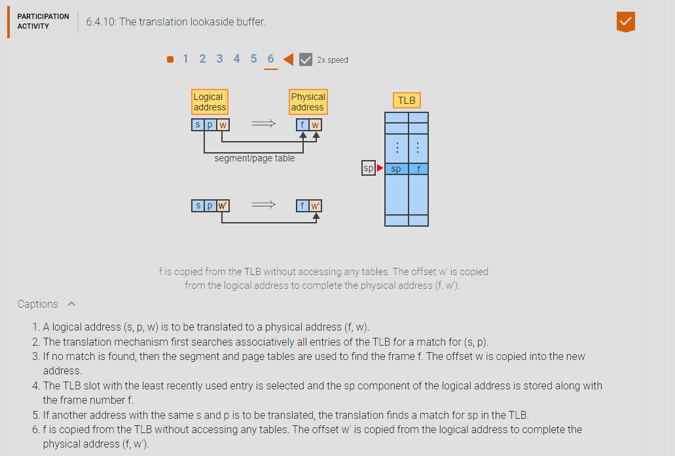

1. **CHAPTER 7 MATERIAL:**
2. **Virtual Memory (VM):** Is a collection of one or more logical address spaces, each of which may exceed the size of physical memory. A logical address is then referred to as a virtual address. A paged VM creates a single large contiguous address space per process. A paged VM with segmentation creates multiple large address spaces per process, each of which is paged.
3. **Demand paging:** is the principle of loading a page into memory only when the page is needed, rather than at the start of execution.
4. **Present bit:** is a binary flag in each page table entry that indicates whether the corresponding page is currently resident in memory. If a page is resident, then the entry points to the frame that holds the page.
5. **Page fault:** is an interrupt that occurs when a program attempts to reference a non-resident page. The interrupt triggers the operating system to find the page on disk, copy the page into a frame, and set the present bit to 1. Demand paging makes the implementation of VM possible by moving pages to main memory only as needed.

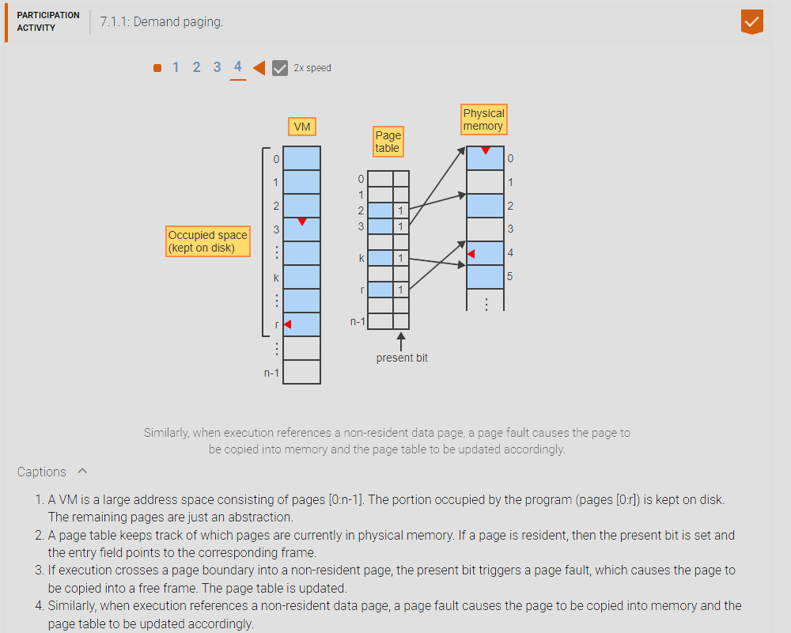

1. **Page replacement:** Virtual memory is typically much larger than the available physical memory. When all frames are occupied and a page fault occurs, one of the resident pages must be removed from memory to create a free frame. Page replacement is the act of overwriting a page in memory with a different page loaded from the disk when needed. Moving pages between memory and the disk is very time consuming and must be minimized. When the page to be removed has not been modified during execution then an exact copy still exists on the disk and the page does not have to be copied back to the disk.
2. **Modified-bit (m-bit):** is a binary flag in each page table entry that indicates whether the corresponding page has been modified during execution. The modified bit is set to 1 automatically by any instruction that stores data into the page and is used by the operating system to minimize the movement of data to disk.

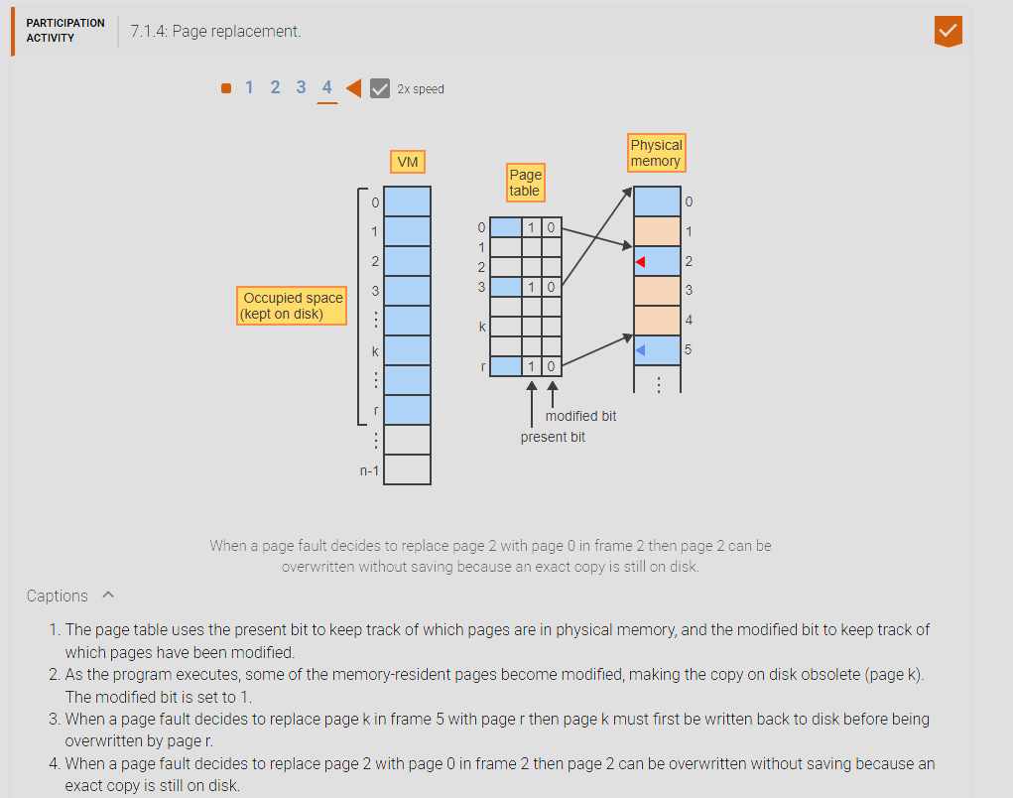

1. **Page replacement with fixed numbers of frames:** Memory consists of a fixed number of frames. One approach to sharing the frames among multiple processes is to let the processes compete with one another. When a page fault occurs and no free frame is available, the algorithm chooses one of the resident pages for replacement, regardless of which process the page belongs to.
2. **Reference string:** is the sequence of page numbers referenced by an executing program during a given time interval. Reference strings are used to compare different page replacement algorithms by counting the number of page faults generated.
3. **Fixed page replacement algorithms:** 1. Optimal fixed page replacement algorithm, 2. First In First Out (FIFO) fixed page replacement algorithm, 3. least-recently used (LRU) fixed page replacement algorithm, 4. Aging fixed page replacement algorithm, 5. Second chance fixed page replacement algorithm, 6. Third- chance fixed page replacement algorithm.
4. **1. Optimal fixed page replacement algorithm:** selects the page that will not be referenced for the longest time in the future. The algorithm is guaranteed to generate the smallest number of page faults for any reference string. However, the algorithm is unrealizable because the replacement decisions depend on future references, which are unknown at runtime. But the algorithm provides a useful lower bound on the number of page faults for comparison with other algorithms.

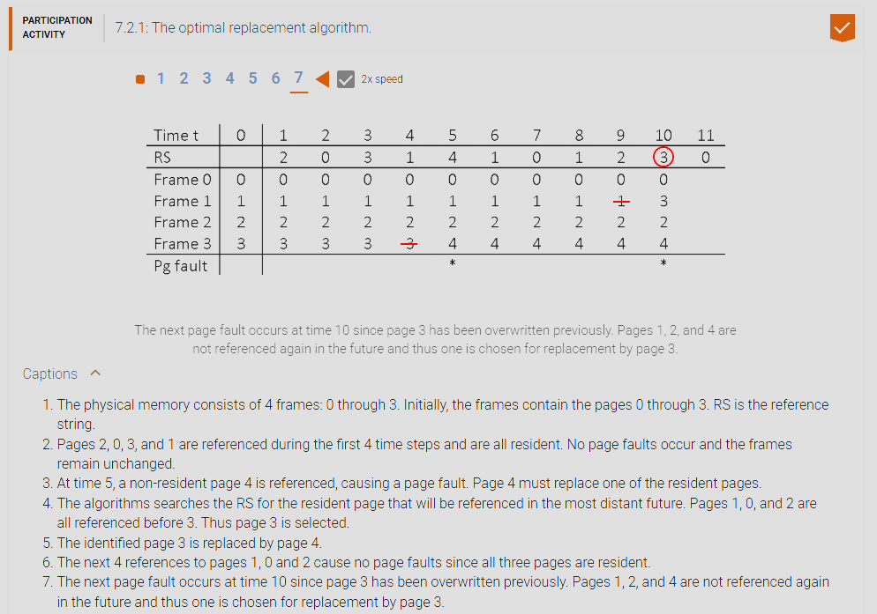

1. **2. First In First Out (FIFO) fixed page replacement algorithm:** selects the page that has been resident in memory for the longest time. The algorithm is easy to implement, requiring only a single pointer to designate the oldest page in memory. When the page is replaced, the pointer is advanced to the next frame modulo n. The FIFO algorithm takes advantage of the principle of locality. Except for branch instructions, which constitute only a small percentage of all instructions, execution is sequential. As execution advances sequentially through the code, the likelihood of referencing a page used in the distant past diminishes with time. Similarly, many large data structures are processed in sequential order.

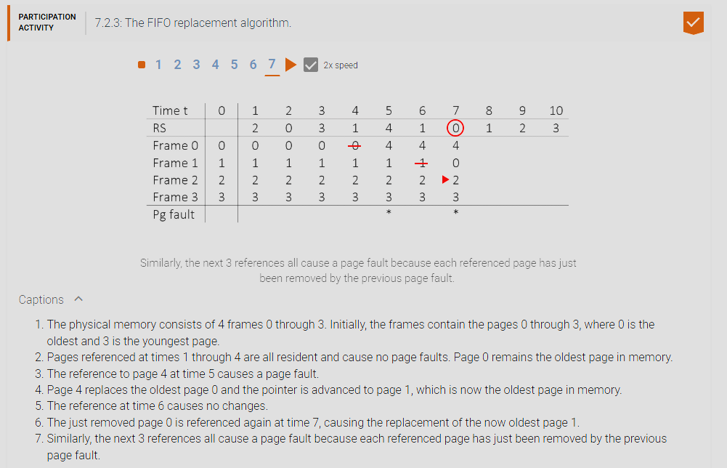

1. **3. The least-recently-used page replacement algorithm:** Selects the page that has not been referenced for the longest time. The implementation requires a queue of length n, where n is the number of memory frames. The queue contains the numbers of all resident pages. Whenever a resident page p is referenced, p is moved to the end of the queue. Thus the queue is always sorted from the least recently used page (head) to the most recently used page (end). When a non-resident page p is referenced, p is moved to the end of the queue and the least recently referenced page q at the head of the queue is removed. Page p then replaces q in memory.

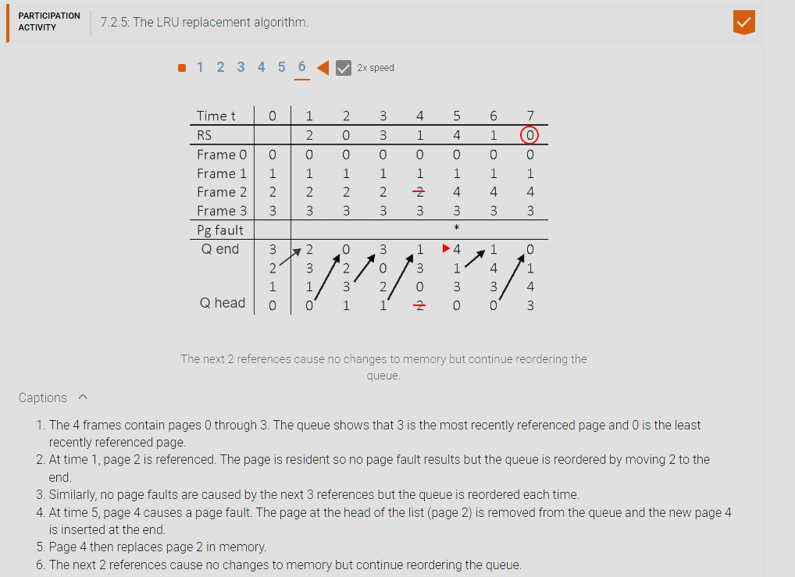

1. **4. Aging fixed page replacement algorithm:** The LRU fixed page replacement algorithm requires the queue of pages to be modified at each memory reference, which makes the algorithm too inefficient in practice. Several algorithms exists that approximate LRU and can be implemented efficiently. The aging fixed page replacement algorithm uses a referenced bit (r-bit) is a bit associated with a page and is set automatically by the hardware whenever the page is referenced by any instruction. An aging register is associated with a page and is shifted periodically to the right by 1 bit. Unless the most significant bit is set to 1, the page is aging in the sense that the associated register value is steadily decreasing. This algorithm does not maintain pages sorted in the exact LRU order, but groups together pages referenced during a period of ‘d’ consecutive references. Each period is represented by 1 bit in a periodically shifting aging register. With d = 50, a 4-bit aging register containing 0100 indicates that the page has not been accessed during the last 50 most recent references but has been accessed at least once during the 50 previous references. A register value 0000 indicates the page has not been accessed during the last 200 references. The larger the d value the less accurate the aging register is because you could have two pages one could have been referenced only one time and another page had been referenced 50 times but both could have the same age value when d = 50 which means the OS could arbitrarily choose the page referenced more times to replace since both have the same age value while having a lower d value makes it rather inefficient and the approximation gets closer and closer to the actual LRU algorithm. The algorithm is invoked periodically after every d reference, where d is a parameter determined experimentally: 1. Shift all aging registers to the right by 1, discarding the least significant bit. 2. Copy all the r-bits into the most significant bits of the aging registers. 3. Reset all r-bits to 0. When a page fault occurs: Select the page with the smallest aging register value for replacement. If multiple pages have the same smallest value then select one at random.

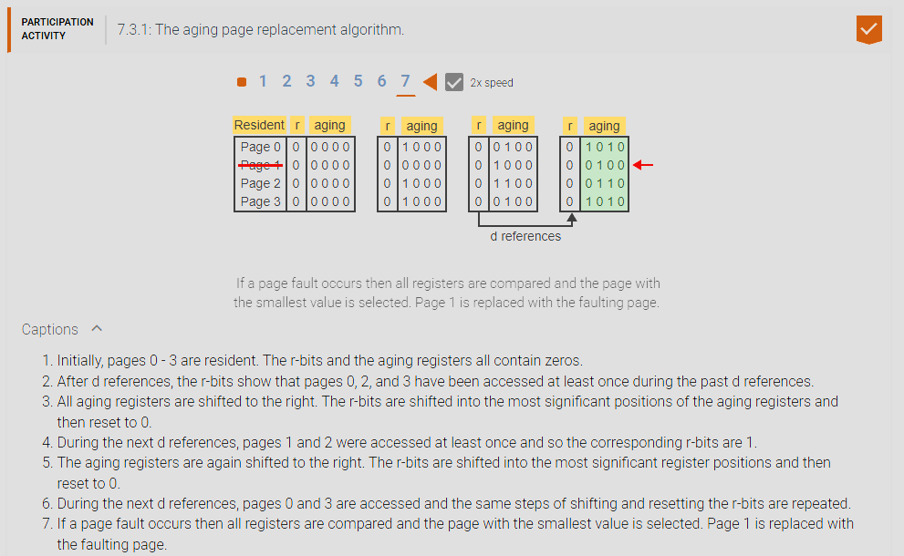

1. **5. Second chance fixed page replacement algorithm:** Is a coarse-grain approximation of LRU. The algorithm uses the r-bit to divide all pages into only two categories: recently referenced and not recently referenced. A page is selected from the not-recently referenced category. Similar to FIFO, the algorithm maintains a pointer that cycles through the pages when searching for a page to be replaced. Because of the circular nature, the algorithm is also known as the clock algorithm. At a page fault, the algorithm repeats the following steps until a page is selected for replacement: 1. If the pointer is at da page p with r = 0 then select p and advance the pointer to the next page. 2. Otherwise, reset r to 0, advance the pointer to the next page, and continue the search.

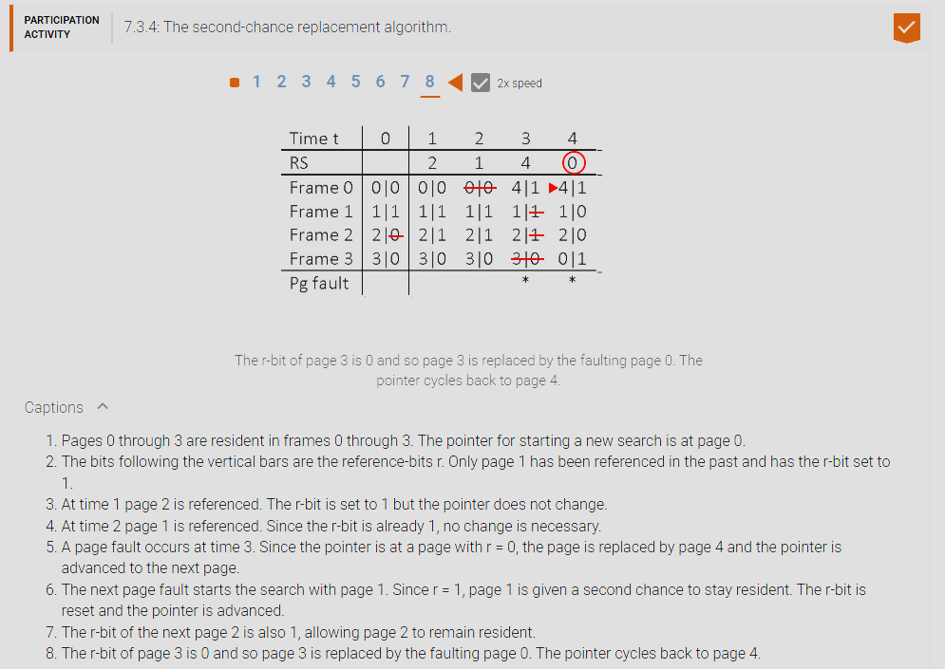

1. **6. The third chance fixed page replacement algorithm:** The third-chance algorithm is a refinement of the second-chance algorithm. The algorithm takes advantage of both the r-bit and m-bit associated with every page. Since replacing a modified page is more costly than replacing an unmodified page, the algorithm gives modified pages an additional chance to remain resident. The third-chance page replacement algorithm, also known as the not-recently-used page replacement algorithm (NRU), is a coarse-grain approximation of LRU, which divides pages into 4 categories based on the 4 possible combinations of the r-bit and the m-bit. At a page fault, the algorithm repeats the following steps until a page is selected for replacement: 1. If the pointer is at a page p with r = 0 and m = 0 then select p and advance the pointer to the next page. 2. Otherwise, reset the bits according to the following table, advance the pointer to the next page, and continue the search. modified page: 11 -> 01, 01 -> 00. Unmodified page: 10 ->00. A third bit is needed to remember if a page has been modified and thus needs to be written back to disk when selected for replacement.

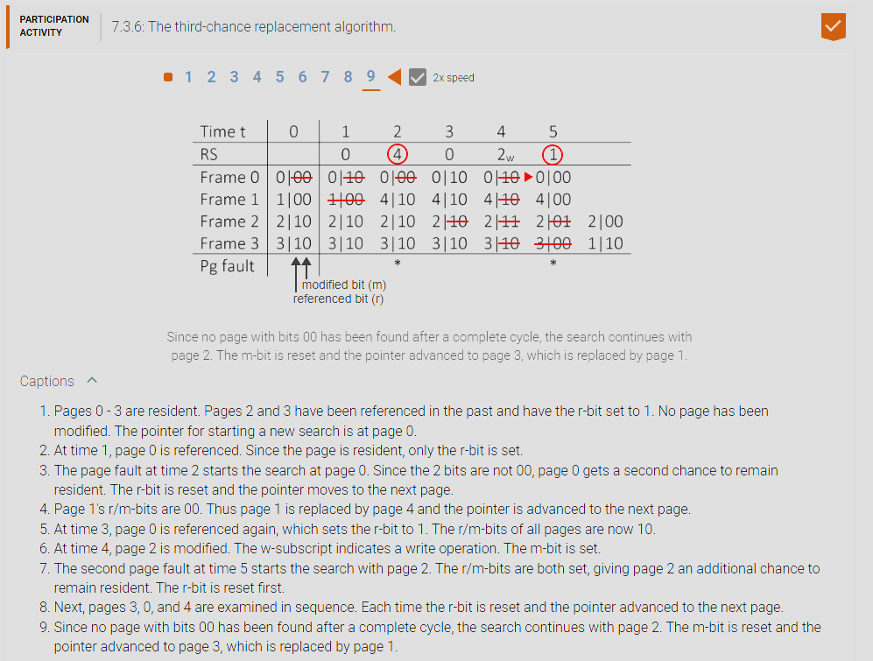

1. **Page replacement algorithms with variable frames:** 1. Optimal working set variable page replacement algorithm, 2. Working set variable page replacement algorithm, 3. page-fault-frequency variable page replacement algorithm.
2. **1. Optimal working set variable page replacement algorithm:** Of a process is the set of resident pages that will still be needed in the immediate future and thus should remain resident. Impossible in real life since we do not have a crystal ball to look into the future. To determine the optimal working set at time t, a window of size ‘d’ is superimposed on the reference string. Currently resident pages that are still visible in the window belong to the set. The size and composition of the set change automatically as the window slides forward with each memory reference. The window size is determined by the typical behavior of the newly started program. During the first few memory operations, the number of pages referenced increases rapidly, but the rate of increase diminishes with time. Thus d must be chosen to cover the period of rapid growth but not past the point where adding more pages is of only marginal benefit.

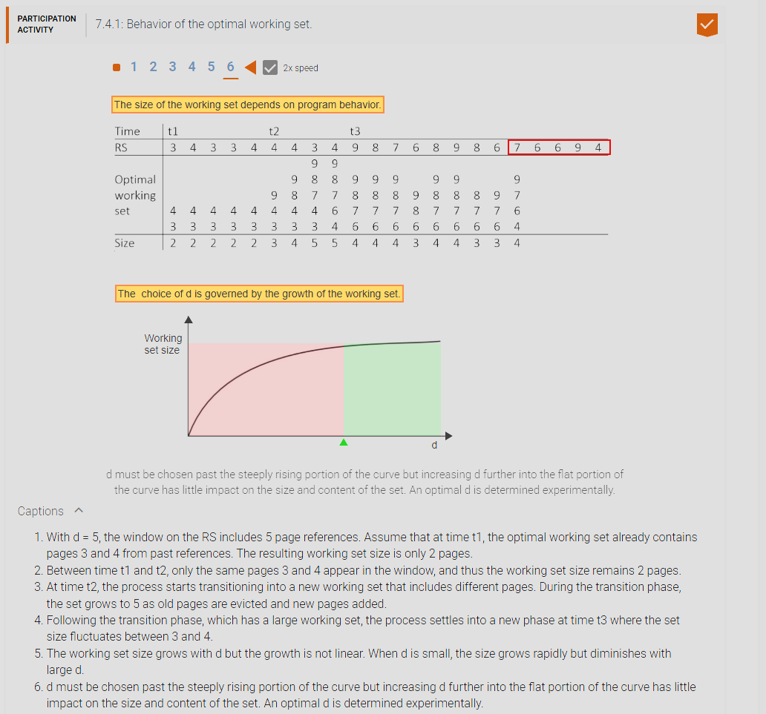

1. **2. Working set variable page replacement algorithm:** The working set (WS) of a process at time t is the set of pages referenced during the past ‘d’ memory operations preceding t. The working set page replace algorithm uses a trailing window of size ‘d’ superimposed on the RS to determine the size and composition of the working set at time ‘t’. Analogous to the forward-looking window of the optimal working set, pages visible in the trailing window belong to the working set. At each memory reference, the algorithm follows the steps: 1. Advance the sliding window by 1 to include the current reference. 2. Keep resident only the pages that appear in the window.

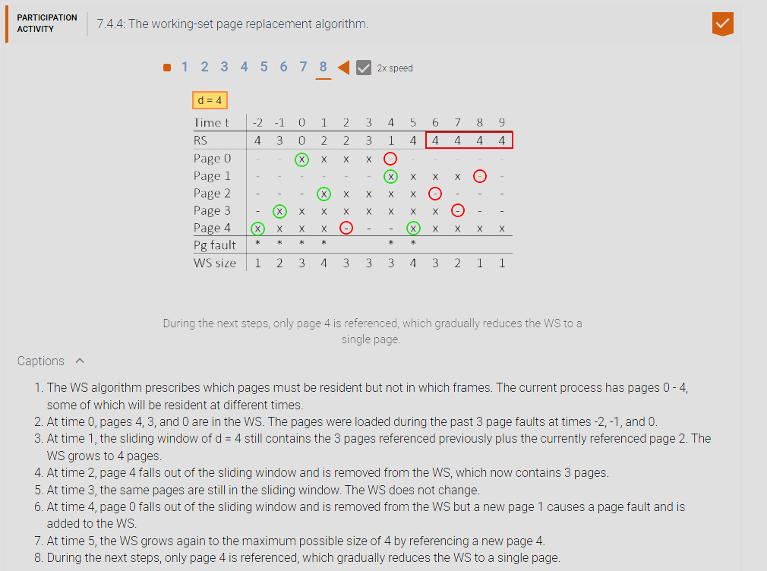

1. **3. Page-fault-frequency variable page replacement algorithm:** takes a direct approach to controlling the page fault rate by adjusting the current resident set based on how frequently consecutive page faults occur. A constant ‘d’, determined experimentally, is used to decide if the page faults frequency is too high and thus the resident set should be increased. If the page fault frequency is acceptable then the resident set can be reduced by removing some of the pages not referenced recently. When a page fault occurs: 1. Add the currently referenced page causing the page fault to the resident set. 2. When the time since the previous page fault is greater than ‘d’, remove all page from the resident set that have not been referenced since the previous page fault. The algorithm can be implemented efficiently since any action is taken only at a page fault.

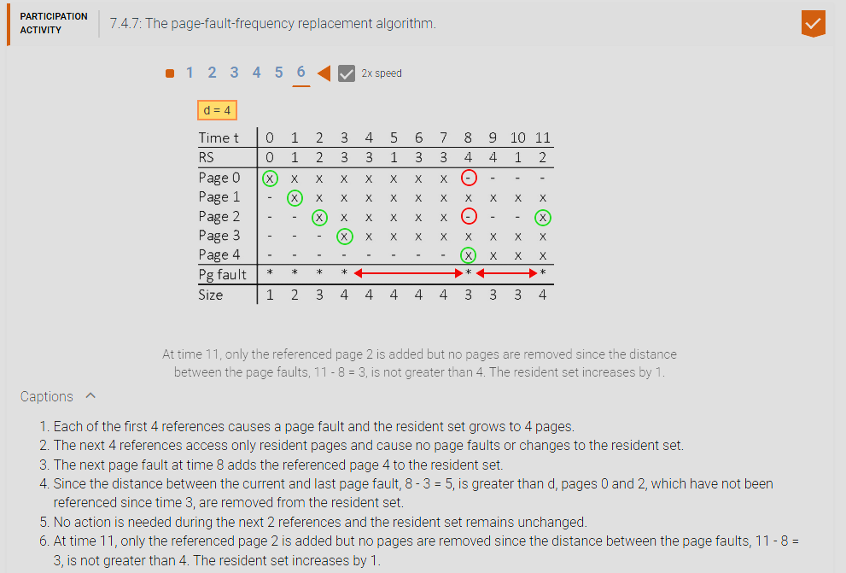

1. **Overhead of demand paging:** Page fault rate is the number of page faults, f, occurring during a number of memory references, t. The page fault rate can be expressed as P = f/t, where 0 <= P <= 1. P = 1 means that every memory reference results in a page fault, and P = 0 means that no page faults occur. A page fault results in a significant overhead, which increases the average access time to memory. Effective access time is the average time to access memory in the presence of page faults. The effective access time, E, depends on the frequency of page faults: E = (1 – P) * m + P * S. where ‘m’ is the time to access physical memory and S is the time to process a page fault.
2. **Load control:** is the activity of determining how many processes should be running concurrently at any given time to maximize overall system performance.
3. **Thrashing:** is an execution state during which most of the time is spent on moving pages between the memory and the disk while the CPU is mostly idle and no process is making any real progress. Thrashing occurs when too many processes are sharing memory concurrently and no process has enough pages to operate without frequent page faults.

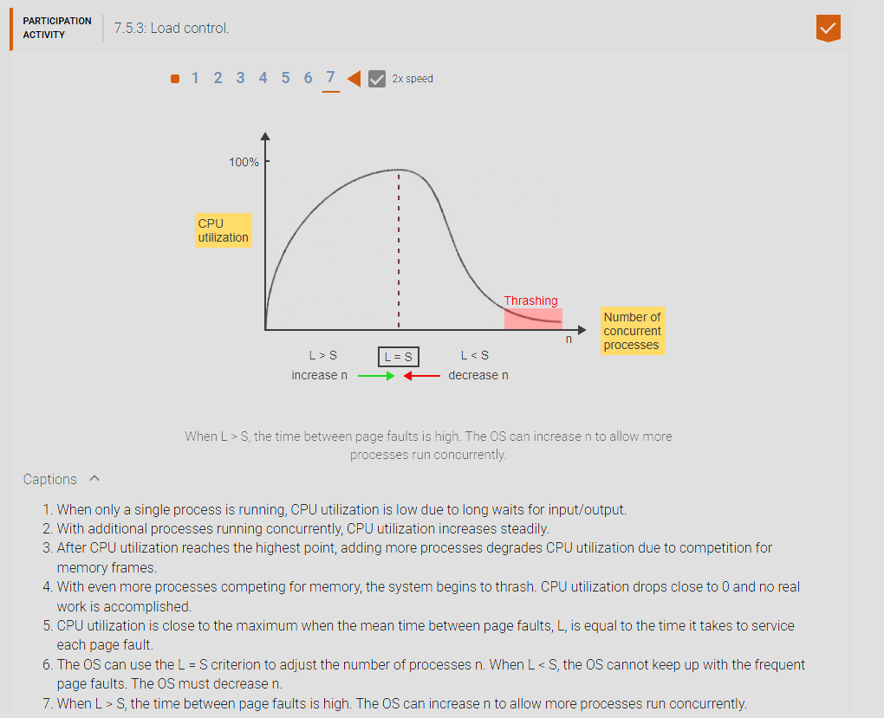

1. **The choice of page size:** Larger Page Size Pros: fewer pages and smaller page tables, TLB is more effective, Seek less, disk IO cost decreases. Cons: internal fragmentation size increases page fault rate increases since larger page contains more stuff that won’t be use leading to page faults. Smaller Page Size Pros: decreased internal fragmentation page fault rate decreases since a smaller page contains less that won’t be used leading to less page faults. Cons: more pages and larger page tables, TLB is less effective, seek more, disk IO cost increases.

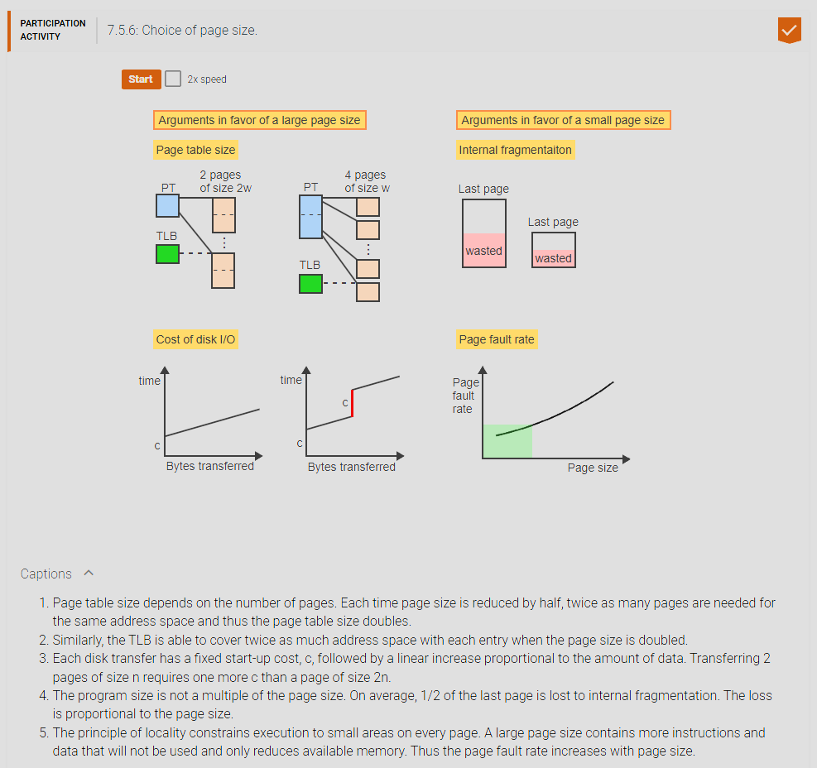

1. **CHAPTER 8 MATERIAL:**
2. **File System (FS):** is an integral part of every OS, whose function is to implement the concept of files. a file system is responsible for implementing the concept of files in an operating system. BTW the file system is responsible for implementing the concept of files and a file is a stream of bits that is stored in persistent storage like the disk and is either comprised of bits or records. A record is a structure of related data like IDs, names, addresses, etc. The access method is how a file is interpreted/read either by reading the next ‘n’ bits in the stream or the next record, and some OS can have direct access to a location of a file.d
3. **File:** Simply a stream of bits, is a named collection of information managed on secondary storage by the FS. The user can view a file as a single abstract unit of data storage and access the file’s contents using high-level operations provided by the FS’s interface, without knowing the specific characteristics of the underlying storage devices. Depending on the FS, a file can be viewed as an unstructured stream of bytes or a series of records. A file is simply a stream of bits that can be view as an unstructured stream of bits or a series of records. Users can use high level operations like create/destroy/read/write/seek/close on a file.
4. **Record:** A structure of related data items, possibly of different data types, identified within a file by a record number of a unique key field. Ex: A student ID would uniquely distinguish all student records in a file. A record is a structured data structure of related items and information.
5. **Access method:** is a set of operations provided by the OS as part of user interface to access files. The most common access method is sequential. The FS maintains the current position within the file and each read/write operation accesses the next n bytes or the next record of the file. Some Oss (Ex: most IBM systems) support also direct access methods, where a record can be accessed directly by specifying a record number or a key value. The access method of a file is typically done by reading the next ‘n’ stream of bits or the next record of the file. Some systems can directly access a record number of a key value.

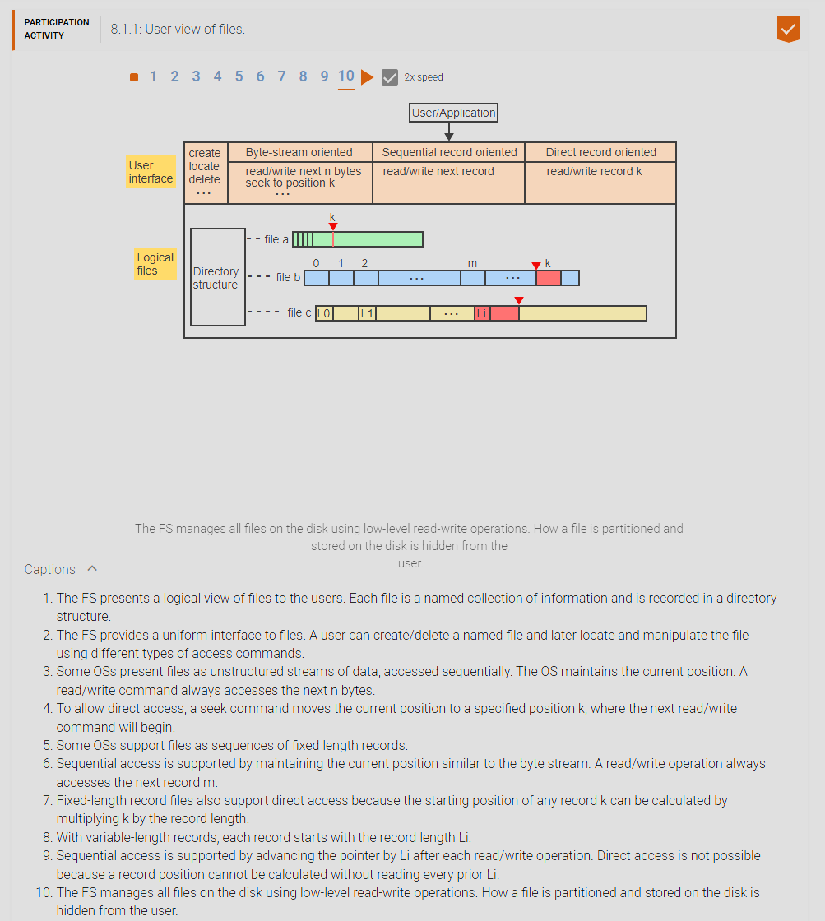

1. **File types:** Applications use files to store information on the disk and to pass information from one application to another. The producer and the consumer of a file must agree on the format of the information within the file. Ex: A compiler expects a file consisting of ASCII characters organized as lines of source code. The output of the compiler is a file consisting of executable binary code, data, relocation information, and various tables and flags, which must be understood by the linker. The file type is how a file would be interpreted by a program and is stored inside the file header, not to be confused with file extensions which is a weak version of the file type.

File types determine the type of file it is and that value is set by the magic number which determines, both of which is stored in the file header. Metadata is also stored in the file header which has information about the file. The File header goes before the actual file’s data.

1. **Metadata:** Every file consist of data and metadata. Data is the portion of the file visible to the file’s user. Metadata is information about the format and organization of a file’s data and is generally stored in a file header. Every file consist of metadata which is a portion of data visible to the user of the file. Metadata stores information about the format and organization of the file’s data and is generally stored in the file header. File header stores the file type and meta data as well as the magic number.
2. **File header:** A portion of the file preceding the actual data and is visible to only the FS itself. The file header is the portion of the file that goes before the actual file data that is visible only to the File system.
3. **Magic number:** is a short sequence of characters at the start of the file header, which identifies the file type. The file type, in turn, determines which programs are allowed to access and interpret the file. Ex: The OS will allow only properly compiled and linked binary files to be loaded into memory for execution. The file type is determined by magic number that determines what type of file it is.
4. **File extensions:** Another way to represent file types is to use file extensions. A file extension is a sequence of one or more characters following the file name. A file extension, unlike a magic number, is not hidden within the file header and thus can conveniently be examined by the user. The drawback is that a file extension can easily be changed without changing the file’s type. Thus file extensions support only a weak form of file typing by providing convenient hints about a file’s type but do not rigorously enforce which operations are valid for a given file type. A file extension is a weak version of a file type which can be edited by the user (like in windows). You can change the file extension without changing the file type and in some programs will use the file extension to interpret the file and some will strictly use the file type in the file header where the metadata is also stored in the file header.

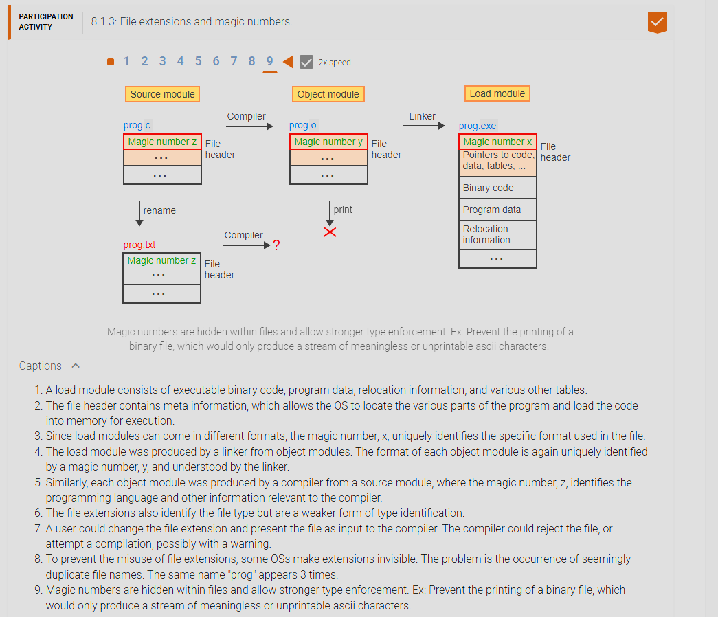

1. **File directory (or folder):** a special-purpose FILE that records information about other files and possibly other directories. The directory consists of a set of entries, each containing the name of a file followed by other information necessary to access the file. Several approaches exist to organizing the individual file directories into a global directory structure. A file directory or file folder is a special purpose FILE that holds the information of other files inside the current directory.
2. **A tree-structured directory hierarchy:** is a collection of directories organized such that (1) every directory points to zero or more files or directories at the next lower level, and (2) every file and directory except the root is pointed to by exactly one parent directory at the next higher level. The root of a tree-structured directory hierarchy is the highest level directory, which does not have a parent directory. Every file and every directory has a unique ID, assigned by the FS at the time of creation. This ID is used only by the FS for internal management purposes and is not visible to the users. Instead, users assign arbitrary ASCII names to files and directories, which become part of the path names. A tree-structured directory has a root at the top which is the parent/ancestor of all files and file directories. Every directory below the root can point to 0 or n files and file directories. A file itself cannot have any children.
3. **Absolute path name:** Of a file is a uniquely identified by an internal ID, f, is the concatenation of the directory and file names leading from the root to the file f. The individual names are separated by an agreed-upon delimiter, typically a forward slash or a backslash. To avoid using long path names, the FS allow the user to designate one directory as the current working directory. A path file that starts from the root which is the internal ID of a file.
4. **Relative path name:** A concatenation of file names staring with the current directory. To be able to navigate the hierarchy both up and down, the FS provides a special convention, generally “..”, to refer to a parent directory. A path file that starts at the current working directory.

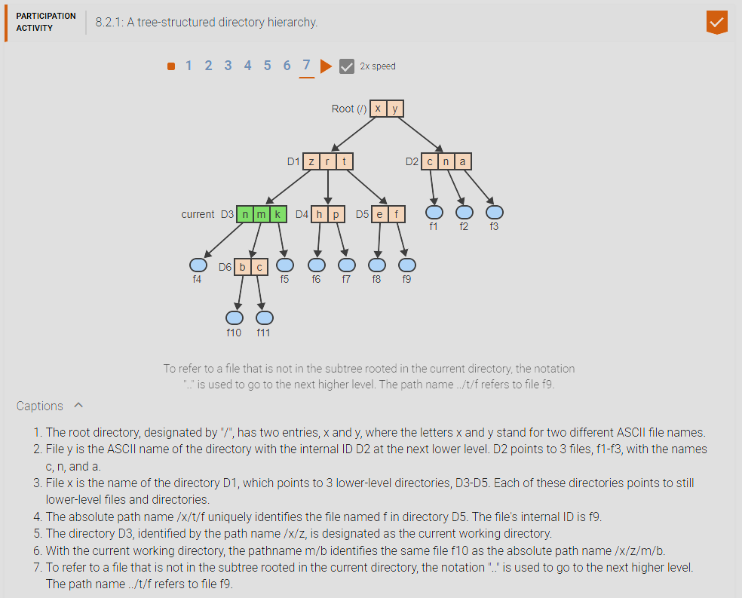

1. **Operations on directories:** 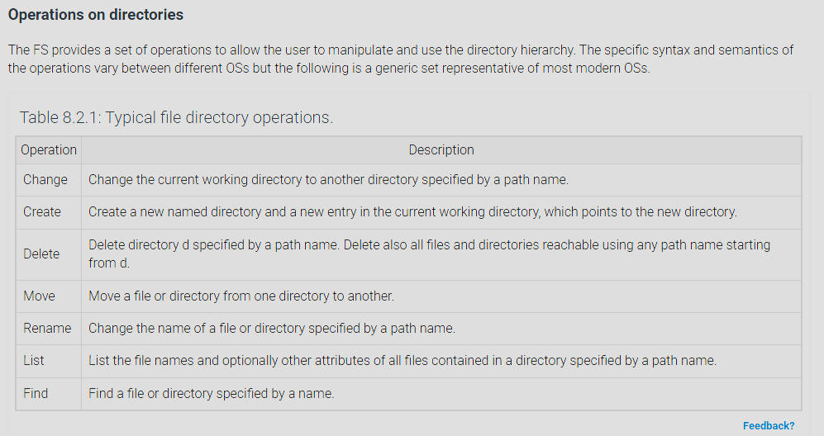

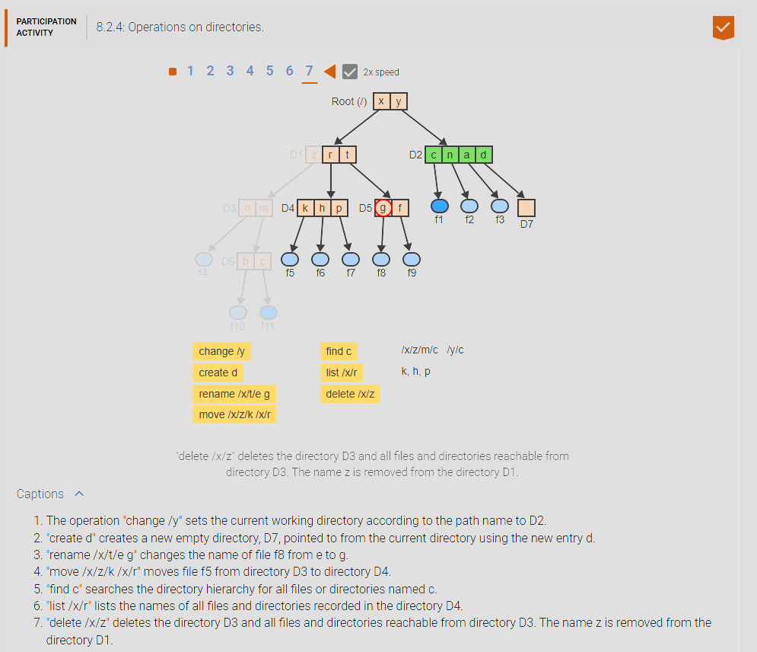

1. **Directed acyclic directory hierarchy:** The main drawback of a tree-structure directory hierarchy Is that file sharing is asymmetric. Only one directory can be the parent of a file or another directory. Other users must refer to the file by first navigating up to a common directory and then down to the desired location. A directed acyclic directory hierarchy organizes directories such that any directory at a given level may point to zero or more files to other directories at lower levels but also permits any file or directory to have more than one parent directory. To permit the creation of multiple parents, the FS provides an additional operation of the form “link path1 path2”, which creates a new link from the directory identified by the path name path1 to the directory or file identified by path2. Drawbacks: deleting is more complicated, must also not allow cyclic hierarchies: if a file can point to a file, you could have a folder, that has a subfolder, it’s parent folder. This can cause an infinite loop when searching for files. The main drawback of a tree-structure directory hierarchy is that a file or file directory/folder can only have one parent except obviously the root. In a directed acyclic directory hierarchy (acyclic means no cycles) a file or file directory can have any ‘n’ number of parents or file paths. This allows for faster access or searching of a file rather than having to traverse the entire file structure. The issue with a directed acyclic directory hierarchy is that it makes deletion of a file or file directory more complicated because of the amount of references to that file/file directory.
2. **Reference count:** Since any file, including any directory, can now be pointed to by more than one directory, the semantics of file deletion must be extended. A reference count is a non-negative integer associated with a file f, which indicates how many directories are pointing to the file. The file is deleted only when the reference count is 1, indicating that f has only a single parent directory. Otherwise only the pointer to f is deleted from the parent directory and the reference count of f is decremented. A reference count is how many parents a file or file directory currently has, once its reference count is 1 the file can be deleted but if the reference count is greater than 1 then the link to the file is deleted and not the file itself.

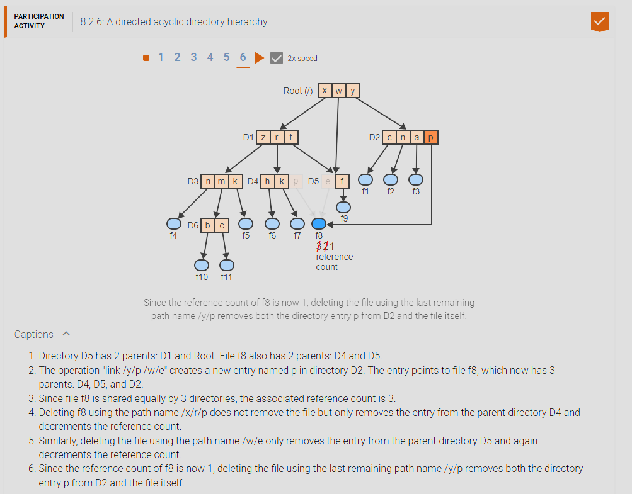

1. **A general graph structure with symbolic links:** If a directory is allowed to point to a file or another directory at a higher level, then a cycle can form in the hierarchy. A cycle, if undetected can lead to an infinite loop in algorithms that search the hierarchy for a given file. File deletion can also more difficult. A reference count is not sufficient to prevent the create of unreachable subgraphs in the directory hierarchy, but can only be removed using a garbage collection system. A general graph structure with symbolic links allows for a file directory to point to directories above its current level and thus can allow for cycles which can lead to infinite loops for recursive search algorithms for a file or file directory. Deletion is also much more complicated since you can now attempt to delete a file directory that is the parent of the current directory and thus could inadvertently delete the current directory which is an obvious problem with cycles.
2. **Symbolic link (or shortcut):** A directory entry that points to a file or directory just like a regular entry but is treated different with respect to deletion. A delete operation only removes the link but the file itself. A directory with a symbolic link or shortcut when deleting a shortcut/symbolic link it only deletes the link to the file/file directory and not the file / file directory itself. Only 1 regular link is allowed and if you delete the regular link then that deletes

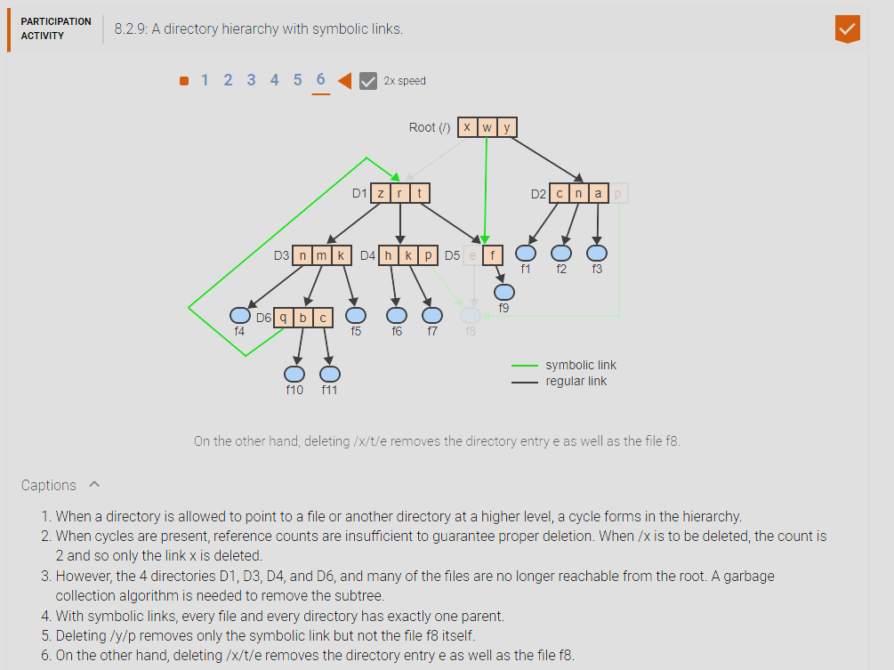

1. **Implementation of file directories:** In addition to a file’s name, data, and metadata, the FS must keep track of various attributes necessary for accessing the file and for providing relevant information to the user. The typical file attributes include: 1. Size: current size in bytes or words, 2. Type: regular file? directory? executable? (NOT filetype), 3. Location: where is the file’s blocks on disk, 4. Projection: who can do what with/to this file, 5. Use: data/time of creation, last access, last modify. FS System must keep track of 5 attributes of a file which are 1. size of the file in bytes or words, 2. type of file if it is a file or directory, 3. location of the file’s blocks on the disk 4. Projection: what can a user do to the file and 5. Use: the data/time of creation, last access, and last modify.
2. **File Control Block (FCB):** Is a data structure associated with a filename that contains all relevant attributes of the file. FCBs are stored apart from file directories and are pointed to by the corresponding directory entries. In Unix and other Oss an FCB is called an i-node. A fille control block (FCB) is a data structure that is associated with a filename that contains all relevant information of a file.

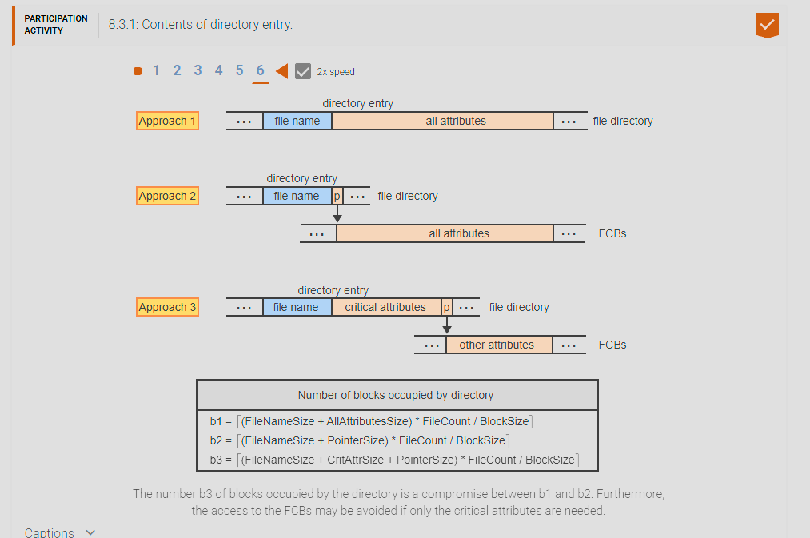

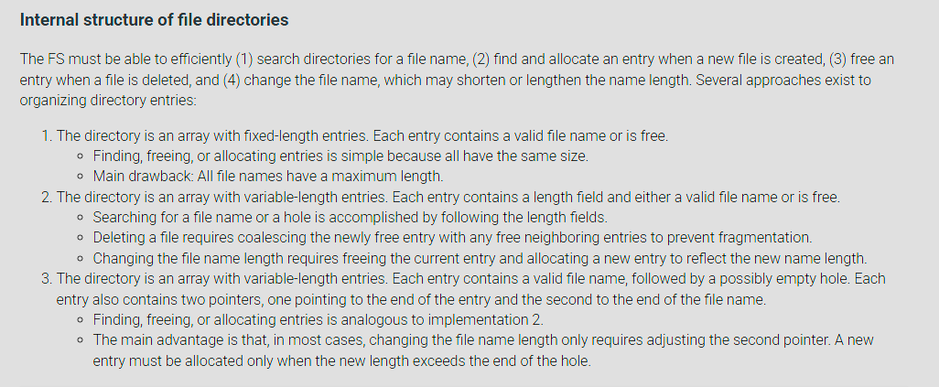

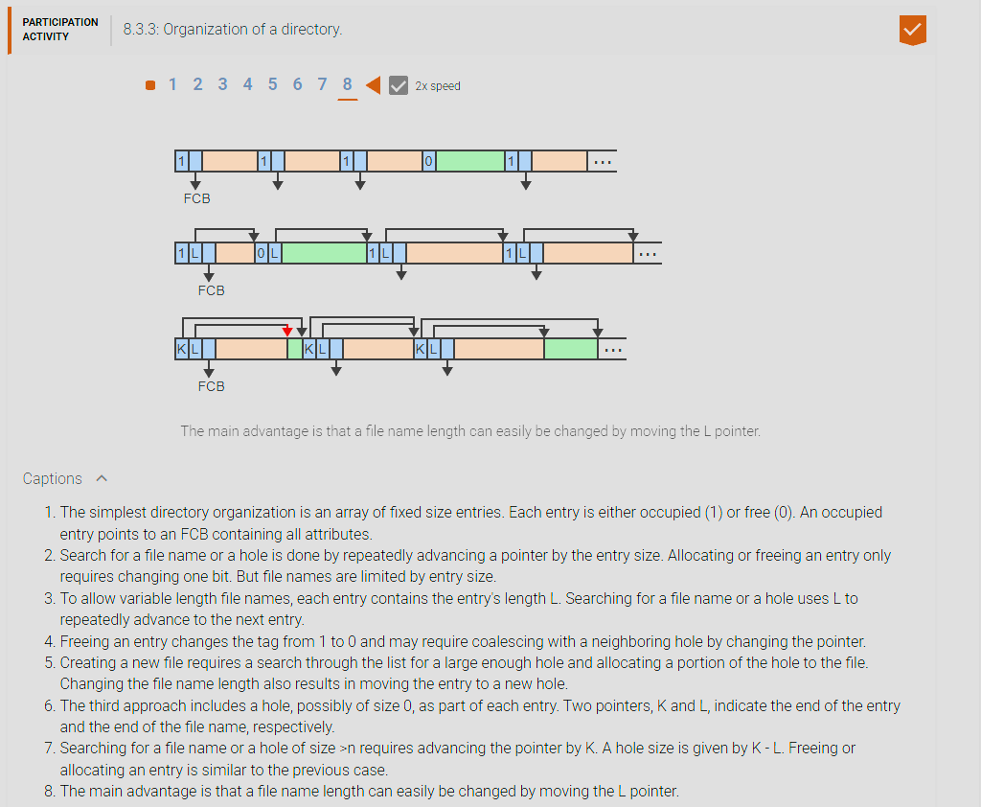

1. **Operations on files:** The FS provides a set of high-level operations to create, destroy, read, write, and otherwise manipulate files. Jointly, the set of all file operations constitutes the user interface to the FS. (NOTE: disks are organized into blocks which is a fixed amount that can be read from a disk). FS common operations on a file: Create, Destroy, Read, Write, Seek, Close.
2. **Create file:** operation causes the creation of new named file. As part of the create operation, the FS allocates and initializes a new File Control Block (FCB). The FS also allocates a free directory entry, which contains the file’s name and a pointer to the FCB. 1. create new named file 2. FS allocates and initializes a new FCB 3. allocates a free directory entry continuing the name and a pointer to FCB.
3. **Destroy file:** operation removes an existing file from the FS. The operation reverses the process of creation by freeing up the file’s FCB and directory entry. If the file is not empty, then the location information in the FCB points to blocks on the disk, where the file’s contents are stored. The FS marks the file’s disk blocks as free. 1. Reverse the allocations of create, 2. for non-empty files, FCB points to block on the disk, the FS marks the file’s disk blocks as free.

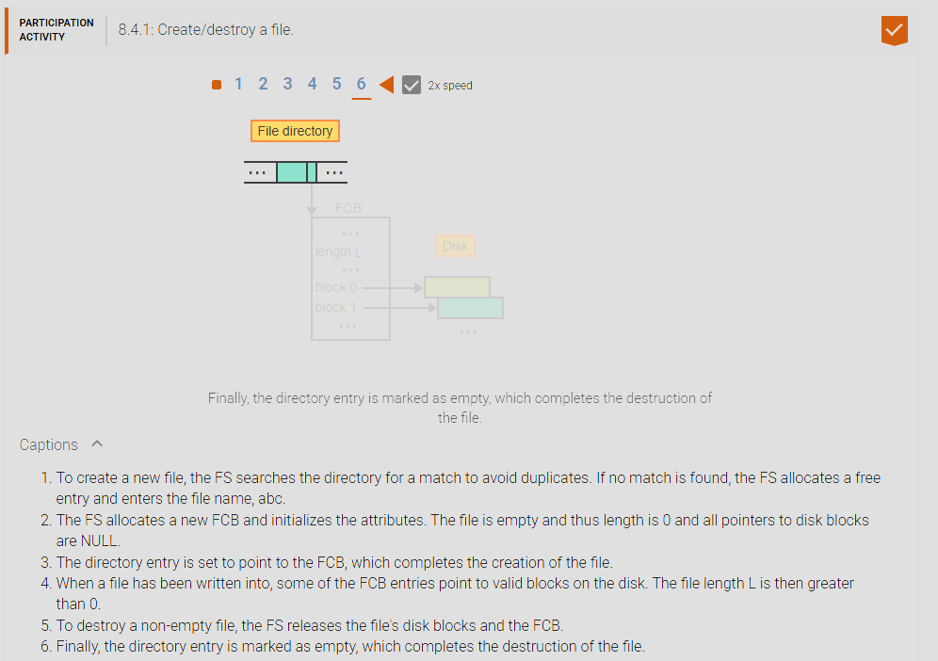

1. **Open file table (OFT):** is a data structure that keeps track of all files currently in use to facilitate efficient access to and manipulation of the files.
2. **Open File:** 1. Verify that the invoking process has the right to access the file and perform the requested operation 2. Fine and allocate a free entry in the OFT. 3. Allocate read/write buffers as necessary for the given type of file access. 4. Copy relevant information from the FCB to the OFT entry, including the file length and location on the disk. 5. Initialize other information in the OFT entry, such as the initial position of a sequentially accessed file. 6. Return the index of the allocated OFT entry to the calling process for subsequent access to the file.

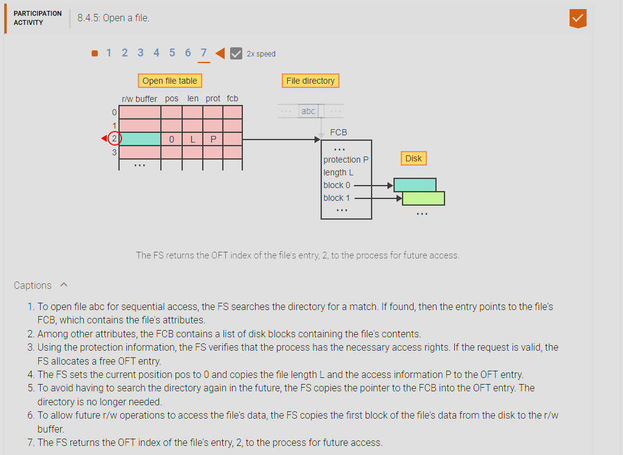

1. **Read:** In the open file table (OFT) is maintained a r/w buffer 1. To start, the current position is 0 and the r/w buffer contains first block of file 1. Note: disks are organized into blocks which are fixed amount that can be read from a disk 2. A general read command will look like this: 1. read i, m, n => I is the OFT index, n specifies number of bytes to read, m is location in memory where the data is to be stored. 3. The operation read i, m, n copies first n byte from r/w buffer. 4. the next operation may continue from there, 1. if it reads past the end of the r/w buffer, the FS loads in the next block of the file. Files are composed of blocks on the disk, when reading the FS reads a file into a r/w buffer which contains the first block of a file once it reaches the end of the r/w buffer then it loads the next block of the file into the r/w buffer.

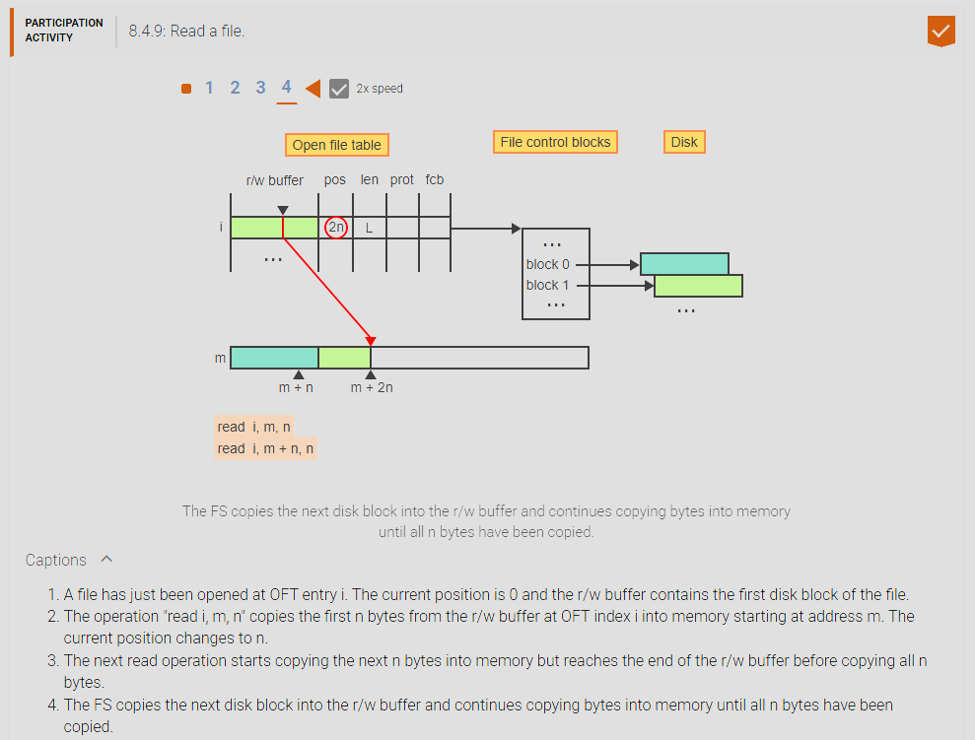

1. **Write:** 1. write i, m, n –I is OFT entry, m is starting location in memory, n is number of bytes to write. 2. copies n bytes from the memory area m into the r/w buffer of the open file i. The current position and file length are n. 3. The next write operation starts copying the next n bytes from memory to the r/w buffer but reaches the end of the buffer before all n bytes have been copied. 4. The FS allocates a free disk block and saves the r/w buffer in the new disk block. 5. The operation then copies the remaining bytes from memory to the now empty buffer starting at offset 0. The current position and the file length change to 2n. When writing the FS copies the data into the r/w buffer until it reaches the end of the r/w buffer in which the FS finds and allocates a new free disk block and writes the data from the r/w buffer into the new free disk block. Then resets the offset at the start at 0 to allow for more write operations into the newly cleared r/w buffer.

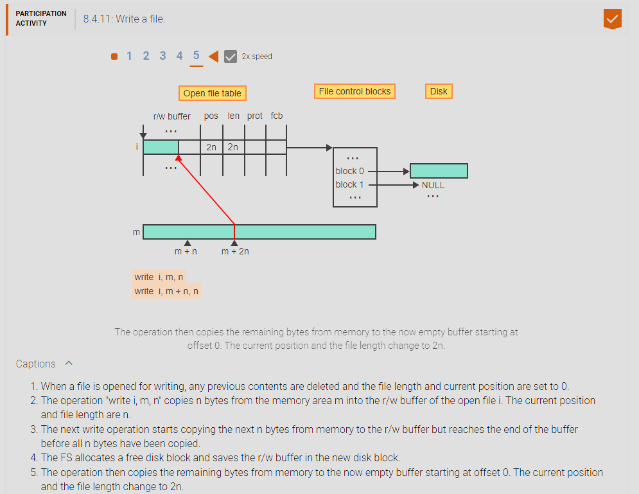

1. **Seek:** run through the file using the r/w buffer, traverse/run through the entire file using the r/w buffer until you reached your position. since files are streams of bits you will need to keep seeking until you reached your desired position via using the r/w buffer.

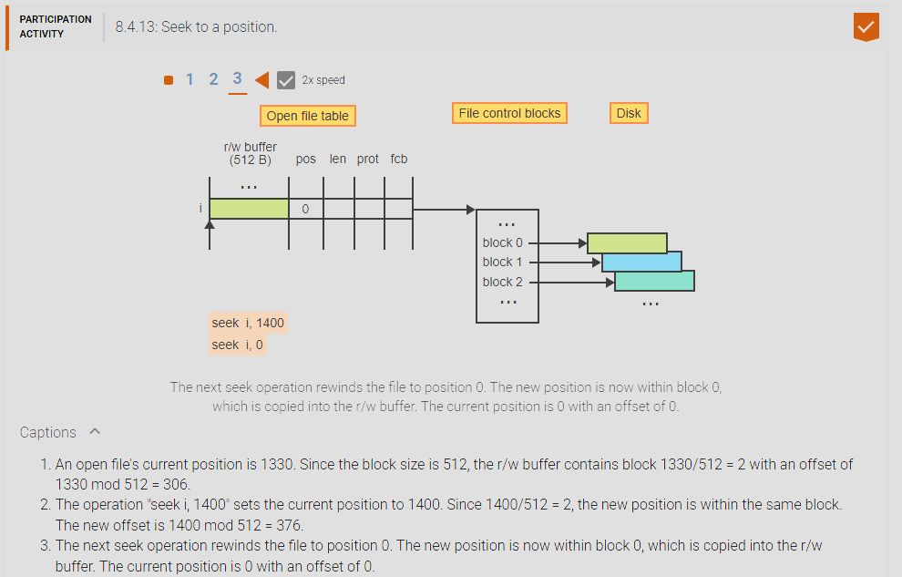

1. **Close:** 1. undo what you did when you opened the file, 2. be sure to write out the current buffer. When closing a file you must undo what you did when opening a file then whatever is inside the r/w buffer but be written out to the disk on a free disk block.

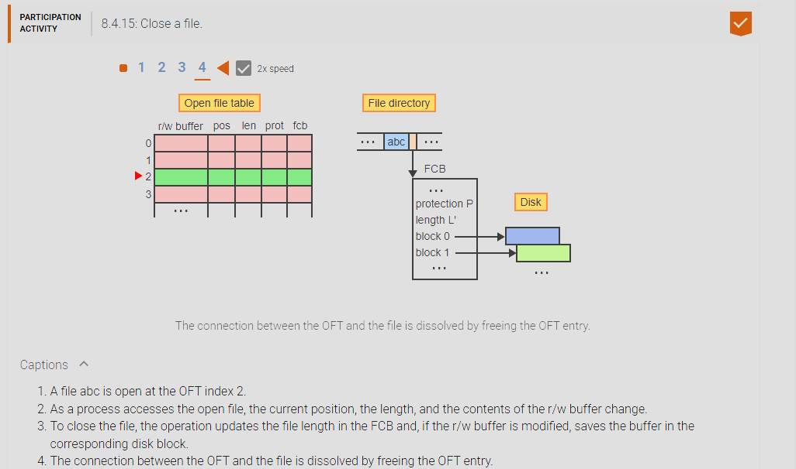

1. **Disk block:** fixed sequence of bytes on the disk, which can only be accessed as a single unit. The FS views the disk as a sequence of blocks. A file may be viewed as a series of 1 or more blocks, numbered 0 through f – 1, where f is the number of blocks constituting the file. The way disk blocks are allocated to file blocks has a major impact on the efficiency of most file operations. The FS views the disk/persistent storage in disk blocks which are fixed sequence of bytes on the disk which can only be accessed as a single unit. A file is composed of 1 or more disk blocks from 1 to f – 1 where ‘f’ is the number of disk blocks the file is composed of. These disk blocks can be located anywhere on the physical disk (HDD) or (SSD) which will require different methods to access them.
2. **Contiguous Block Allocation:** Pros: Simple, Easy/Efficient access. Cons: Disk fragmentation, can’t expand if you run out of room and there’s another file, hard to know how much space to allocate for future use by each file. Contiguous block allocation, similar to physical memory, the file is stored contiguously (side by side) on the disk which makes it easy/ simple to use and have an efficient access because the file’s disk block locations works like an array from n to m where n is the index of the first disk block and m is the index of the last disk block. The issue of this is that it is difficult to expand a file because we do not know how much extra disk block spaces to add and thus will have to move files around which is has a large overhead, and like physical memory fragmentation is an issue and having smaller and smaller sections of disk having small already of disk blocks that may be unusable for the average size file.

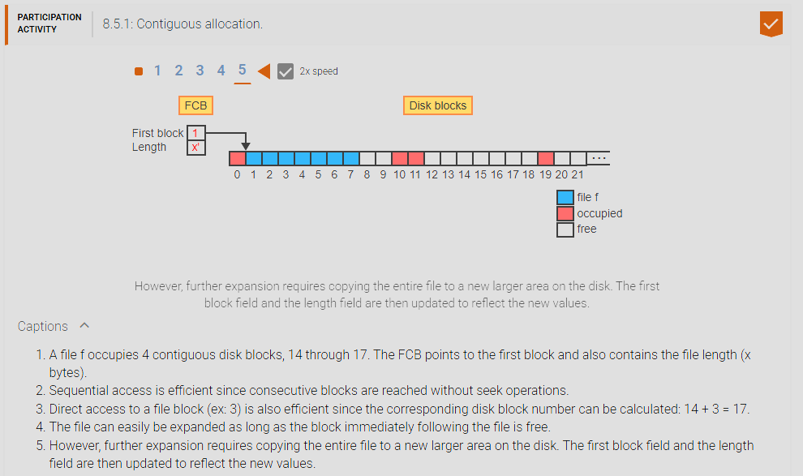

1. **Linked Block Allocation:** FCB points to first block, each block points to next, Pros: easy expandability, Cons: slower sequential access which requires multiple seeks, can’t do direct access, if part of a disk is damaged, more likely affects MULTIPLE files, wastes disk space with pointers. For linked block allocation the FCB points to the first block and at the end of each disk block is a pointer to the next disk block and so on. This addresses the issue of expansion of a file which we can now store the file into any location on the disk regardless of how small the hole is, the downside is that if the disk gets damaged many files could be affected because they are more spread out across the disk unlike contiguous block allocation. It is also slower to do operations like seek/read/write because you cannot do direct access as easily as you can with contiguous block allocation and have to traverse the file to find the next pointer to the next disk block and so on.

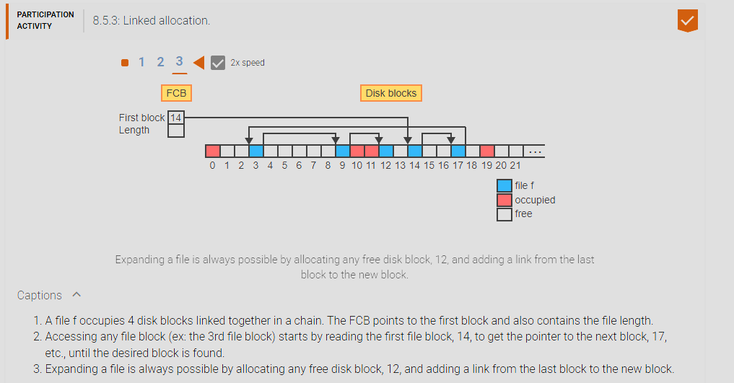

1. **File Allocation Table:** FAT (like FAT-32) an array where each entry corresponds to a disk block keeps track of which disk blocks belong to a file by linking block in a chain of indices. FCB points to the first entry in FAT. Fixes the problems with linked blocks but is potentially a big table. File Allocation Table (FAT-32) instead of having links/pointers to different disk blocks at the end of each disk block in a linked block allocation we segregate the disk block and the File Allocation Table array, the FCB now stores the index of the first disk block that is inside the File allocation table array. The issue with contiguous block allocation is that is hard to expand but easy to sequentially access. The issue with linked block allocation is that it is easy to expand but hard to sequentially access. File Allocation Table fixes both issues in which the FCB now stores the index of the first disk block that is inside the File allocation table array. Each entry points to a disk block and stores the index of the next disk block, this way sequential access is easier since you do not have to seek the entire disk block and can immediately go to the next index to find the disk block you need and get the position. The file can also be stored anywhere in the disk without it being contiguous so it is easily expandable.

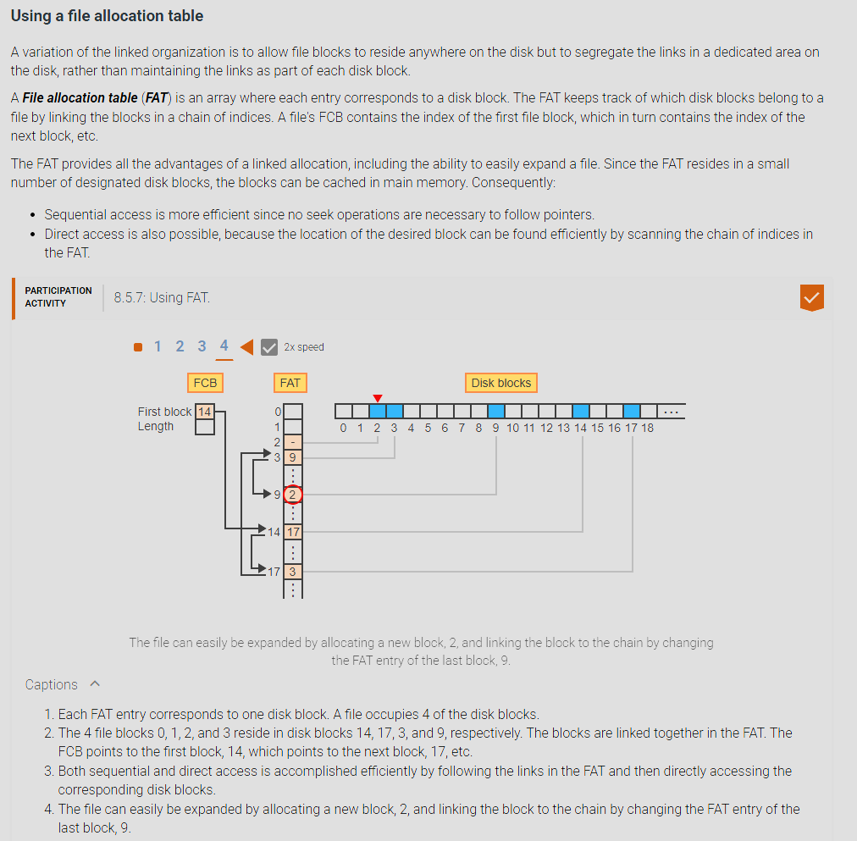

1. **Index Allocation:** Keep an index of blocks for each file (in the FCB) main problem: how big should the index table be? Expandable Index Tables, basically, the last entry of the main index table can point to additional index tables. For index allocation the FCB stores an index table of disk blocks and can be expanded by adding a new index table at the end of the main index table this allows expansion of a file. Basically inside the FCB is a index table and we store the disk blocks in each entry until the last index can point to a new index table which allows for easy expansion of a file, the problem then becomes how big should the index table be?

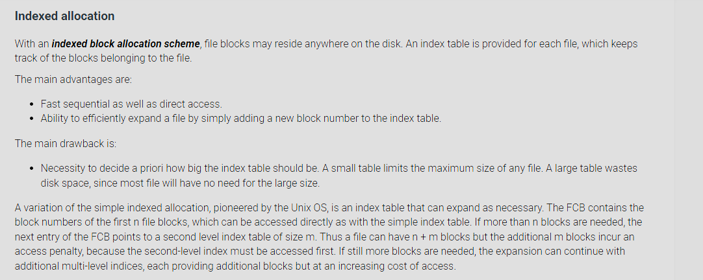

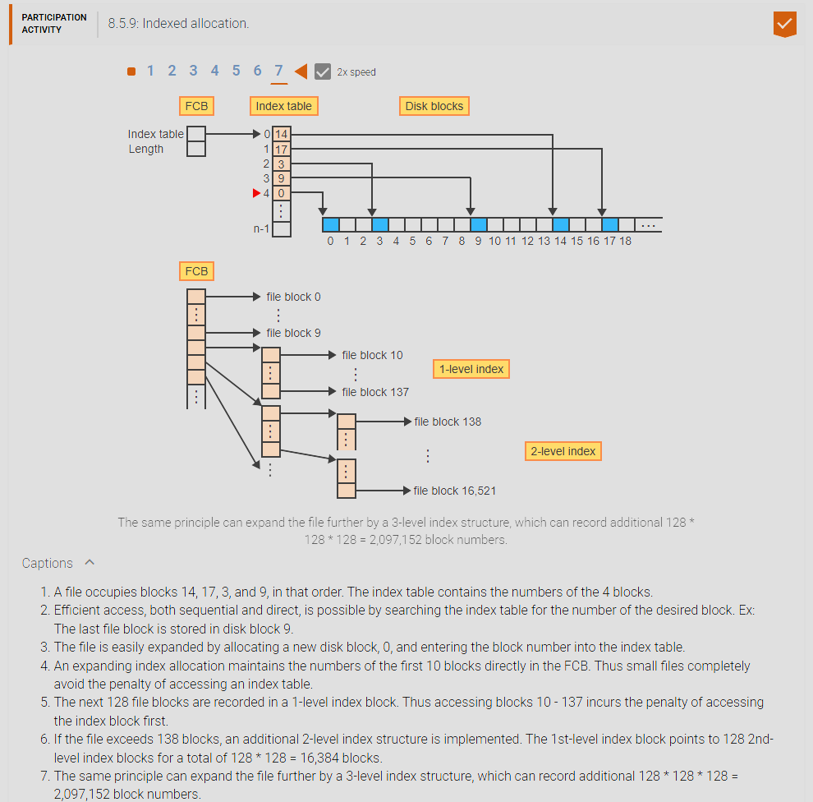

1. **FS:** responsible for implementing the concept of files
2. **File:** simply a stream of bits that is comprised of disk blocks that is accessed via a stream or records that is held in persistent storage (i.e. a disk/HDD/SSD). High level FS operations can be used to manipulate a file like create/destroy/read/write/seek/close.
3. **Record:** a structure of related items/data/information. Like names, passwords, dob, age etc.
4. **Access method:** the two access methods for a file is sequential accessing via a stream of bits or reading ‘n’ bits or reading the next record.